**THEORIES ACROSS ALL TOPICS: Family, Education, Crime, Stratification and general approaches**

**D group 2019**

* Functionalism p.
* New Right p.
* Marxism p.
* Neo marxism p.
* Liberal feminism p.
* Radical feminism p.
* Marxist feminism p.
* Interactionism p.
* Weberian p.
* Postmodernism p.
* Other theories p.
* Linking theory to methods p.

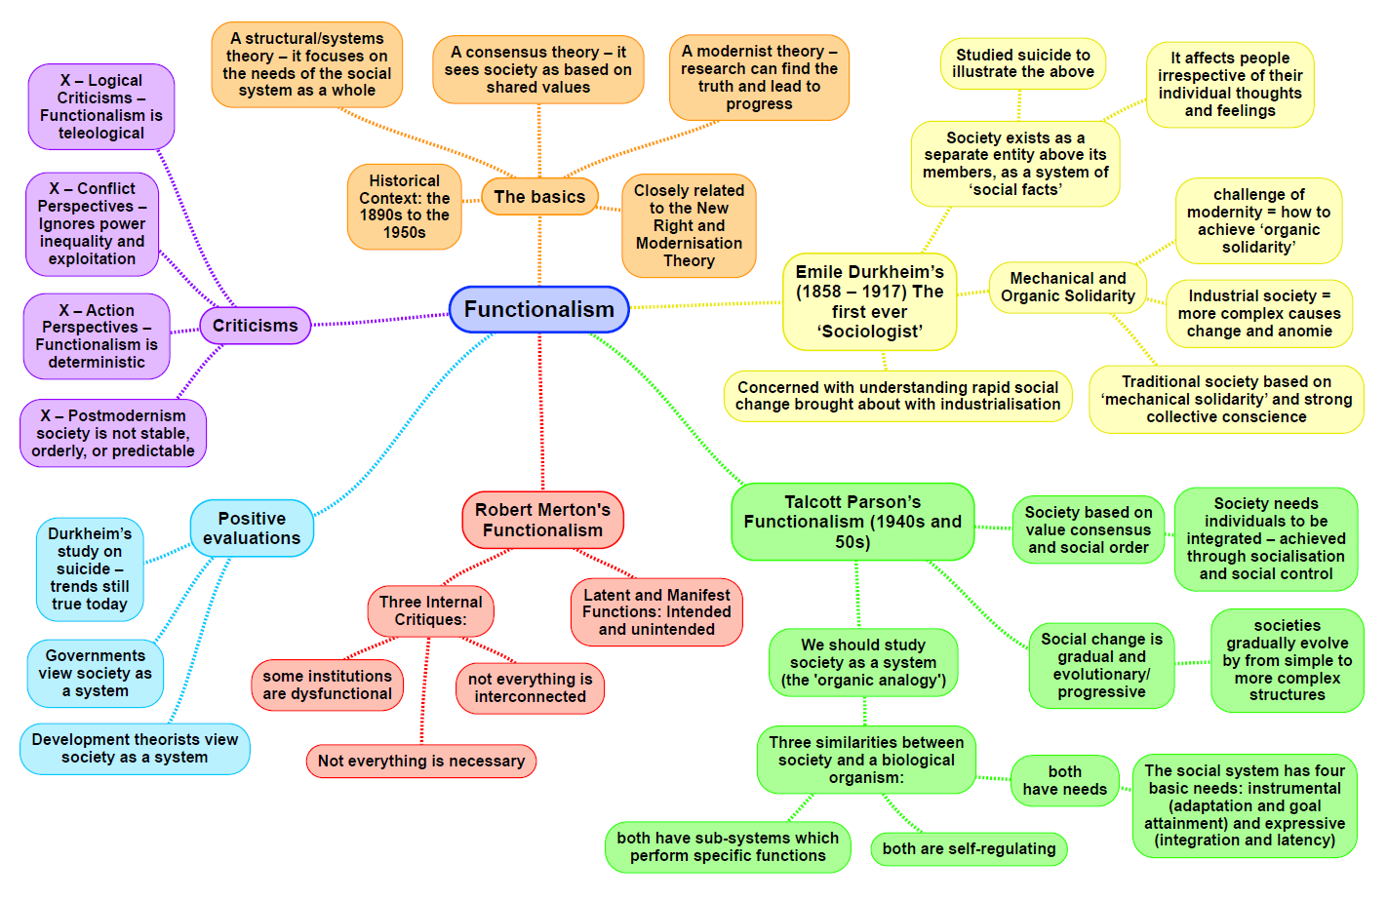

|  |  |
| --- | --- |
| **Theory: Functionalism MACRO STRUCTURE CONSENSUS** | |
| Family:  **Parsons**- 1951 said the nuclear family has become dominant in industrial society. In preindustrial society the extended family is most common. Families live and work together producing crops to live from, this is where the term cottage industry comes from. In industrial society the nuclear family became dominant, there’s a huge increase in individuals learning the home to work for wages. The key social change that industrialisation separates home from work. Parson also thought there were two functions of the family which are primary socialisation of children and the stabilisation of adult personality. Men and women have separate roles – instrumental and expressive  **Murdock**- he concluded that the family is useful for society and is inevitable and universal and that you can’t avoid having family units in society. He looked at 250 societies in different cultures and argued some form of nuclear family existing in all societies. Saying there were 4 basic functions, sexual, reproductive, economic and educational | Education:  **Durkheim** – education passes on norms and values in order to integrate people into society, he believed education helps to create social order based on cohesion and value consensus, also to strengthen social solidarity.  **Parsons**- he described school as a bridge between the family roles and adult society, they pass on universal value of achievement. Parsons said education selects children in propitiate roles. He also agrees with Durkheim that education helps make people agree about norms and values  **Davis and Moore** – 1945 said every society sorts its members into different position, the rules for how education does this is called principles of stratification, thinking there has to be a system of unequal rewards to motivate people to train for the top position. |
| Crime:  **Durkheim**- Durkheim 1897 said deviance allows social change, he and others who came after argue said all society’s need some change to remain healthy/stable. If society reacts positively to deviant behaviour then maybe in the future it seen as non-deviant. However, he said crime becomes dysfunctional when the level of crime is too high, and threatens social order, or too low and there’s no social change.  **Merton** – 1968 from his American study that individuals shared the same goals but didn’t have equal access to the means of achieving them. The main cultural goals is success and wealth (American dream). The main institutionalised of achieving them was in the educational system, when people were excluded or failed from this system it created an anomie (lack of values and feeling on normlessness). When people were unable to achieve society/cultural goals due to factors beyond there control (e.g discrimination or deprivation), it caused strain which leads to deviant behaviour.  **Subcultural theories** –  Subculture theory says the cultural values of some groups encourage deviance, some deviance is conformity to different norms and values to mainstream society. Cohen 1955 said gangs provide respect for young frustrated kids at their lack of status in society.  Cloward and Ohlin 1960 combined Merton and Cohens ideas. They believed there’s a legitimate (passing exam=job Merton) and illegitimate (gang=crime) opportunity structure. Arguing access to illegitimate opportunity structure could be unequal like access to legitimate system. Some criminal gangs provide adolescents with deviant routes to succeed and some don’t, explaining why not all frustrated W/C boys turn to crime.  Cloward and Ohlin came up with 3 different subcultures which encourage different types of deviance: Criminal subculture- areas established criminal culture where young people are taught by adult career criminals. Crime in these areas is usually utilitarian which is crime that makes money e.g robbing or drug selling. Areas controlled by mafia or mob have criminal subculture. Conflict subculture- areas that don’t have established criminal culture (due to factors like rapidly changing population), young people organise themselves into gangs. Crimes tend to be non-utilitarian e.g vandalism and violence. They engage in wars with other gangs locally. And Retreatism subculture- young people who failed both legitimately and illegitimately retreat from society and turn to drugs or drinking.  They have been criticised for assuming the majority of people aspire to be the mainstream goals of success and wealth. Taylor, Walton and young 1973 point to deviant groups like hippies who don’t share these groups. Subcultural theorists assume there’s no overlap between these three groups | Stratification:  **Class** – The class system helps people find the right place/role in society, most important positions are filled by the brightest, they say societies meritocratic, high people are there because of their talents and efforts not their parents. The higher status, power and income are rewards for conforming to societies values. Functionalists say most people don’t object to people in power getting extra status and rewards showing they support the system.  **Gender** – Parsons (1955) refers to expressive caring roles that women play compared to instrumental role men play. Because mothers nurse their children they have a closer and stronger relationship with them, this is common in modern society where the isolation of the nuclear family led to a strong relationship between mothers and their children. The male breadwinner spent their working day competing in a meritocratic oriented society which led to stress and anxiety. The expressive female would relieve this tension with love, consideration and understanding, Warm bath theory  Murdock says man has superior physical strength and can better undertake the more strenuous tasks e.g. Lumbering, mining, quarrying, land clearance and house building. Due to her biological functioning of childbearing and nursing a women is tied to the home because of her physic a women is limited to much strenuous tasks. Murdock found the sexual division of labour is present in all of society and concluded that ‘ the advantages inherent in a division of labour by sex presumably account for its universality’  **Ethnicity** – Parsons (1966) predicted that black Americans would gradually be assimilated and would eventually play a full role in a meritocratic society  **Age** – Parsons, Eisenstadt, A Cohen, Matza  Functionalists see age inequality as useful to society. Parsons 1977 say you learn more, set roles of different age groups allows people to develop fully. It doesn’t explain how older people get no respect. |
| **General view of the theory** - Functionalism is a modernist structuralist consensus theory rooted at the work of Durkheim and refined by parsons and Merton. It was a very popular approach in the 1950s and 60s but now it is generally regarded as inadequate and old-fashioned approach to understanding society. functions regarded society as a stable harmonious integrated social system with social order and cohesion maintaining by a fundamental value consensus.  **Durkheim** – suggests that people are selfish and that society would soon fall into chaos and disorder unless they learned to share some common values and show commitment to cooperation in society. Therefore Durkheim placed great importance on the role of social institutions such as family and the education system, in socializing people into what he called a value consensus or collective conscience.  **Merton** – he criticises parsons for his assumption that ll social institutions performed beneficial, positive functions for society and individuals. Merton recognises that in highly complex independent social systems there’s plenty of scope for things to go wrong. There also may be unforeseen consequences when some apparently beneficial functions are performed. Merton introduces the idea of dysfunction to describe the situation whereby consequences with harmful effects for society or for some individuals  **Parsons** (GAIL)- he suggests that to survive in a health state all societies have to resolve two sets of problems which are instrumental and expressive, and satisfy four functions prerequisites which are met by 4 related subsystems. This is known as GAIL which is goal maintain, adaption, integration and latency | **Evaluation**:  Strengths of functionalism is it is along with Marxism, a reasonably successful attempt to produce a general theory of the workings of society. It also recognizes the importance of social structure in understanding society, how it constrains individual behaviour and how the major social institutions like the family, education and the economy often have links between them.  Weaknesses of functionalism is it is a metanarrative or grand theory that tries to explain everything from a single perspective. |

New Right – Ollie and Mia

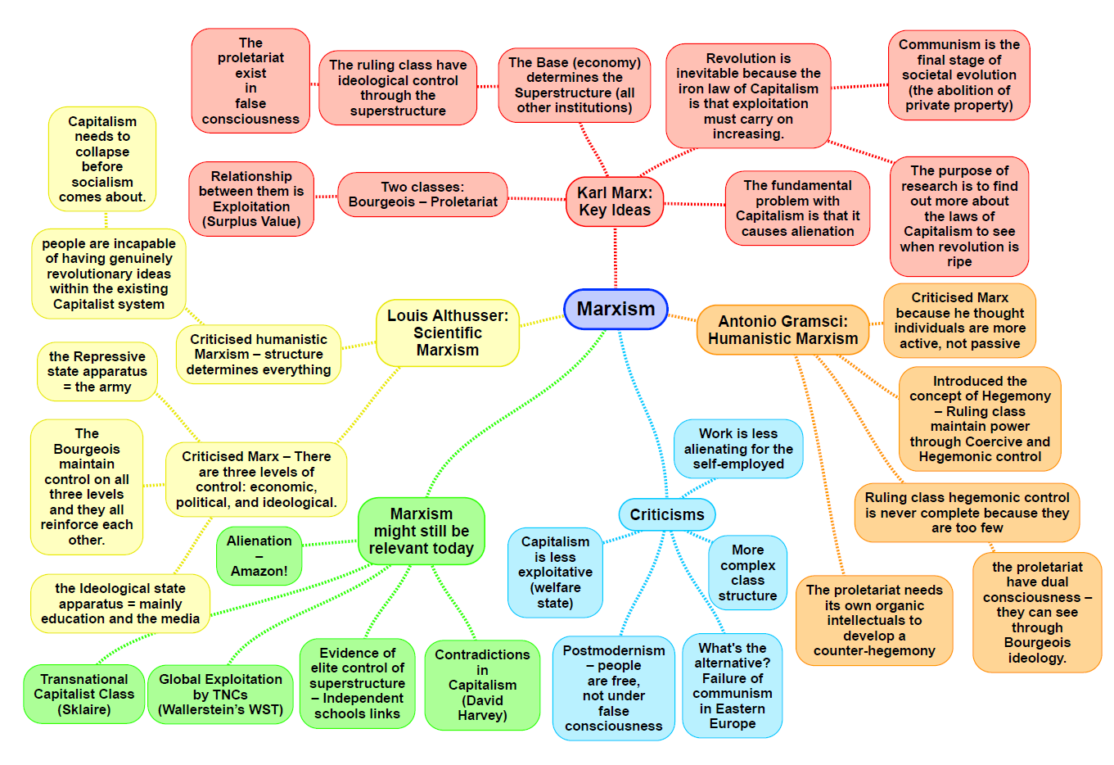

Marxism: Emma

**Neo Marxism: Rowan**

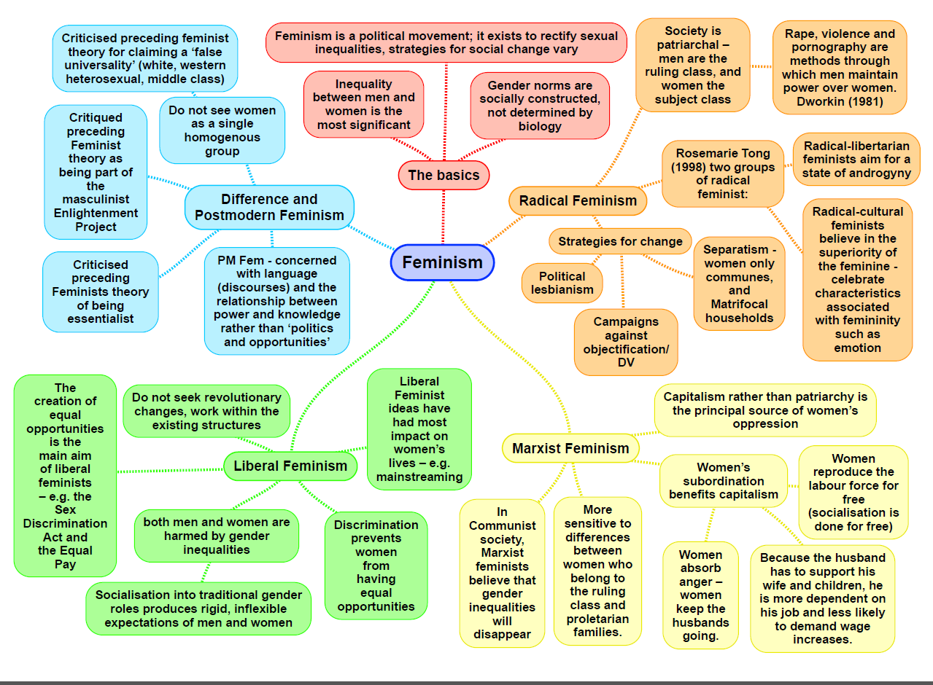

|  |  |
| --- | --- |
| **Theory: Feminism: liberal MACRO/MICRO STRUCTURE/ACTION CONFLICT** | |
| Family: Roles are more symmetrical than before. Pressure on institutions like the government to change laws and social policy which discriminate against women.   * Equal Pay Act 1970 * Sex Discrimination Act 1975   Oakley: Manipulation and canalisation in homes as part of primary socialisation, defines gender role in the future  Best: Girls and boys are given different toys to play with and different books to read. Starts creating a gender domain  Sharpe: Less emphasis on family first. Women having children in later life after they have fulfilled their career goals. | Education:  Oakley: canalisation because of canalisation in schools leading the gendered  Subject choices at school eg girls doing arty subjects, boys doing sport.  Sharpe: Changing aspirations in girls has led to them doing better in education  to secure a career and professional employment in the future.  Stanworth: teachers were more likely to give boys more attention in classrooms  McRobbie (see crime) |
| Crime:  McRobbie: ‘Bedroom culture’ girls socialized into staying at home where it’s safe  Carlen: Women are judged in the Criminal Justice System in terms of their gender role as mothers and wifes instead of on their offences  Adler: liberation thesis: With the disappearance of the Patriarchy woman will start commiting at much crime as men  Walklate: Women have less opportunity to offend because they are most likely to be home with the children  Heidenson: Women are more likely to be treated harshly in court if they deviate from the social norms of femininity. | Stratification: Women still face disadvantages in the home, most likely to have  To take care of the housework, in politics, only 29% of female MP’s in 2015, and  In employment, men get payed 18% more than women.  Gender – Oakley, Sharpe, McRobbie Overall changing aspirations for women  proven through interviewing girls in the 70s and 90s have led to putting their  career first, increasing their absolute social mobility |
| General view of the theory (391 Browne):  Liberal feminists want equal rights and opportunities for woman. They acknowledge that there has been significant progress made, but also know that the best way to bring about equality is though socialisation and reforming the legal system. | Evaluation:  **Radical feminists**, would argue Liberal feminists are too positive. Social change  is not possible as long as the Patriarchy remains.  **Functionalists** believe gender differences and inequalities are functional and  don’t need to be changed  **Postmodernists** believe women can now choose their social roles and their  careers, not as influenced by the wider structure of society |

|  |  |
| --- | --- |
| **Theory: Feminism: radical MACRO STRUCTURE CONFLICT** | |
| **Family:**  Firestone – Sees basic biology of childbirth as the issue. Women are dependent on Men as they need men to have babies. Four facts how the nuclear family is dominated by patriarchy-  1. Women, because of their reproductive biology, have always been dependent  upon men for their protection and survival.  2. Human infants are dependent upon adults for a relatively long period of time  (during which they have to be looked after).  3. There is a basic and universal mother - infant bond based upon the fact that  the mother actually gestates the child - it comes from her body. Firestone sees  this as a special, interdependent, relationship unlike that which exists between a  father and child.  4. The biological (reproductive) division between the sexes is the origin of all  other divisions - economic, political and ideological.  Duncombe and Marsden- Women perform a ‘triple shift’ in the home. This consists of paid work, housework, and emotion work, as they make sure everyone is ok. Women often do more housework than the man even if they are holding down a full time job.  Bernard- Believes that Housework makes woman sick.  Millet- Patriarchy’s key institution is the family The family teaches to conform with patriarchy. The personal is political – Men exploit women in both personal and sexual relationships. | **Education:**  Still a sexual harassment of girls.  Patriarchy still exists to reinforce gender roles, which is seen in subject choice, girl choose food tech, and boys choose PE.  Teachers attitudes encourage boys to follow a route of computing/sciences.  Girls can’t break through the ‘glass ceiling’  Boys get more attention from teachers even if it’s negative.  Male Gaze- Masculinity is constructed on them boasting their sexual conquests, and how far girls would let them go. Promiscuous boys are seen as ‘studs’ yet promiscuous girls are seen as sluts/slags.  Shows double standards, which helps to encourage conformity to separate gender identities for men and women, with the stereotyped man as sexual athlete and stereotyped women as the passive and faithful lover, wife or girlfriend.  (Willis) Lads- Confirmed that Boys constantly chased girls for sex.  2017- The BBC revealed 2/3 of its biggest paid stars were men. Women made just 34/96 top names. The BBC’s 12 highest paid stars are all Men. To resolve the issue a number of BBC men took pay cuts.  2019- More than nine out of 10 British universities pay their average male employee more than they pay their average female employee.  Barclays bank- This company has reported a pay gap of 44.1% in favour of men. |
| **General view of the theory (Browne p.391):**  Patriarchy is the most important form of inequality, the world is divided into two ‘sex classes’ of women and men. Men dominate women in all areas of life. All women have the shared interest of challenging men, who currently dominate women, through violence fear and intimidation. Men are the key instruments of women’s oppression. Patriarchal power inequalities are found in public and personal spheres of life. Women are dependent on vulnerable through stages like childbirth, which allows men to develop physical and psychological control over women. A complete destruction of patriarchy is needed. | **Stratification:**  Gender –  Workplace pay gap of 16.4% between men and women who have the same job.  Dual labour market-  Primary -characterised by high pay, secure jobs and good promotion prospects  Secondary- low pay, poor promotion prospects, low job security  **Horizontal segregation**      In which the men and women are employed in different occupational groups - managers v receptionists -Vertical segregation   In which the men and women are in the same occupational job but at different levels within that      occupation - doctors v nurses  Women have a greater life expectancy 81 vs 76.6 than Men, as they are less likely to take part in dangerous/risk taking behaviour or do manual work. |
| Evaluation: It assumes women share common interests. Fails to recognise other important factors of inequality such as class and ethnicity.  They seek to improve the position of women, but are then increasing the inequalities Men face.  All the methods suggested like women only households. |

|  |  |
| --- | --- |
| **Theory: Feminism: marxist MACRO STRUCTURE CONFLICT** | |
| **Family:**  **Ansley:** domestic labour provides the capitalist system with a well-rested, cared for workforce who use the women in the home as an ‘emotional safety valve’. ***“When wives play their traditional role as takers of shit, they often absorb their husbands’ legitimate anger and frustration at their own powerlessness.”*** Women also socialise children into the dominant ideologies of capitalism and the idea of accepting patriarchal dominance  **Breughal:** women act as a reserve army of labour. Their unpaid domestic labour maintains capitalism by reproducing and supporting the workforce at no cost to the employer. | **Education:**  **Archer:** hegemonic femininity can get in the way of education – “some girls wanted to leave education and not continue to college or university because they needed to earn money as quickly as possible to fund the maintenance of their appearance.” “University’s not for me, I’m a Nike person” – lower class girls are oppressed by both capitalist society and patriarchal ideology, so they resist higher education in place of femininity.   * Could be evaluated by considering the fact that girls do better in the education system * Archer could be considered to be more of an interactionist, but clearly is using ideas about capitalism |
| **Dual systems**  **Walby:** blends Marxist and radical feminist theories. Capitalism and patriarchy are seen as two separate systems which interact with and reinforce one another in the form on ‘patriarchal capitalism’. This creates dual roles for women as both homemakers / child bearers and as paid workers outside the home. Patriarchy creates women’s primary responsibilities in the home, which lead to their economic dependence on men. | **Stratification:** women are oppressed within the family and wider society due to patriarchal dominance/capitalism  **Barrett:** ideology maintains women’s oppression. Ideology of ‘familism’ presents the nuclear family and sexual division of labour as natural and normal; the family is portrayed as the only place where women can attain fulfilment – through motherhood, intimacy etc. overthrow of capitalism AND patriarchy is necessary to free both sexes from restrictive stereotypes  **Mitchell:** patriarchal ideology is deeply rooted in women’s unconscious minds – patriarchy difficult to overthrow |
| **General view of the theory**  They argue that gender inequalities arise primarily from the nature of capitalist society (rather than patriarchy alone). Capitalism intensifies patriarchal inequality – women used as cheap, flexible labour in the workforce and free labour in the home – childcare and reproduction, which support the needs of capitalism at no extra cost. Capitalism is the root source of inequalities, and patriarchy supports it. | **Evaluation:**  -They don’t explain the fact that patriarchy exists in all known societies, not just capitalist ones (radical feminists)  -Men also benefit from women’s’ subordination – not just capitalism – they have positions of power, high status and pay, and often discriminate against women and commit sexual/physical violence against them (radical feminists) |

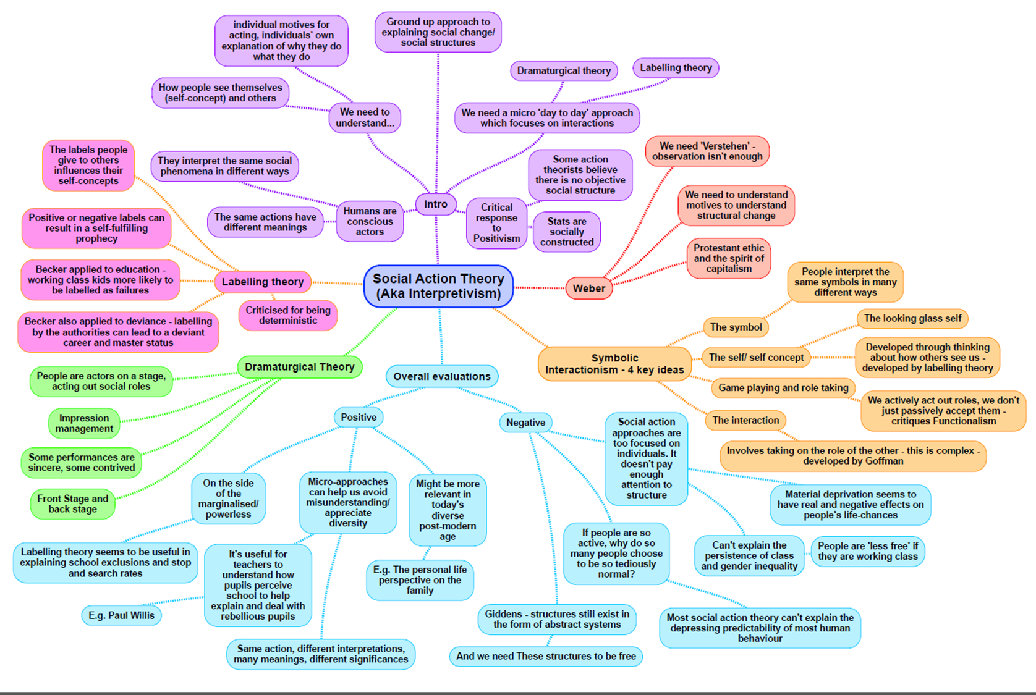

Interactionism: Charlotte

|  |  |
| --- | --- |
| Theory – Weberian | |
| Stratification  Class - Goldthrorpe- He distinguishes between a service class an intermediate class. The service class from a higher class of employee, who get increments on their salary and have pension rights and promotion aspects.  Criticised for:   1. Failing to identify a difference between managers and   employers and professionals   1. Disagreeing with the Marxist view that big employers constitute a ruling class.   Gender –  Ethnicity – Weberian expiations are more flexible and multi-dimensional.  Parkin (1968) terms minority ethnic groups as ‘negatively privileged status groups’. He uses the concept of social closure to argue that the more privileged groups can operate a system of social segregation and keep minority groups out of positions of authority. **Concept of the glass ceiling.**  Rex and Moore (1967) minority groups are servery disadvantaged in the labour market so much so they formed part of a duel labour market, being placed In the secondary labour market. Their life chances and market position were noticeably weaker than their white counter parts; they were marginalised and risked forming an underclass in society.  Age – The aging process can clearly be associated with issues of status and power in the UK. Old age and retirement can be constructed as triggers for a loss of status (**McKingsley, 2001**) and this is as much cultural as it is economic. Without a strong market and work situation there will inevitably be a weakening of status and power. Youth groups could also be explained with adherence to these concepts. **Parkin (1968)** used the concept of negatively privileged status groups in his work on ethnicity, a concept which could be applied to older people who have lost their position in the labour market, kept out by younger workers keen to work their way up the occupational ladder. This further relates to the glass ceiling concept.  Disability - | Methods  Verstehen is now seen as a concept and a method central to a rejection of positivistic social science (although Weber appeared to think that the two could be united). Verstehen refers to understanding the meaning of action from the actor's point of view.  Felt values were significant in choosing methods but not in the data collection stage. |
| General View of theory  Weber suggest that there is a need to distinguish between CLASS (which has an economic base), STATUS (which is based on esteem) and PARTY (which is based on access to and use of power)  Weber meant that the chance of one person, or a group of people, realizing their own will in a communal action, even the rest of the population might not want the same thing.  Class for Weber is the market situation of a person. If someone has a rare skill or one that is in much demand, then the person’s worth to society will be greater than that of an unskilled worker.  Status is honour accorded to certain individuals or groups. A person might have a low economic value but high social status. Weber defined social classes as clusters of occupations with similar life-chances and patterns of mobility (people’s opportunities to move up or down the occupational ladder). On this basis, he identified 4 distinct social classes:  1. Those privileged through property or education  2. The petite bourgeoisie (the self-employed, managers)  3. White-collar workers and technicians (the lower middle class)  4. Manual workers (the working class). | Evaluation  Weberian; class, status and party are all aspects of unequal distribution of power. Classes are distinguished by their unequal life-chances. Which as a result could involve antagonistic relationships such as, negotiation over work and pay. If classes are distinguished by life-chances, there is inevitably a boundary problem: exactly how unequal do life-chances have to be before one can talk about different classes existing? In other words, where is the line drawn between classes. |

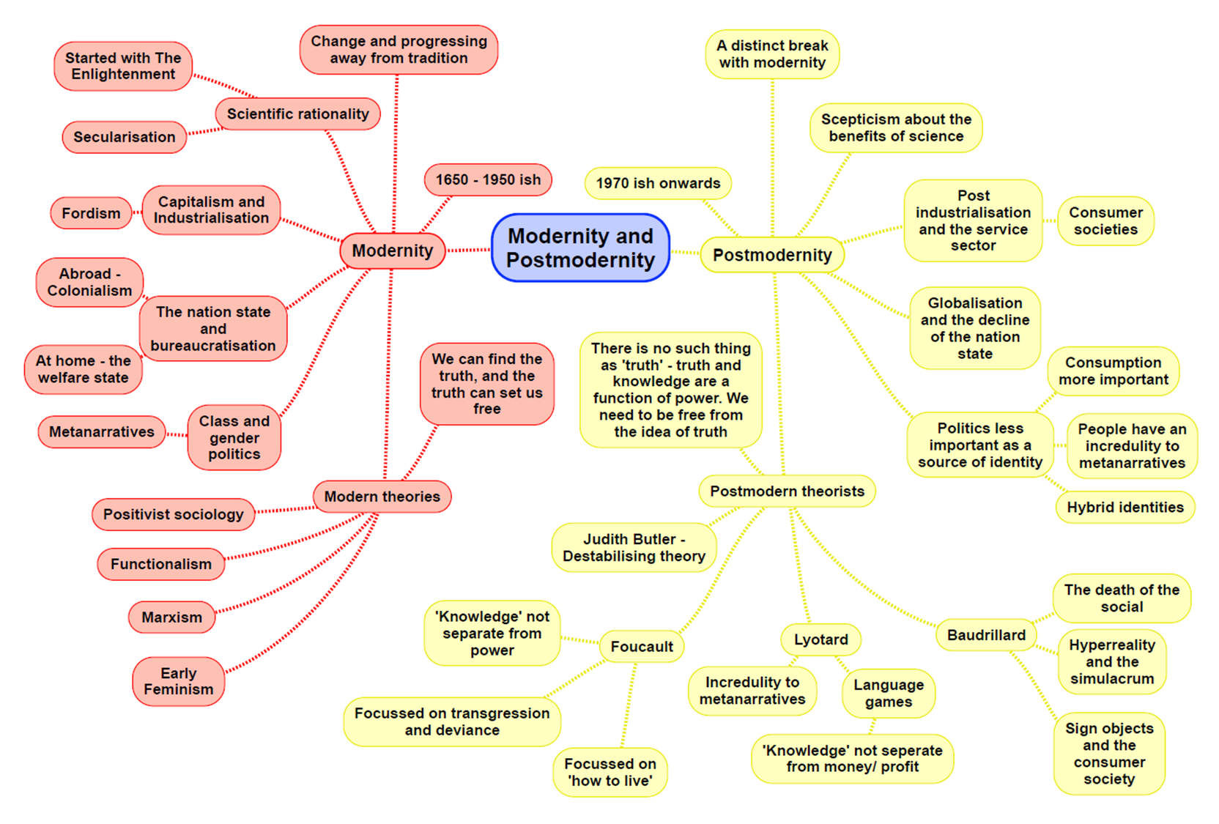

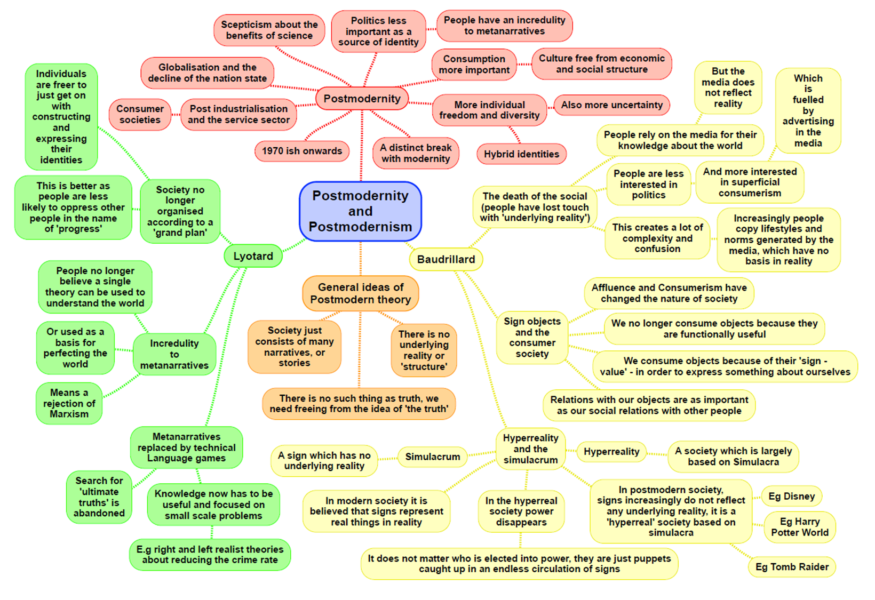

|  |  |
| --- | --- |
| **Theory: Postmodernism Would not see itself as consensus/conflict or structure/action – these are metanarratives** | |
| Family:  Alan and Crow – In contemporary society the traditional family life cycle and life course have changed. In the past, the typical life cycle took the form of set stages with a standard life course of individuals. Young people would grow up in 2-parent families, finish education, leave home, get married and have children. In contemporary society, there are huge changes as young people face uncertainty in their personal lives and have to make more choices about whether to focus on education or careers rather than starting a family.  Rapoport and Rapoport – Suggests that professional wives are still expected to take on major responsibility for most of the housework and that it is mainly women who take time off to look after sick children.  Beck and Beck-Gernsheim – These sociologists suggest that in an individualized world, which is more insecure and uncertain than ever, love is the only place where people can truly find themselves. IT is the growth of confluent love and the search for pure relationships with growing individualization that they suggest lies behind the growing diversity of families in contemporary society. | Difference feminism (p.393 Browne)  Difference feminists suggest that other variants of feminism viewed women’s subordination through the eyes of white middle class women. While all women suffer many of the same problems, not all are in the same position. The subordination of women and their experiences of oppression can take diverse forms in different contexts and among different social groups.  The case in postmodern societies. Postmodernists claim that there has been a weakening of structures like gender, social class, and ethnicity as sources of identity. People can choose identities and lifestyles, which is reflected in a diversity of meanings attached to being a woman in contemporary society. |
| Crime:  Messerchmidt – Suggests men turn to c rime and deviance as a means of asserting their masculinity when legitimate and traditional means are blocked. Men seek alternative masculine validating resources.  Lyng – Studied crime as edgework. Individuals committing crime for the excitement and thrills they get from risk raking as they explore boundaries between legal and criminal behaviour.  Katz – Explores the pleasures and seductions of crime for individuals. | Stratification:  Class – Pakulski + Waters – Discuss the decline of group solidarity and the way in which individualization is nor paramount and that stratification is based on lifestyles. Individuals belong to several groups and so have many identities.  Sklair – Suggests transnational capitalist class is made up of 4 groups: owners and controllers of transnational global corporations, globalizing officials and politicians, globalizing professions who have high skill and education levels, and consumerist elites of the media and merchants trading globally.  Gender – Alan + Crow, Beck, Hakim – preference theory cannot really explain the class differences that exist.  Ethnicity – Modood – critical of ethnic minority groups as victims. Wants to develop a more plural approach to ethnic relations.  Age – Featherstone + Hepworth, Mannheim  Disability – Oliver – suggests that physical/mental impairment only becomes a disability when society fails to make provision for the individual concerned to live a normal life. Finkelstein – dated the perception of the physically impaired as a distinct disabled group to the arrival of industrialization and the need for factory hands to work. Until this point, they were seen as one of several marginal groups but not as distinctly different. |
| General view of the theory: p.396-401 Browne  Bauman – argues that life resembles a shopping mall and people can consume whatever they like, changing identities to whatever they choose. People buy goods for identity symbols rather than usefulness.  Giddens – Accepts we live in a runaway world and risk society and that there is growing individualization. He says these changes are a continuation of modern society in an intensified form and that they have not brought us into a new era, but instead into late modernity. Sees late modernity as characterised by social reflexivity.  Lyotard – contemporary society is rapidly changing and full of uncertainties with people questioning a whole range of traditionally accepted values. Argues that individuals have lost faith in metanarratives. They are just myths and there are no certain truths of the world.  Baudrillard – Sees life dominated by media imagery (media saturated) Mass media used to reflect some basic reality, but media distorts the way we see the world. Suggests the media present simulacra, images that appear to reflect events of the world but have no basis in reality. The distorted view of the world, which is created and defined by the media, is what he calls hyper-reality. | Evaluation (p.401-402 Browne):  + It has highlighted important cultural changes in the media. It also emphasises that the construction of identity has become more complex and that people have more choices based on consumerism.  - Giddens doesn’t dispute that changes in society have occurred, but he thinks that we live in a risk society marked by new risks. These changes have not brought us into a new era but are a continuation of modern society into late modernity.  - Exaggerates the scale of social change. Cultural tastes are still strongly influenced by class, gender and ethnicity. |

|  |  |
| --- | --- |
| **Theory: Others** | |
| Crime  Left Realism:   * Society is unequal because of capitalism, but reform rather than revolution * Practical policies and solutions to crime – criticise Marxists for lack of these * Recognise crime as a growing issue. Take crime seriously – criticise Marxists for glamourising crime and seeing working class offenders as Robin Hood characters * Believe official statistics are accurate – believe offending is higher amongst BAMEs, Men and working class * Crime is caused by marginalisation, subcultures and relative deprivation * Consider the victim – unlike Marxists. Working class are majority victims so crime is not political (criticise Marxists) * Crime stats are accurate since 90% of crime is reported to police – can’t invent working class/BAME/male crime | Crime:  Green criminology   * Crime is defined by harms. A crime is any act that harms humans, animals or the environment, even if no laws have been broken * Allows for crimes against the environment to be classified as crimes * Expands traditional criminology to new issues – zemiology (study of harms) * Definition of harms is used since different countries have different laws so the law is consistent around the globe * Develops a global perspective eon environmental harm * Removes the ability of states/TNCs to define harms in their own terms to suit their needs |
| Crime - Victimology:   * A shift in research away from the offender to the victim, their behaviour and their response to victimisation * Risk society – we are told that modern society is full of risks, and we should take appropriate measures to protect ourselves from risks * Citizens should take on more responsibility for their prevention of being a victim. Being a victim of crime is part of living in modern society * Ditton and Chadee – media amplify our fear of crime * Walklate – becoming a victim of crime is due to the personal characteristics of the victim (e.g. gender, class). Crime doesn’t affect people randomly or occur in a social vacuum | Stratification  Theories of disability:   * Medical Model – sees the disabled person as characterised by their disability. Medical professionals should do everything in their power to ‘fix’ the disabled person, regardless of personal choice. Out of date in contemporary UK * Social Model – sees that the difficulties faced by disabled people are as a result of discrimination by society rather than due to their impairment. Disabled people are ‘disabled’ by society (Shearer). There is nothing ‘wrong’ with them. |
| Stratification  Black feminism:   * Feminism is too focused on the experiences of white middle class women – should also focus on ethnicity, age and class as well as gender * Recognises that black women are twice oppresses – in terms of racism and sexism – bell hooks * The family is a source of solidarity and support for women (criticises other feminists) * McDowell and Pringle – black women face sources of oppression that white women do not | Education  Social democrats:   * Associated with the old Labour party, redistribution of wealth, high government spending, high taxation, welfare state, social justice, equality of opportunity * Wanted to (and did) replace tripartite system with comprehensive system since tripartite system favours middle class pupils * The education system is not meritocratic, due to different types of school, setting and streaming, teacher labelling etc * Gerwitz – disconnected choosers – some working class parents are less able to select the best schools for their children’s, which limits working class educational achievement * Ball – shift in emphasis from what the school can do for the student to what the student can do for the school. Competition between schools creates winners and losers |

**Writing a theory question in paper 1 and paper 3**

In the education exam (paper 1) and crime exam (paper 3) you could be asked to answer questions about sociological theories. These could take the form of:

**10 MARK THEORY QUESTIONS**

Outline and explain two [insert theory] concepts [10]

Outline and explain two arguments to suggest [insert theory] might have little to contribute to our understanding of society today [10]

Outline two reasons for the growth of globalisation [10]

Outline and explain two [insert theory] view of the nature of society today [10]

Outline and explain two criticisms of [insert theory]

Outline and explain two ways [insert theory] views social inequality today [10] – really similar to a stratification

The expectation with these questions is to use content from across all of your topics. It means there is a lot of variability in what you can write and you can use material from pretty much anywhere.

These 10 mark questions take the same format as every other one you do. They need a clearly stated point, which is explained with evidence (named people, contemporary examples, concepts) and then briefly evaluated.

**20 MARK ESSAY QUESTIONS – IN PAPER 3**

These questions have an item and will get you to do several possible things:

Evaluate the approach of a particular theory

Evaluate the contribution a theory has made to our understanding of society

Evaluate the view that conflict approaches are more useful than consensus approaches (or visa versa)

Evaluate the view that action/micro approaches are more useful than structural/macro approaches

Evaluate the contribution of modernist theories [functionalism/marxism] as compared to postmodern approaches

These questions need an introduction that clearly outlines the debate in the essay and then a range of paragraphs (suggestion of 3) that compare the approach/es in the question. Come to a conclusion. They need you to show a clear understanding of key concepts within the theory and theoretical approaches e.g. consensus vs conflict views, structure vs action, modernity vs postmodernity.

Approaches could include:

|  |  |
| --- | --- |
| **Using topics** | **Using themes from within the theory** |
| Doing a paragraph on a topic and evaluate within the topic. Pick three topics as your paragraphs and then do an additional paragraph that discusses general issues and concerns. | Each paragraph becomes a key idea from the theory that you then evaluate with issues/problems from other theories. This can draw across topics. |

