REVISION OF POST-MODERNISM (*Humans* and *Zoella*)

**Starter:** Discuss the surrealist image of a pipe by Magritte, *The Treachery of Images* – how does this relate to the idea of ‘reality’?

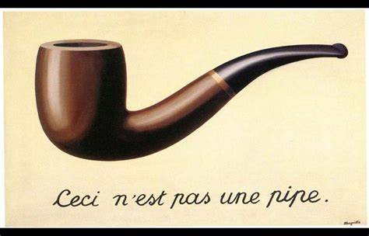

One of Baudrillard’s key concerns is the relationship between:

* Reality, symbols and society
* He stated that: *“We live in a world where there is more and more information, and less and less meaning”*

Ensure you understand (and can use/apply) the following terms:

**Simulation:** an imitation or copy**;** the blending of ‘reality’ and representation, where there is no clear indication of where the former stops and the latter begins.

**Simulacrum:** an image or symbol that has become real, and no longer depicts a reality.

**Hyperreality***:* inability to distinguish reality from a simulation of reality, due to the bombardment of electronic media messages.

**Task A: Baudrillard and Reality**

View the *Dove Evolution* video.

*Dove Evolution*: <https://www.youtube.com/watch?v=iYhCn0jf46U>

Dove site – useful for exploring the purpose of the video: <https://www.dove.com/uk/stories/campaigns/evolution.htm>

1. What is the purpose of the video?
2. How does the video relate to the idea of media and reality?

*“The media represents a world that is more real than reality that we can experience. People lose the ability to distinguish between reality and fantasy. They also begin to engage with the fantasy without realising what it is.”* (Baudrillard)

1. How does this idea relate to the video?

**Exercise B: Baudrillard and Simulacrum**

Watch this clip from *Gogglebox:* <http://www.channel4.com/programmes/gogglebox>

1. How does *Gogglebox* link to this quote? … *(people) “… seek happiness and fulfilment through the simulacra of reality – e.g. media, and avoid contact/interaction with the real world”* ( **Baudrillard)**
2. What pleasures does the audience gain from viewing *Gogglebox*?

*“The media represents a world that is more real than reality that we can experience. People lose the ability to distinguish between reality and fantasy. They also begin to engage with the fantasy without realising what it is.”* (**Baudrillard)**

1. How can we relate this to *Gogglebox*?

**Exercise C ‐ Analysing postmodern techniques in media products**

Below is a list of some key elements of postmodern products. Pick some clips from the set texts (TV and Online) and consider how the techniques have been used.

**Irony, playfulness, black humour**

Postmodern texts will often treat very serious social issues or historical events in a purposely inaccurate manner to create a point or be humorous

**Pastiche**

Many postmodern texts combined, or “pasted” elements of previous genres and styles to create a new voice.

These are often tongue in cheek or pay homage to a previous work, for example the music video for *Buddy Holly* by Weezer: <https://www.youtube.com/watch?v=kemivUKb4f4>

**Intertextuality**

An important element of postmodernism is its acknowledgment of previous media works. These are often re-worked in a way that audiences recognise and find clever. Intertextuality is often used in products such as music videos. *The Simpsons* is a useful product to illustrate this concept.

**Metafiction**

Often used in literature and theatre, in media this relates to the breaking of the ‘4th wall’ – to emphasise to the audience that the fiction is a construct – e.g. Miranda’s asides directly to the audience.

**Temporal distortion**

Temporal distortion is a filmic technique that uses a nonlinear timeline; the author may jump forwards or backwards in time, or there may be cultural and historical references that do not fit: for example, the playful use of time in *Sherlock.*

**Generic blurring/ hybridity**

Mixing genres to create “new” experiences for the audience.