Essential Viewing

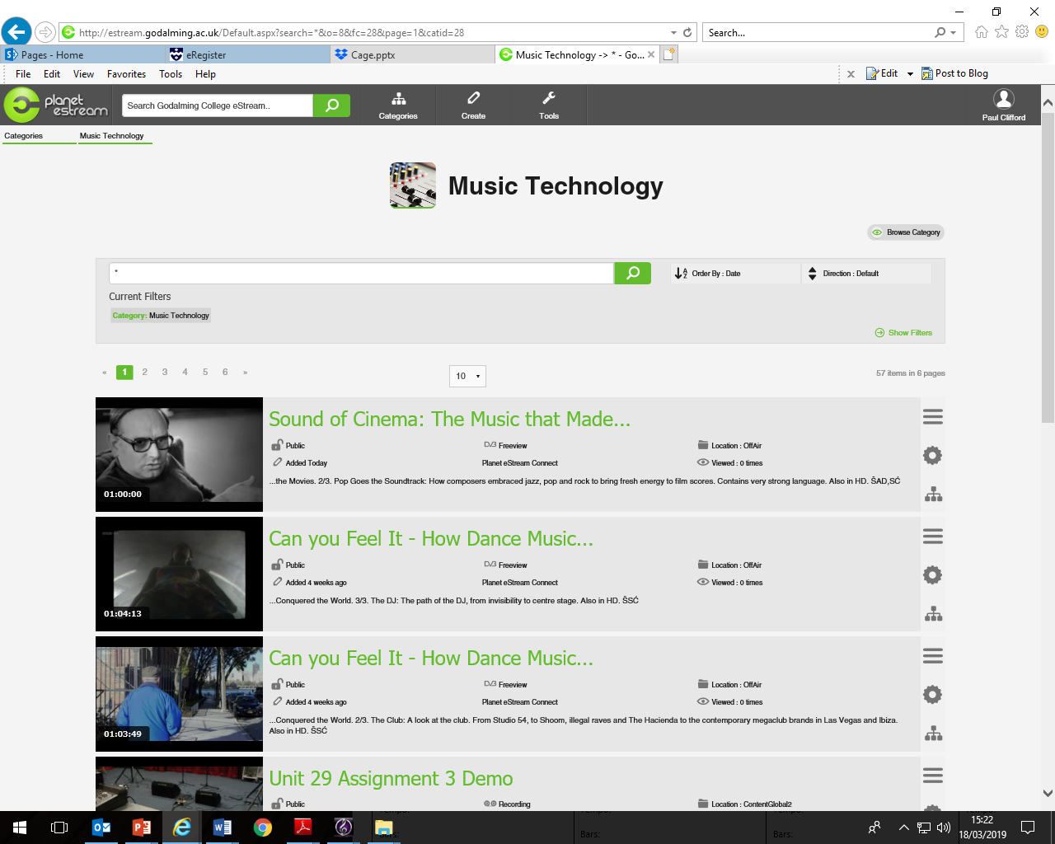All videos are available on **ESTREAM** in the **Music Technology** category. Over **20hrs** of content for your viewing pleasure.

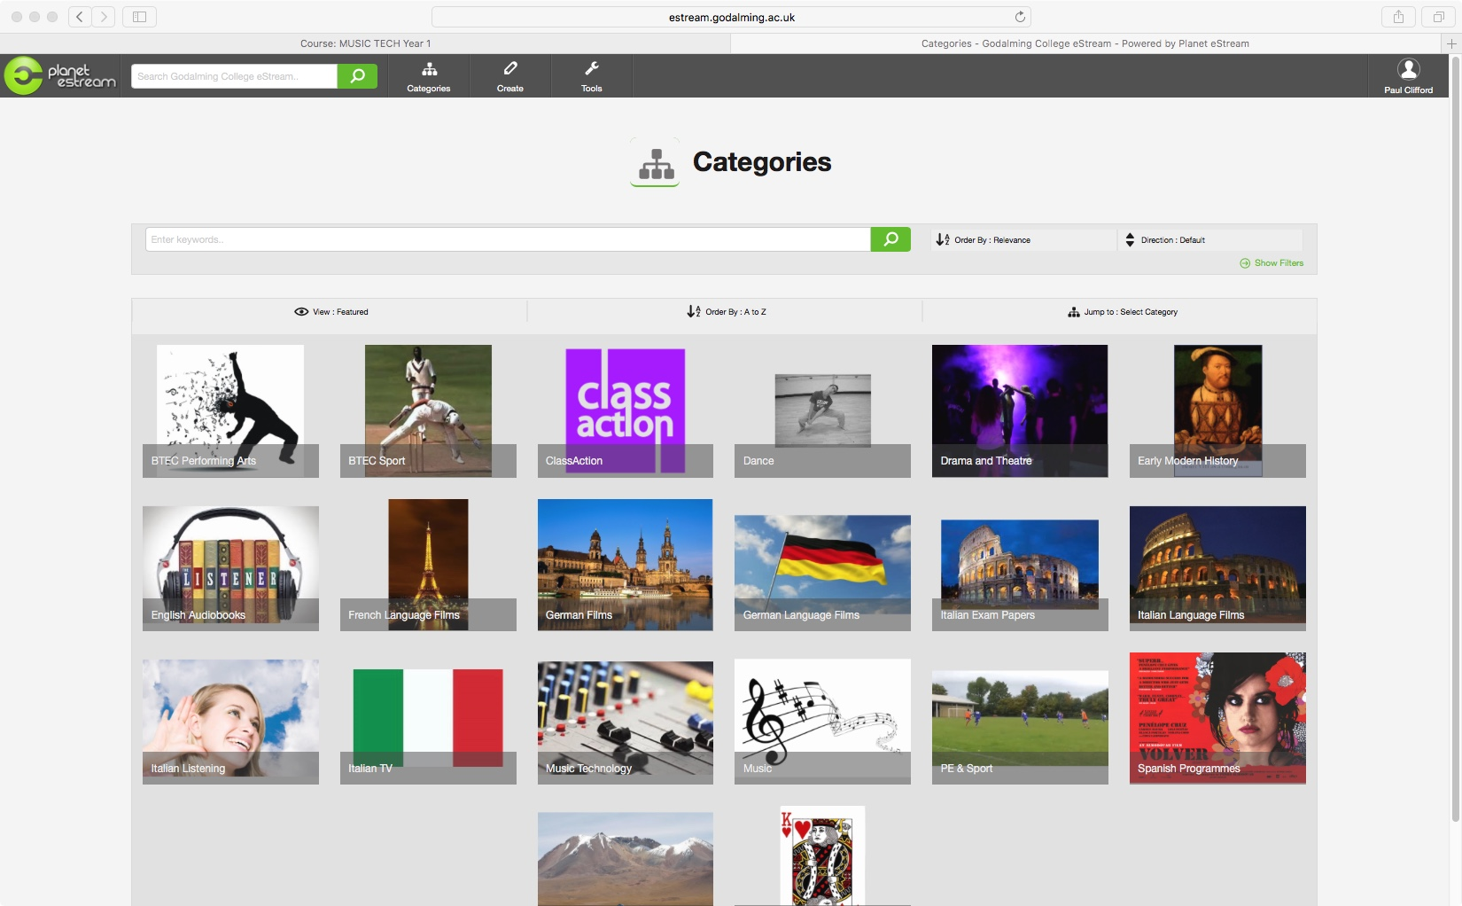



Basics of Sound

*Sound Waves: The Symphony of Physics*

viewing time: **2hrs 10 minutes**

*Studio Acoustics*

**viewing time: 17 minutes**

Historical Context and the development of music technology

*The Sound of Song* Part 1, 2 and 3

**viewing time: 3hrs 00 minutes**

*Can You Feel It-How Dance Music Conquered the World* Part 1, 2 and 3

**viewing time: 3hrs 10 minutes**

*Music and Misfits:* The Story of Indie Part 1, 2 and 3 viewing time: **3hrs 00 minutes**

*Sound of Cinema* Part 1, 2 and 3

**viewing time: 3hrs 00 minutes**

*Sgt Pepper’s Musical Revolution*

**viewing time: 1hrs 05 minutes**

*Les Paul: Chasing Sound*

**viewing time: 1hrs 30 minutes**

*Flat Pack Pop: Sweden Music Miracle* **viewing time: 1hrs 05 minutes**

Key Topics

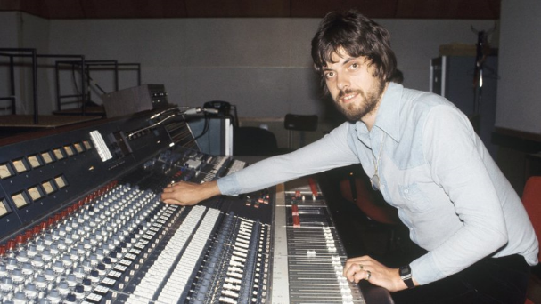Microphones

EQ

Compressor and Limiters

Noise Gates

Reverb

Delay

MIDI

Consoles and Controllers

Digital Audio and Computers

**Total viewing time: approx. 5hrs 30 minutes**

Revision videos

*Component 4 Mock* video playlist includes completing Audio and MIDI editing tasks.

**viewing time: approx. 45 minutes**

More Audio and MIDI Editing videos

**viewing time: approx. 35 minutes**