BTEC Assignment Brief
Qualification | Pearson BTEC Level 3 National Diploma in Creative Digital Media Production (Film & Television)
Unit number and title | Unit 18: Storyboarding for Digital Media
Learning aim(s) (For NQF only) | A: Understand the use of storyboards in a range of digital media sectors
Assignment title | Storyboards - Convince the investors!
Assessor | Stephen Grantham / Matt Toogood / Karina Free / Mark Piper
Issue date | 09th May 2023
Hand in deadline | Friday 26th May 2023
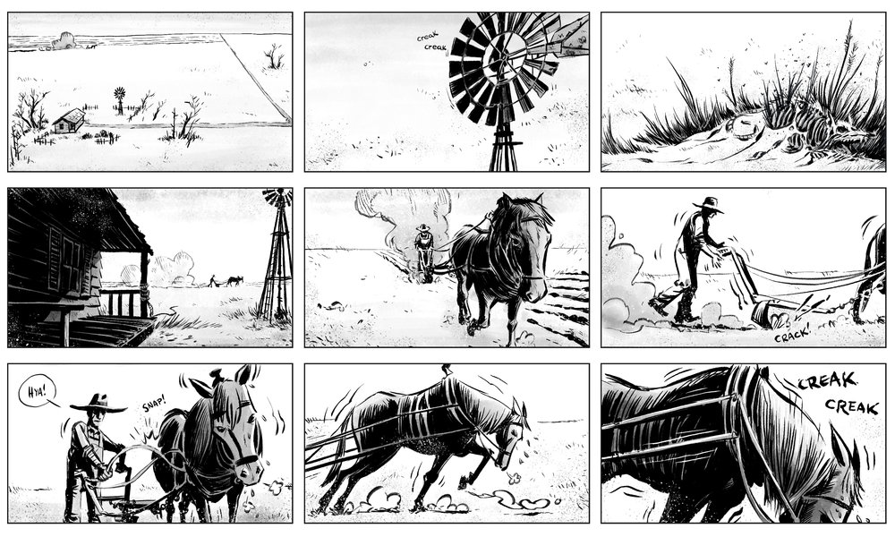

Vocational Scenario or Context | You are employed by Funaki Productions - an independent film studio - which is seeking financial backing for a movie project. Investors need assurance that the visual planning of the movie will be highly effective and so you have been given the task of preparing a visual report to demonstrate and evaluate the effectiveness of a range of storyboards across different production contexts.
Task 1 | You have been asked to produce a visual report evaluating the effectiveness of storyboard designs in communicating ideas and information. You must evaluate examples from a range of different sectors (e.g. television, film, games design) and contexts (e.g. animation, music videos, documentaries).  For each example given you should consider the following features;  - Effective use of imagery  - Effective use of camera movements, framing, angles  - Effective communication of sound direction  - Effective use of transitions and edits.  - How effectively the storyboards give directions and visualise the content of production on a scene-by-scene basis.  - Clarity of layout, style and format (e.g. frames per page) for ease of use  - Continuity  You must evaluate the effectiveness of your examples in fulfilling their purpose of visually communicating ideas and information leading to efficient production outcomes.
Checklist of evidence required | - A visual report evaluating researched visual examples.
Criteria covered by this task:
Unit/Criteria reference | To achieve the criteria you must show that you are able to:
18/A.D1 | Evaluate the effectiveness of a range of storyboard designs in communicating ideas and information across a range of production contexts.
18/A.M1 | Analyse the use, purpose and features of storyboard designs in communicating different purposes for different digital media contexts.
18/A.P1 | Explain the purpose of storyboards in moving image production for different digital media context.
18/A.P2 | Identify the features of storyboard designs that have been used for different production contexts.
Sources of information to support you with this Assignment | Textbooks  All of the following textbooks will provide learners with detailed information on the nature and uses of storyboards within the creative media sectors.  - Cristiano, G., Storyboard Design Course: Principles, Practice, and Techniques: The Ultimate Guide for Artists, Directors, Producers, and Scriptwriters, Barron's Educational Series (2007) ISBN 978-0764137327  - Cristiano, G., The Storyboard Artist: A Guide to Freelancing in Film, TV, and Advertising, Michael Wiese Productions (2012) ISBN 978-1615930838  - Glebas F – Directing the Story: Professional Storytelling and Storyboarding Techniques for Live Action and Animation (Focal Press, 2008) ISBN 9780240810768.  - Halligan, F., The Art of Movie Storyboards: Visualising the Action of the World's Greatest Films (Ilex Press, 2015) ISBN 978-1781572863  - Hart J – The Art of the Storyboard: A Filmmaker's Introduction, Second Edition (Focal Press, 2007) ISBN 9780240809601.  - Krisztian G and Schlempp-Ülker N – Visualizing Ideas: From Scribbles to Storyboards (Thames & Hudson Ltd, 2006) ISBN 978-0500286128  - Jew A and Paez S – Professional Storyboarding: Rules of Thumb (Focal Press, 2012) ISBN 9780240817705.  - Tumminello W – Exploring Storyboarding (Delmar Cengage Learning, 2005) ISBN 9781401827151.  Websites  - www.finegamedesign.com - website has resources for game scripts and storyboard creation  - www.storyboardthat.com - provides online resources and a storyboard creator.

