[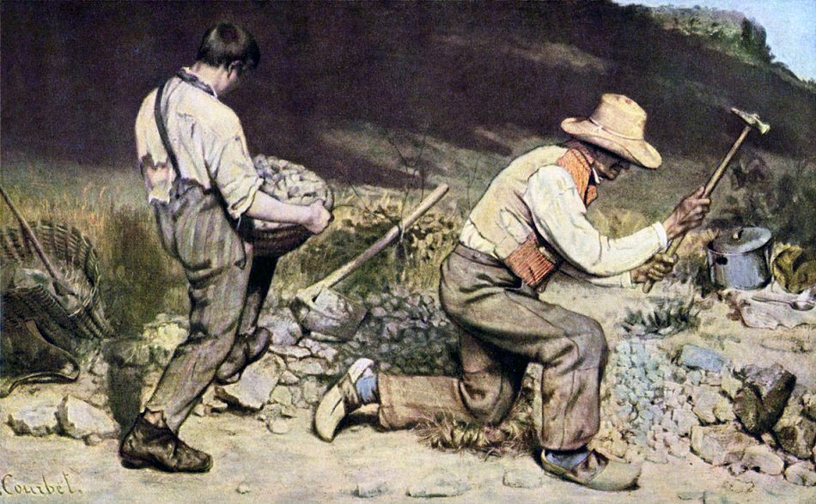](http://www.google.co.uk/url?sa=i&rct=j&q=&esrc=s&source=images&cd=&cad=rja&uact=8&ved=2ahUKEwiq37Sv6PzhAhUQExQKHaUVD8oQjRx6BAgBEAU&url=%2Furl%3Fsa%3Di%26rct%3Dj%26q%3D%26esrc%3Ds%26source%3Dimages%26cd%3D%26ved%3D%26url%3Dhttps%253A%252F%252Fwww.gustave-courbet.com%252Fthe-stonebreakers.jsp%26psig%3DAOvVaw29UvspWoirLCKnp1mXCKsz%26ust%3D1556885436122556&psig=AOvVaw29UvspWoirLCKnp1mXCKsz&ust=1556885436122556)

Courbet, *The Stone Breakers*, 1849

Explain how one painting is Realist in style. (5 marks)

1. Courbet, *The Stone Breakers* is a depiction of working life in rural France. We see two male figures breaking stones for the creation of a road. Such subjects were popular with Realist artists.

2. The figures are shown breaking stones and wear tattered clothing. The older figure kneels, his face is dark suggesting working outdoors at all times. This unidealism is typical of Realists who rejected Academic conventions.

3. Colours are muted and dull. The grey stones and brown clothing of both figures give the scene a monotonous appearance- linking to the work they do.

4. Paint has been applied roughly- the earth both figures stand on appears uneven and shows the painter’s brushmarks. This challenges the polished finish of Academic painting.

5. The young boy struggles to carry a basket of stones. We pity his plight and Courbet wants to emphasise the role that such figures had in everyday life at that time.

6. The large scale of the work gives the subject matter importance but this was controversial at the time and large scale was usually reserved for history paintings.

[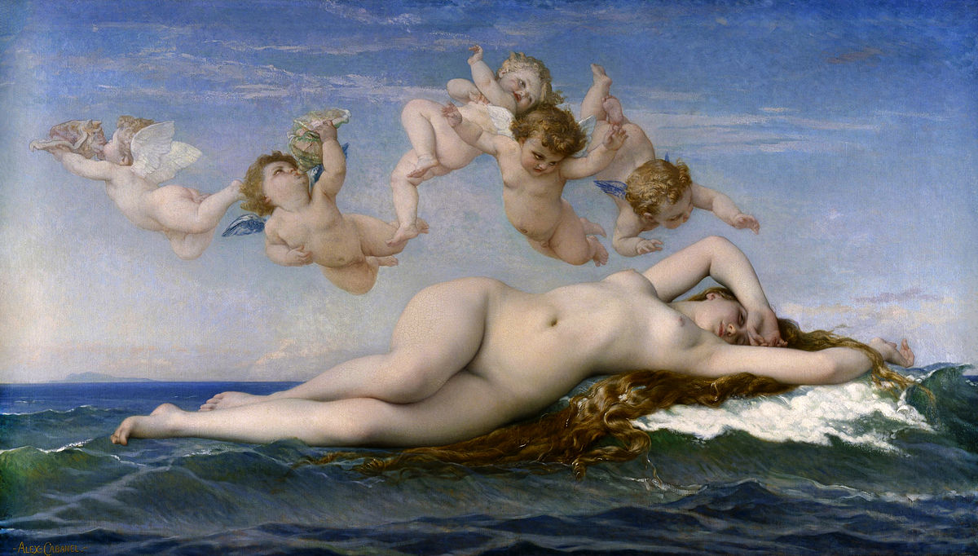](https://www.google.co.uk/url?sa=i&rct=j&q=&esrc=s&source=images&cd=&cad=rja&uact=8&ved=2ahUKEwji8OfY6PzhAhUK3OAKHbLFACoQjRx6BAgBEAU&url=https%3A%2F%2Fen.wikipedia.org%2Fwiki%2FThe_Birth_of_Venus_(Cabanel)&psig=AOvVaw3Il1vo9VgvwzG1nNoGB-mr&ust=1556885524913391)

Cabanel, *The Birth of Venus*, 1863

Discuss how one painting/work of art is Academic in style. (5 marks)

1. Cabanel’s *Birth of Venus* depicts the nude fully grown figure of Venus being born from the sea. Such mythological scenes were popular with Academic artists.

2. Venus is shown reclining nude across the waves, above her we see a group of cherubs (putti) heralding her arrival and reinforcing the mythological theme.

3. Her figure is idealised, she appears elongated and her hips and feminine form exaggerated. Idealism in figure painting was typical of Academic artists.

4. Colour is bright and clear with the blue of the sea and sky contrasting with the pale pink and white skin tones of Venus and the putti. This gives the work a pleasing appearance and would make it popular with the Salon audience.

5. The surface of the painting is highly polished and Cabanel uses finely blended brushstrokes to give Venus a perfect complexion and emphasise his own working method.

6. The composition is balanced with Venus placed centrally and the small figures fly above her. The overall effect is one of perfection and harmony.