[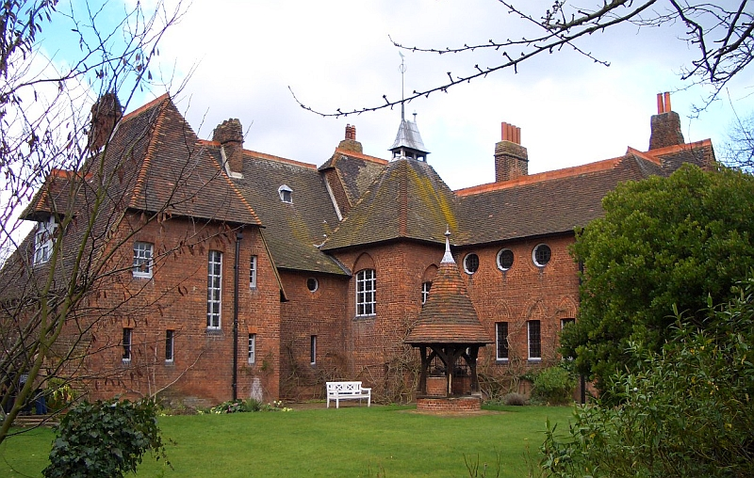](http://www.google.co.uk/url?sa=i&rct=j&q=&esrc=s&source=images&cd=&cad=rja&uact=8&ved=2ahUKEwjhntu6-fzhAhUs6uAKHb5GCNMQjRx6BAgBEAU&url=http%3A%2F%2Fwww.victorianweb.org%2Fart%2Farchitecture%2Fwebb%2F1.html&psig=AOvVaw3tBBBH59QSAuSzLTyn4P2Q&ust=1556890022186827)[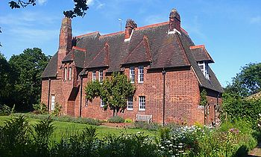](https://www.google.co.uk/url?sa=i&rct=j&q=&esrc=s&source=images&cd=&cad=rja&uact=8&ved=2ahUKEwjt1KDW-fzhAhVJ1eAKHcv7DSMQjRx6BAgBEAU&url=https%3A%2F%2Fen.wikipedia.org%2Fwiki%2FRed_House%2C_Bexleyheath&psig=AOvVaw3tBBBH59QSAuSzLTyn4P2Q&ust=1556890022186827)

William Morris and Philip Webb, *Red House*, 1850

**Q: Analyse how the form of one British domestic building affects its function (5 marks).**

1. Morris and Webb’s *Red House* is a two-storey red brick building located in Bexleyheath, England.

2. The L-shaped building has irregular placed windows which are designed to suit the rooms they illuminate. Larger windows are used in rooms requiring more light such as the drawing room and smaller windows for the bedrooms.

3. The red brick is local to the area, giving the house a warm and welcoming appearance. The use of local materials links to the vernacular appearance of the house which is in the Arts & Crafts style.

4. A courtyard at the back of the house is framed within the L-shape of the building and contains a well- providing the house with fresh water.

5. The interior is decorated with furniture in the Arts & Crafts style of wood and stained glass with references to nature- giving the home a homely appearance.

6. The pitched roof allows for high ceilings in the living area, giving a light and airy feel to this space.

7. Morris used designs from his own company (Morris & Co) such as textiles and drapery with natural motifs, making this home also a showcase for his skills and ideas.

[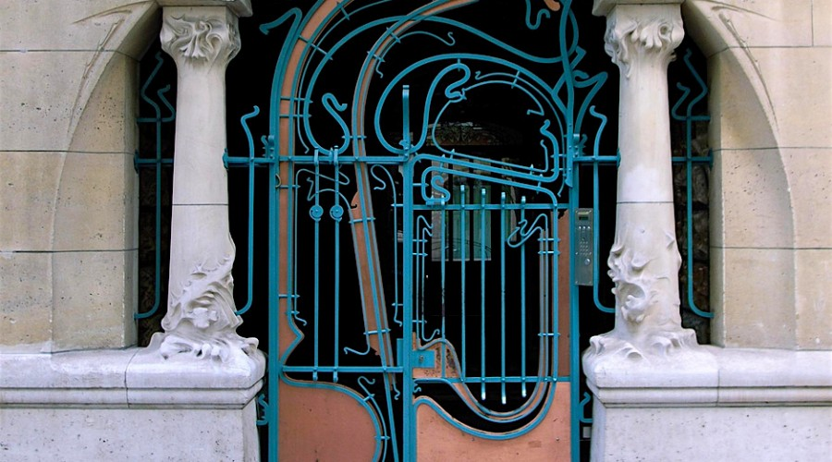](http://www.google.co.uk/url?sa=i&rct=j&q=&esrc=s&source=images&cd=&cad=rja&uact=8&ved=2ahUKEwilmNC7-vzhAhWHHxQKHSldC9YQjRx6BAgBEAU&url=%2Furl%3Fsa%3Di%26rct%3Dj%26q%3D%26esrc%3Ds%26source%3Dimages%26cd%3D%26ved%3D%26url%3Dhttps%253A%252F%252Fwww.unjourdeplusaparis.com%252Fen%252Fparis-insolite%252Fle-castel-beranger-art-nouveau-paris%26psig%3DAOvVaw3dEdY1ZbgDiYxEO9MvKUAp%26ust%3D1556890284668562&psig=AOvVaw3dEdY1ZbgDiYxEO9MvKUAp&ust=1556890284668562)[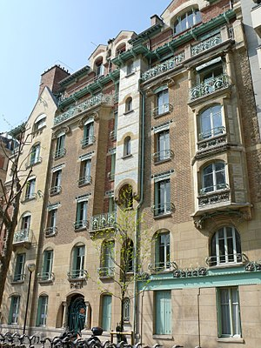](https://www.google.co.uk/url?sa=i&rct=j&q=&esrc=s&source=images&cd=&cad=rja&uact=8&ved=2ahUKEwj5lci2-vzhAhWWAWMBHYlnC_AQjRx6BAgBEAU&url=https%3A%2F%2Fen.wikipedia.org%2Fwiki%2FCastel_B%25C3%25A9ranger&psig=AOvVaw3dEdY1ZbgDiYxEO9MvKUAp&ust=1556890284668562)

Guimard, *Castel Beranger*, completed 1898

**Q: Analyse how the form of one French domestic building affects its function (5 marks).**

1. Castel Beranger is an Art Nouveau block of apartments built in Paris and commissioned by a wealthy widow. Each apartment rented.

2. A six storey block of apartments, all designed differently, giving a sense of individuality to each home.

3. Main front door of building gives access to a central hall on the ground floor- similar to a foyer. The ground floor apartments have access to a central open air courtyard- allows for fresh air and recreation.

4. Upper storey apartments have cast-iron balconies allowing opening air and views of Paris.

5. Colours are homely and earthy throughout- bronze, green, red. Materials are similarly organic- terracotta tiling in entrance hall, flowing cast iron framework and details add to the style of the building.

6. Balustrades, window frames and ceiling decoration are all composed of flowing lines. These all collectively provide a sense of originality but warmth to the building.

7. Use of strong materials such as stone, iron suggest strength and a domestic safe haven for occupants.