**1 a** Express  in partial fractions. **(3 marks)**

**b** Hence integrate  giving your answer in its simplest form. **(4 marks)**

**2 a** Evaluate  **(4 marks)**

**b** Evaluate  **(5 marks)**

**3** A trophy for a new rugby tournament is to be manufactured in the shape of a rugby ball. The designer models this using an ellipse with parametric equations



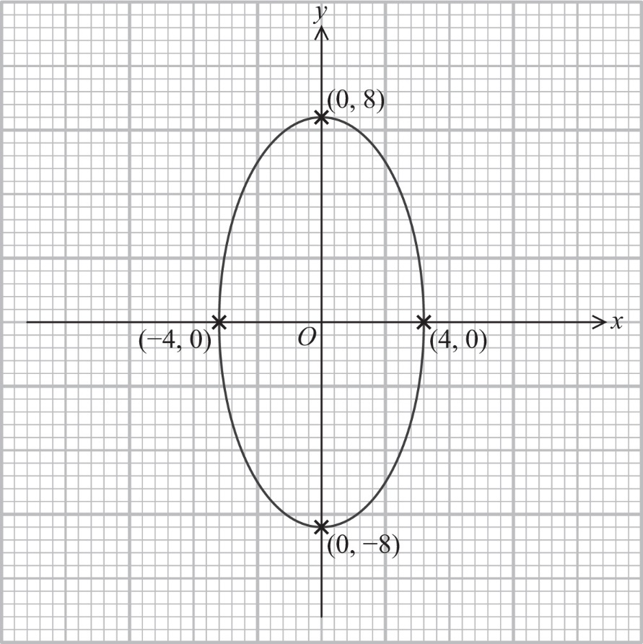

The ellipse is to be rotated about the *y*-axis to form a 3-dimensional solid.

**a** Show that the volume of the solid is given by  **(3 marks)**

**b** Calculate the exact volume of the solid produced. **(5 marks)**

**c** The finished trophy will measure 16 cm tall and will be manufactured from bronze, which has a density of 8.7 g/cm3

Calculate the mass of the trophy. **(2 marks)**

**4 a** **i** Differentiate



with respect to *y* find an expression for  in terms of *x* **(5 marks)**

**ii** Hence, or otherwise, differentiate  with respect to *x* **(2 marks)**

**b** The curve with equation



has one turning point. Find the exact coordinates of this point and determine its nature. **(7 marks)**

**5**

**a** Find  using the substitution  **(5 marks)**

**b** Find the mean value of *f*(*x*) over the interval  **(3 marks)**

**c** Hence find the mean value of  over the interval  **(2 marks)**