**1** Find the particular solution of the differential equation



For or which *y* = 1 when 

Give your answer in the form  **(7 marks)**

**2** Find the general solution of the differential equation



**(4 marks)**

**3** Find the general solution of the differential equation



given that *y* = 0 and  when *x* = 0 **(11 marks)**

**4** An engineer wants to study the effect of adding a damper to an oscillating system to control the oscillations. She models the systems, as shown in Figure 1, with a mass attached to a spring, which is suspended vertically from an oscillating device. The mass is also attached to a dashpot damper.

Figure 1

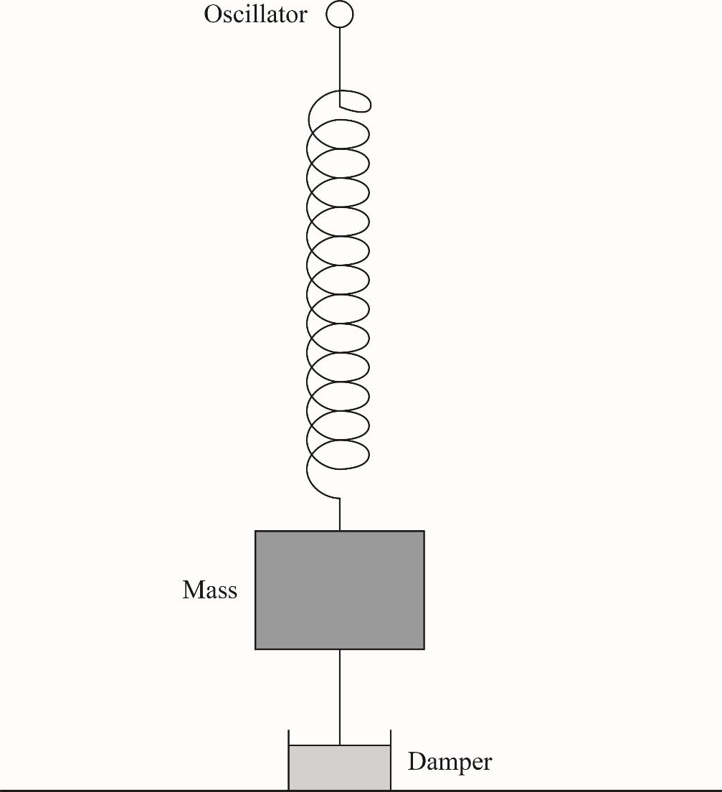

The motion of the mass is modelled by the differential equation   
 

where *x* is the displacement, in metres, of the mass from its equilibrium position and *t* is time measured in seconds.

**a i** Show that a particular integral for the differential equation is **(3 marks)**



**ii** Find the general solution to the differential equation. **(5 marks)**

**b** Given that *x* = 0 and  when *t* = 0, find the particular solution for this model. **(4 marks)**

**c** Describe what happens to the motion of the mass as  **(1 mark)**

**5** A remote island has colonies of two competing species of insect, *X* and *Y*. Each species reproduces at a rate proportional to its population and is adversely affected by the other species at a rate proportional to the number of that species. At time *t*, measured in centuries, the populations of the species, measured in tens of thousands, are *x* and *y* respectively. The populations are modelled by the pair of simultaneous equations





Initially *x* = 21 and *y* = 12

**a** Show that:



**(3 marks)**

**b** Find the particular solution for the number of insects in species *X* at time *t* **(5 marks)**

**c** Find the particular solution for the number of insects in species *Y* at time *t* **(4 marks)**

**d** This model predicts that one of the species will become extinct. Calculate the time at which this is predicted to happen and calculate the size of the population of the other species when this happens. **(3 marks)**