**1** A body of mass 2 kg is moving at a constant speed of 5 ms−1 in a straight line on a horizontal plane.

**a** Calculate the Kinetic Energy of this moving body. **(2 marks)**

The same mass of 2 kg is now stationary and raised from ground level to a height 10 cm above ground level.

**b** Calculate the increase in Gravitational Potential Energy of this stationary body. **(2 marks)**

The masses of two different objects, *m*1 and *m*2, are in the ratio 2:3.

The lighter object is travelling in a straight line on a horizontal plane at a constant speed of –***υ*** ms−1.

The heavier object is stationary and held at a height *h* m above the horizontal plane. The amount of energy in both systems is equal.

**c** Express the height, *h*, in terms of *g* and *υ*. **(3 marks)**

**2** A stone block of mass 80 kg is pulled forward by a constant applied force of 80 N, so that it moves in a straight line along an assumed perfectly smooth horizontal surface for a distance of 10 m.

**a** Assuming the motion of the block is in the same direction of this pulling force, calculate the work done by this applied force. **(2 marks)**

The same stone block is now pulled by a different force, F N, which is applied to the block at an angle of elevation of 20° to the horizontal. The work done in moving another 10 m is the same as in part **a**.

**b** Find the magnitude of this new applied force, F N to 2 significant figures. **(2 marks)**

**c** Given that: Power = Work done by an applied (driving) force ÷ time taken

Show that: power = Driving Force × Average velocity **(2 marks)**

The time taken for the stone block to move 10 m in part **a** was shorter than the time taken to move the same block the same distance by the inclined force in part **b**.

**d** Explain, with reasons,

**i** which applied force, **a** or **b**, had the greater power output. **(1 mark)**

**ii** why there was no power output in relation to the vertical component   
of the force F N. **(1 mark)**

**3** A water skier with equipment of total mass 50 kg is being pulled by a rope attached to a speed boat so that the skier travels in a straight line along the surface of the lake at a constant speed of 25 ms−1.

The skier lets go of the rope and then eventually slows to a stop due to the constant resistant drag force of the water surface on the skis.

**a** If the distance from letting go of the rope until stopping is 100 m, use the work-energy principle to determine the size of the constant drag force on the skier. **(3 marks)**

A second water skier with equipment of total mass, *m* kg is also pulled in a similar manner at a constant speed of 25 ms−1 when this skier also lets go of the rope. This person now also experiences exactly the same drag force.

**b** This second skier is travelling at a speed of 4 ms−1 after 100 m.

Find the value of m to 3 significant figures. **(3 marks)**

A third water skier of total mass 40 kg is also pulled in a similar manner at a constant speed of 25 ms−1. She lets go of the rope as she leaves the water surface and starts to ascend a ramp which is inclined at an angle of elevation of 30° to the horizontal. The ramp is 9 m long and when she reaches its upper end she leaves the ramp and begins to make a jump through the air at a speed of 22 ms−1.

**c** Calculate the coefficient of friction, *μ*, between the surface of the ramp and the   
water skier to 3 significant figures. **(4 marks)**

**4** Similar sized packages each of mass 1.5 kg are launched down a chute 2 m long angled at *θ*° below the horizontal with an initial speed of 0.5 ms−1. The chute is assumed to be perfectly smooth. The speed of each package as it reaches the end of the chute must be no more than 2 ms−1.

**a** Explaining your use of the given assumption, find the maximum possible value   
of angle *θ* in the range 0 ⩽ *θ* ⩽ 90 to 3 significant figures. **(5 marks)**

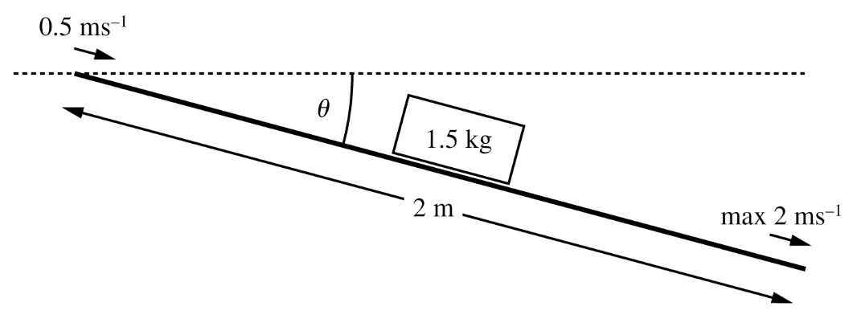

The assumption that the chute is perfectly smooth is now felt to be too inaccurate. Instead, the model is changed so that the chute has a coefficient of friction *μ* = 0.05.

The chute is set at an angle such that *θ* = 7°.

**b** Show that this amended model and arrangement still satisfies the requirement that the package must not exceed a speed of 2 ms−1 as it reaches the end of the chute. **(4 marks)**

**5** A child driving a battery operated toy car, have a combined mass of 35 kg. The car is being driven up a straight path which is inclined at 10° to the horizontal. The resistance to the motion of the toy car from non-gravitational forces is modelled as a force of 12 N. At the instant when the car has a speed of 3 ms−1, it is decelerating at 0.2 ms−2.

**a** Find the power output of the car at this instant. **(6 marks)**

When the car passes a point *A*, its speed is 1.5 ms−1. At this point, the battery is flat and no longer has any driving force. The car comes to rest at a new point *B*. The resistance to motion from non-gravitational forces is again modelled constant of magnitude 12 N.

**b** Using the Work-Energy Principle, calculate the distance *AB* to 2 significant figures. **(4 marks)**

**6** A roughly spherical pebble is released from rest just below the surface in the deepest part of a fresh water lake so that it is assumed to sink vertically downwards. The mass of the pebble is 12.5 g. As the pebble sinks due to gravitational force, it experiences two resistance forces.

The first resistance force is a constant force of 0.015 N due to buoyancy.

The second resistance force is a drag force of *D* N, which is variable and increases in direct proportion to the velocity of the pebble, *υ* ms−1.

**a** The pebble reaches a terminal velocity of 0.8 ms−1. Show that the drag force can be represented exactly by the equation:

*D* = (1/320) (5*g* – 6) *υ* N **(4 marks)**

The pebble reaches its terminal velocity after falling just 1.1 m beneath the lake’s surface.

It then loses a total of 30 J of energy (through its work against resistance forces) in reaching the bottom of the lake.

**b** Find the depth of the lake at the point the pebble was released to 3 significant figures. **(2 marks)**