**1** A light elastic spring of natural length 3 m and modulus of elasticity 25 N has one end attached to a fixed point *A*

A particle *P* of mass 0.5 kg is attached to the other end of the spring and hangs in equilibrium at a point *B*, vertically below *A*

**a** Find the distance *AB* **(3 marks)**

Another perfectly light elastic spring with natural length *a* metres and modulus of elasticity  newtons is attached to a fixed point *C*. A particle *Q* of mass 0.5 kg is attached to the other end and hangs in equilibrium at a point *D*, vertically below *C*

Given that the distance *CD* = 2a metres,

**b** find the value of the modulus of elasticity,  **(2 marks)**

**2**

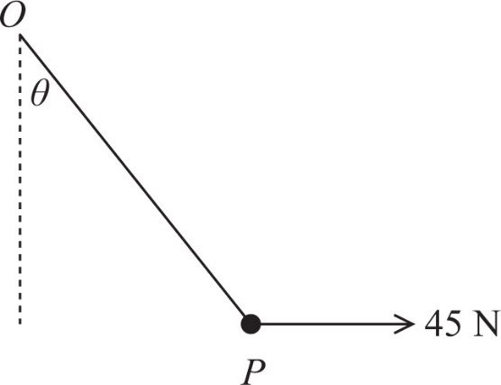

A particle *P* of mass 4 kg is attached to one end of a light elastic string of natural length 0.8 m, and modulus of elasticity 80 N. The other end of the string is attached to a fixed point *O*

The particle is held in equilibrium by a horizontal force of magnitude 45 N, with *OP* making an angle  with the vertical. This force acts in the vertical plane containing the string, as shown in the diagram above.

Find

**a i** the size of the angle , in degrees to 1 decimal place. **(3 marks)**

**ii** the tension in the string. **(2 marks)**

**b** the length *OP* **(3 marks)**

**3**

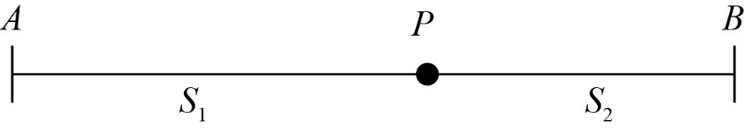

A particle *P* of mass m is attached to two light elastic springs,  and , whose ends are attached to fixed points, *A* and *B*, which are 0.9 m apart.  has modulus of elasticity 12 N and natural length 0.3 m.  has modulus of elasticity 24 N and natural length 0.4 m. The particle *P* is resting in equilibrium on a smooth horizontal surface.

**a** Find the distance *AP* **(4 marks)**

**b** In a refined model for this system, the modulus of elasticity for  is decreased.

State, with a reason, how this would affect the equilibrium position of particle *P* **(2 mark)**

**4** A child’s toy consists of a small bird attached to a spring. The spring is attached to a ceiling at a point *A*, and the bird hangs in equilibrium vertically below *A*. The bird can be modelled as a particle *P* of mass *m* kg attached to a light elastic spring of natural length 0.5 m and modulus of elasticity 6N.

**a** Given that the distance *AP* is 0.745 m, show that the bird has mass 0.3 kg. **(3 marks)**

The particle is now raised to point *C* vertically below *A*, where *AC* = 0.4 m, and released from rest.

**b** Using the conservation of energy principle, find the greatest distance below *A* reached by the bird. **(5 marks)**

**5**

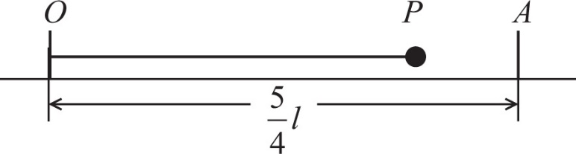

A particle *P* of mass *m* is attached to one end of a light elastic string of natural length *l* and modulus of elasticity 4 *mg*. The other end of the string is fixed at a point *O* on a rough horizontal table. The particle is projected along the surface of the table from *O* with speed . At its furthest point from *O* the particle is at the point *A*, where *OA* = 

**a** Find, in terms of *m*, *g* and *l*, the elastic energy stored in the string when *P* is at *A* **(3 marks)**

**b** Using the work-energy principle, or otherwise, find the coefficient of friction between *P* and the table. **(6 marks)**

**6**

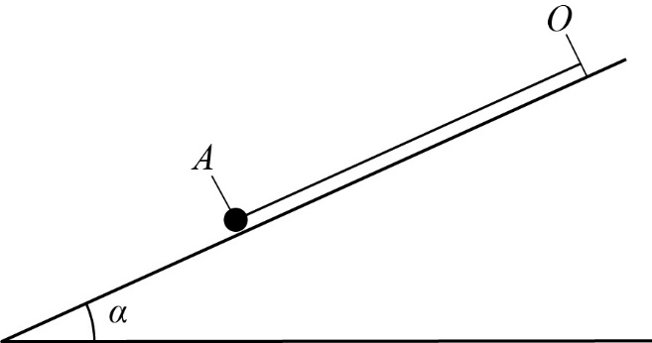

A particle *P* of mass *m* lies on a smooth inclined plane at an angle  to the horizontal, where  The particle is attached to one end of a light elastic string of natural length *a* and modulus of elasticity 3 *mg*. The other end of the string is attached to a fixed point *O* on the plane. The particle *P* is in equilibrium at the point *A* on the plane and the extension of the string is 

The particle *P* is now projected from *A* down a line of greatest slope of the plane with speed *V*

It comes to instantaneous rest after moving a distance 

By using the principle of conservation of energy,

**a** find *V* in terms of *a* and *g* **(6 marks)**

The particle is now pulled down to a point *B*, where *OB* is 2*a*, and released from rest.

**b** Find, in terms of *a* and *g*, the speed of *P* when the string first becomes slack. **(4 marks)**

To refine the model the slope is now modelled as a rough inclined plane. The coefficient of friction between the particle and the plane is 

The particle is projected with speed *W* from the point *A* down a line of greatest slope of the plane. It comes to instantaneous rest after moving a distance 

**c** Use the work-energy principle to find *W* in terms of *a* and *g* **(4 marks)**