**1** A small smooth ball of mass *m* kg is dropped from a point above a smooth inclined plane. The ball falls freely under gravity until it hits the plane.

The plane is inclined at 30o to the horizontal as shown in the diagram below.

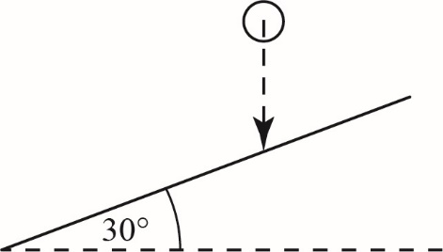

The coefficient of restitution between the ball and the plane is *e*

It is known that the kinetic energy of the ball immediately before impact and the kinetic energy of the ball immediately after impact are in the ratio 12:7 respectively.

Find the value of *e* **(6 marks)**

**2** A small smooth sphere of mass 0.2 kg is moving with velocity (7**i** + 10**j**) m s-1 when it collides with a smooth wall.

The sphere rebounds from the wall with velocity (2**i** – 2**j**) m s-1

**a i** Find the magnitude of the impulse received by the sphere. **(3 marks)**

**ii** Express the direction of this impulse as a unit vector. **(2 marks)**

**b** Find the coefficient of restitution between the sphere and the wall. **(5 marks)**

**3** A smooth uniform sphere *P* of mass 3*m* kg collides obliquely with a smooth uniform sphere *Q* of mass 5*m* kg.

Both spheres have equal radii.

Immediately before the collision *P* is moving with a speed of 4 m s-1 in a direction at an angle of  to the line of centres of the two spheres and *Q* is moving with a speed of 2 m s-1 in a direction at an angle of  to the line of centres, as shown in the diagram below.

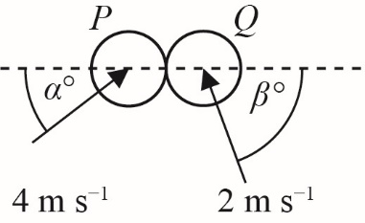

It is known that  and  and the coefficient of restitution between the spheres is 0.52

**a** Given that 3 joules of kinetic energy is lost in the collision find, correct to 3 significant figures, the value of *m* **(8 marks)**

**b** Find the magnitude of the impulse exerted by *Q* on *P* **(3 marks)**

**4** Two infinitely long, smooth vertical walls, *A* and *B*, are fixed on a smooth horizontal surface and intersect at an angle of 135o. A smooth sphere of mass 0.25 kg is projected across the surface towards wall A with a speed of 3 m s-1 and at an angle of 60o to wall *A,* as shown in the diagram below.

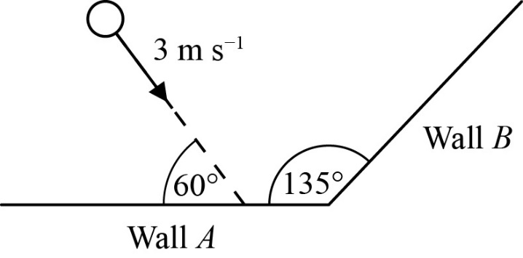

The coefficient of restitution between the sphere and each of the walls is denoted by *e*

After its initial collision with wall *A* the ball is known to rebound and collide, at some point, with wall *B*

**a** Show that the range of possible values for *e* is given by  **(3 marks)**

The exact value of *e* is found to be 

**b** After colliding with wall *B* the direction of motion of the sphere makes an angle *θ* ° with wall *B*. Find the value of *θ* **(3 marks)**

**c** Find the overall kinetic energy lost due to the two collisions. **(6 marks)**

**5** A smooth uniform sphere, *N*, lies at rest on a horizontal smooth surface of ice, and the sphere lies a fixed distance from a long, smooth vertical wall. An identical second sphere, *M*, is projected with speed 2*u* in a straight line, on the same surface, so that it slides freely towards *N* in a direction which is parallel to the wall. *M* collides obliquely with *N* such that the line of centres of the two spheres at the point of contact makes an angle of 60o to the wall, as shown in the diagram below.



The coefficient of restitution between the two spheres is *e*

After *N* collides with the wall, the direction of motion of *N* is parallel to the direction of motion of *M* after the collision between the two spheres.

Show that the coefficient of restitution, *E*, between *N* and the wall is given by the expression:



**(12 marks)**