|  |
| --- |
|  |

**Task 2: Drum recording GUIDE**

|  |  |
| --- | --- |
| Music Tech | COMPONENT 1: RECORDING |

NAME:

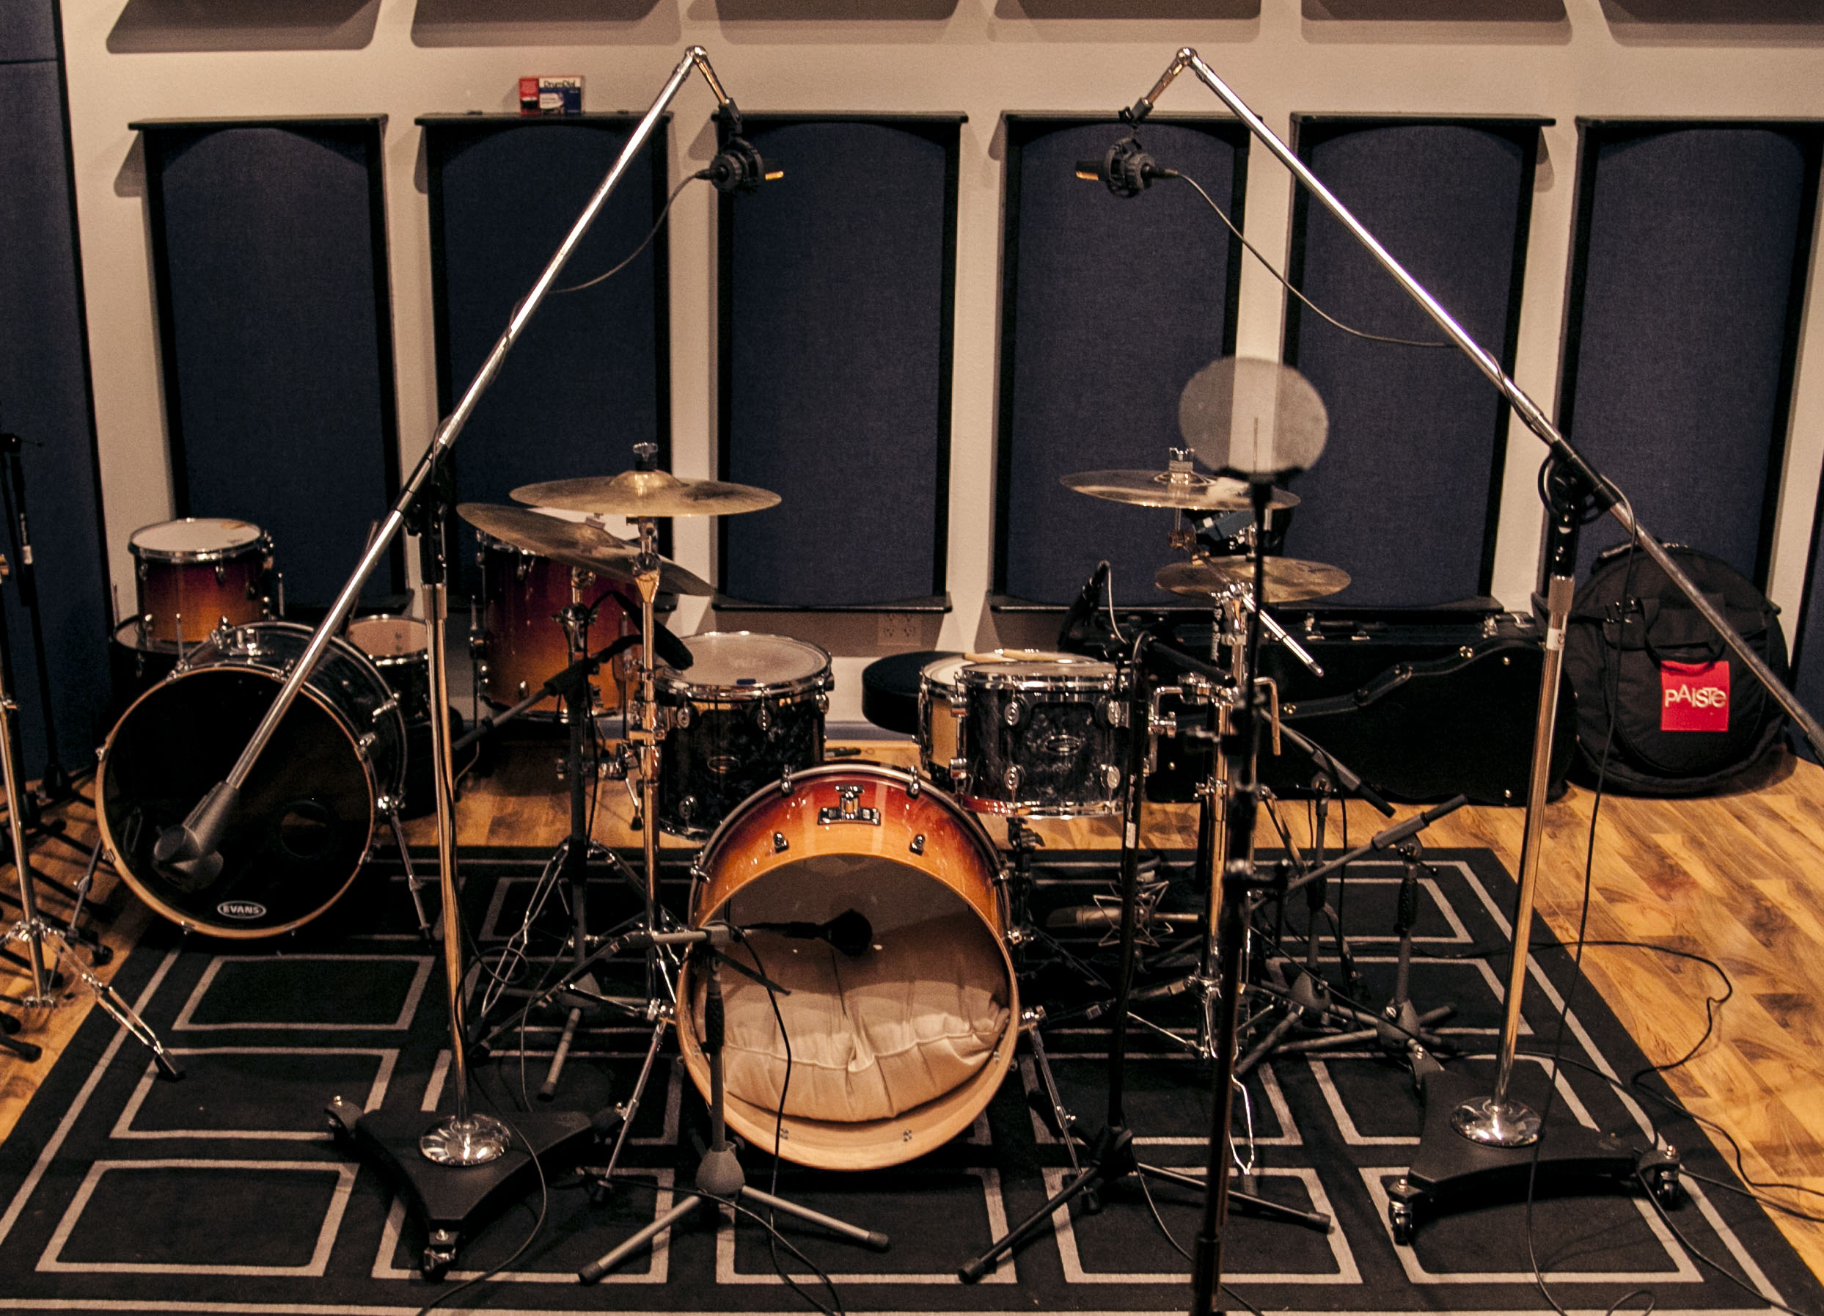

Create a *Youtube channel styled* instructional video choosing **ONE** of the drum set-ups in this workbook. The video must include the following:

1. Preparing for a drum recording sessions
2. Environment: Room Size, Potential issues…
3. Microphone choice
4. Placement and Position

Your submission MUST include:

1. A completed workbook-you must include **pictures** of your research and practice sessions.
2. Instructional video saved as a quicktime movie(.mov) in Music\AS Music Technology\1_C1 SUBMISSION\1_Recording Drums

The video must be broadcast/streaming quality. The presentation must be rehearsed and professional. Any substandard work will not be tolerated.

**Remember the set up you choose will be the set up you use in your Component 1 Recording. You MUST match commercial quality recordings to do well in this component.**

Recording Drums

Setting Up:

* Ensure the drum heads are tuned.
* Dampen overly resonant drums with some moon gel or tissue and gaffer tape
* Place mic clips on the mic stands and carefully place mics in the clips ensuring the mic is secure
* Position mics in the best position to reduce spill. IMPORTANT: you will get spill. Listen for the best possible sound from the drum/cymbal you mic’ing up and position it so that you have the least amount of spill
* Connect mics with XLR cables to the connector panel
* Logically connect each drum mic into an input channel i.e. Kick drum into channel 1, Snare into channel 2, Hi-hat into channel 3 etc. NOT Overhead 1 into channel 1, Kick drum into channel 14, Overhead 2 into channel 13.
* Switch on **48V phantom power** for the condenser microphones **e.g. overheads**
* Listen to each mic individually and adjust the gain ensuring you have sufficient headroom.
* Listen to the entire kit and make any adjustments to ensure a good balance between the drums and mics.
* Check the mix in mono for any phase cancellation

**Scenario .1. Jazz Recording**

To achieve good drum recording, the simplest set up is a stereo microphone set up and a good sounding room. The recording is heavily dependent on the room and therefore is not the technique of choice.

**Process:**

Set up a XY coincident pair or AB spaced pair. Audition both techniques and place in the room for the best overall balance of the kit. Close mic the kick and snare drum.

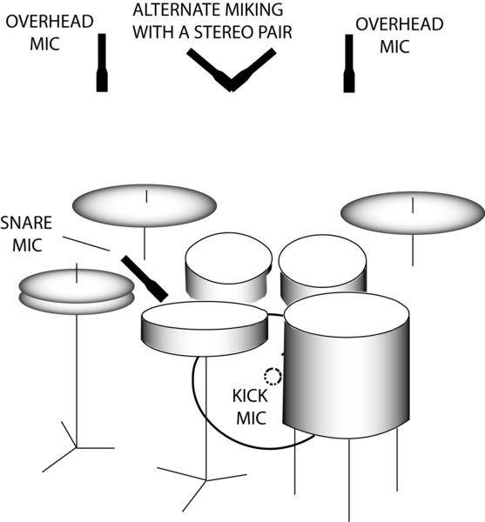

Use the table to document your findings

|  |  |  |  |
| --- | --- | --- | --- |
|  | Microphone | Microphone Placement | Comments  -what do you notice?  -does changing the distance/position of the microphones make a difference? |
| Kick |  |  |  |
| Snare |  |  |  |
| OH1 |  |  |  |
| OH2 |  |  |  |

Attach pictures of set up

**Scenario .2. Glyn Johns Technique**

Glyn Johns is one of the UK’s most respected producers and engineers. Starting his career working as a tape op for The Beatles, he went on to work with thousands of artists from The Rolling Stones, The Who and Led Zeppelin through to Van Halen, New Model Army, Eric Clapton and many more.

Johns is probably best known in the drumming community for his legendary drum sound. His unique recording method was used to create many of John Bonham and Keith Moon’s best recordings.

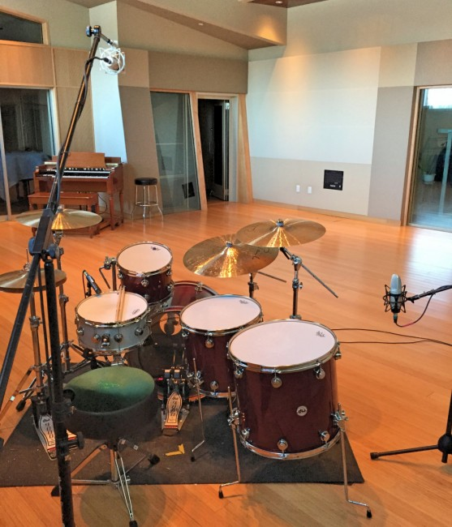

**Process:**

Place a large diaphragm condenser microphone(OH1) a few feet above the kit. Audition and move the microphone until you get the best overall balance of kit. Place a second on the side of the floor tom above the rim. It is important that OH1 is the same distance away from the centre of the snare as OH2. Close mic the kick and snare.

Use the table to document your findings

|  |  |  |  |
| --- | --- | --- | --- |
|  | Microphone | Microphone Placement | Comments  -what do you notice?  -does changing the distance of the microphones make a difference? |
| Kick |  |  |  |
| Snare |  |  |  |
| OH1 |  |  |  |
| OH2 |  |  |  |

Attach pictures of set up

**Scenario .3. Popular Multi-Microphone Technique**

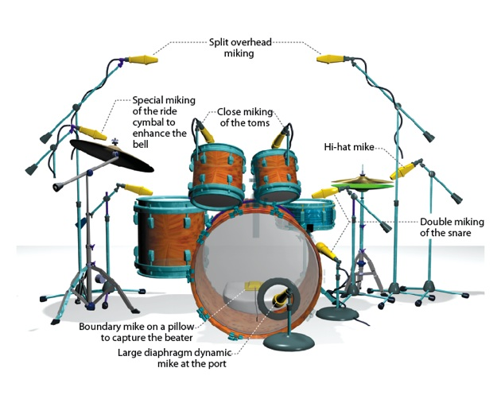

|  |  |  |  |
| --- | --- | --- | --- |
|  | Microphone | Microphone Placement | Comments  -what do you notice?  -does changing the distance of the microphones make a difference? |
| Kick | Large diaphragm dynamic  (cardiod) | If the resonant head does not have a mic cut out, remove the head and place the mic in the kick drum shell approx. 6 inches from the beater. This will reduce spill and room ambience(dry). |  |
| Snare | Dynamic microphone  (cardiod) | Position the mic approx. 2 inches above the beater head, approx. 2 inches away from the edge and angled towards the centre of the head. The mic should also be angled away from nearby drums/cymbals(especially hi-hat) to reduce spill |  |
| Hi-Hat | Condenser microphone  (cardiod) | Position the microphone approx. 2 inches from the edge and angling from above the hi-hat |  |
| Tom-Toms | Dynamic Microphone | Similar set up to snare drum |  |
| Ride Cymbal | Condenser microphone | The stereo overhead microphones usually pick up cymbals. Matched pair of condensers is ideal but 2 of the same microphones will do the job. Position the microphones between 2 and 5 inches above the cymbals |  |
| Crash Cymbal |  |

Attach pictures of set up

List the advantages and disadvantages of each scenario

|  |  |  |
| --- | --- | --- |
| Scenario | Advantages | Disadvantages |
| Jazz Set Up |  |  |
| Glyn Johns Technique |  |  |
| Multi-microphone |  |  |