**Record results for JD Sports**

16 April 2019 By [Grace Whelan](https://www.drapersonline.com/grace-whelan/3000591.bio)

[[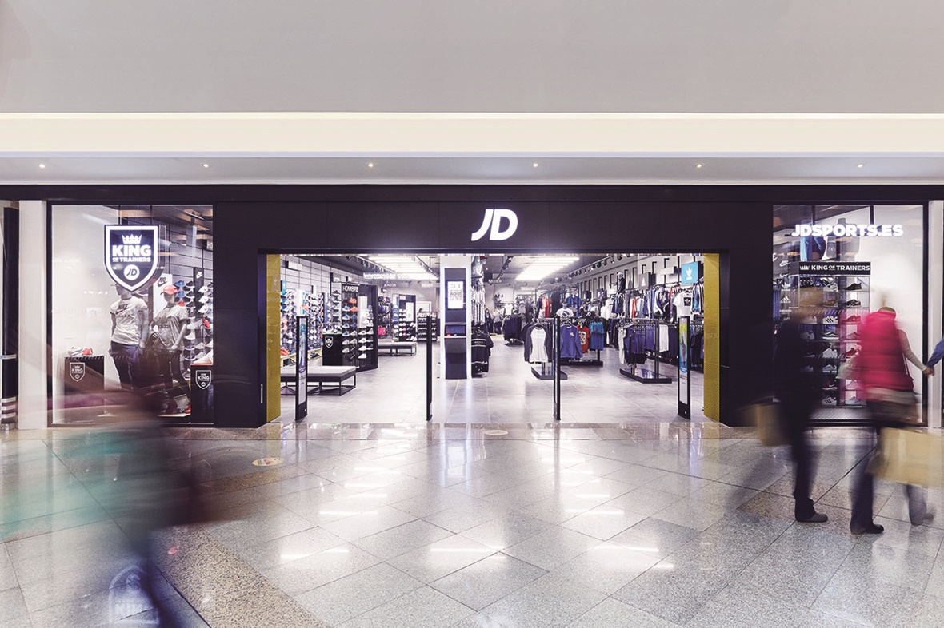](https://www.drapersonline.com/attachment?storycode=7035406&attype=P&atcode=3081967)](https://www.drapersonline.com/attachment?storycode=7035406&attype=P&atcode=3081967)

Revenue at JD Sports Fashion almost doubled to £4.7bn for the 52 weeks to 2 February 2019, as the retailer defied high street gloom by steering clear of reactive discounting and maintaining a clear customer proposition.

The group showed growth across the board for the year, and posted record EBITDA, up 26.8% on the previous year, of £448.4m.

Profit before tax grew 15.4% to £339.9m. Operating profit increased by 17.1% to £361.5m.

Total like-for-like sales across the global sports fashion fascias, which include [JD](https://www.drapersonline.com/companies/jd-sports-fashion) Sports, Tessuti and Size?, grew by more than 6%, despite the difficult UK retail market.

The brand attributed such a successful period to maintaining a close consumer connection, having a flexible property portfolio, improving store operations and avoiding reactive discounting.

Executive chairman Peter Cowgill said: “This new record result for our group has been achieved with a relentless focus on ensuring that, at all times, we provide a compelling differentiated proposition to the consumer with an attention-grabbing theatre both in stores and online.

“Consumers expect our product and brand mix to be emotionally engaging, exclusive, and continually evolving with high levels of social media penetration and an increasing pace of technology adoption across our core demographic, ensuring that new styles and trends spread rapidly across a wide geography.”

During the period JD Sports completed the first phase of works on the 352,000 sq ft extension to its main UK distribution centre in Rochdale.

Internationally it opened a further 39 stores across Europe and 34 stores in the Asia-Pacific region during the period.

The retailer posted a depreciation of £126.9m relating to the acquisition of Finish Line and the JD business in the US. However, the businesses contributed £26.6m to operating profits.

Gross margin fell from 48.4% to 47.5% as a result of the acquisitions.

JD said it would continue to develop Finish Line’s performance by exiting stores, improving product margins by controlling discounting, and improving the product proposition and visual merchandising.

Since the year-end JD Sports has bought [menswear brand Pretty Green](https://www.drapersonline.com/news/latest-news/liam-gallaghers-pretty-green-sold-to-jd-sports/7035237.article?search=https%3a%2f%2fwww.drapersonline.com%2fsearcharticles%3fqsearch%3d1%26keywords%3dJD+Sports) out of administration and has [agreed to](https://www.drapersonline.com/news/footasylum-saved-by-jd-sports-deal/7034938.article?search=https%3a%2f%2fwww.drapersonline.com%2fsearcharticles%3fqsearch%3d1%26keywords%3dJD+Sports) buy its smaller rival, Footasylum, for £90.1m.

<https://www.drapersonline.com/news/latest-news/record-results-for-jd-sports/7035406.article>