**JD Sports achieves 50 % turnover growth**

*Published in Fashion on 17-04-2019*

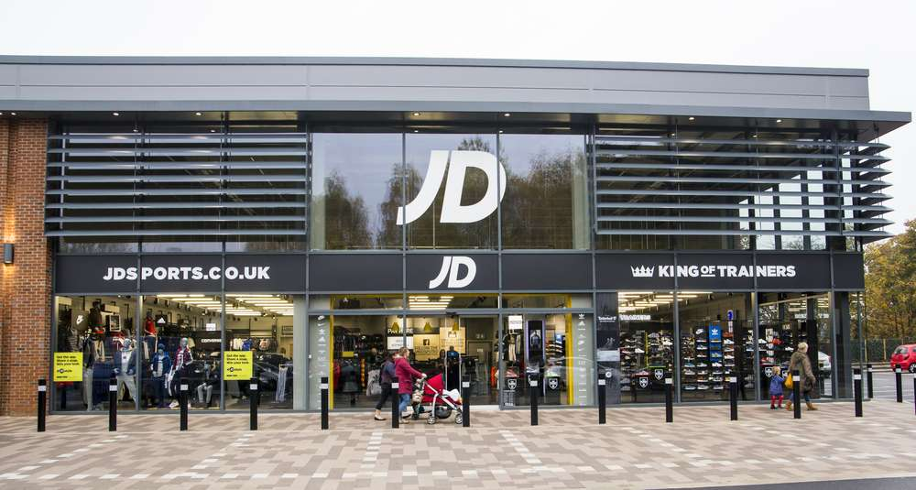

British sports chain **JD Sports** enjoyed an enormous increase in turnover last year: it increased by no less than 49.2% to 4.7 billion pounds (5.4 billion euros). Gross profit growth was slightly lower, but amounted to more than a quarter.

**The Finish Line**

The enormous increase in turnover comes [courtesy of the acquisition of The Finish Line](https://fashionunited.uk/news/business/jd-sports-completes-the-finish-line-acquisition/2018061930283), the American sports store chain JD Sports acquired in the middle of 2018 for 558 million dollars (just under half a billion euros). CEO Peter Cowgill is convinced that the acquisition will have positive consequences for the group in the long term and that it will be possible to make The Finish Line more profitable. Across the group as a whole, [gross profit increased by 26.8 %](https://fashionunited.uk/news/business/jd-sports-posts-record-results-revenues-surge-49-2-percent/2019041642708) to 488.4 million pounds (560 million euros).

JD Sports now has stores in ten European countries, and Austria will become number eleven later this year. Last year, 39 sports shops were added, including the first two in Finland. The chain is also active in Asia, where it opened its first shops in Singapore, South Korea and Thailand.

https://www.retaildetail.eu/en/news/fashion/jd-sports-achieves-50-turnover-growth