**1.4.3 Organisational design**

1. Use the information below to draw an organisational chart for Rosemary Ltd.
   * George is the Managing Director, he has a span of control of 4 functional directors
   * Melissa is Finance Director, Xavier is HR director, Aileen is Marketing Director and Antonio is Operations Director
   * Aileen and Antonio both have 18 employees in their department. Each one has 2 managers with an equal span of control
   * Melissa has 3 managers. Each manager is in charge of 1 assistant manager and 2 junior clerks who report directly to the assistant manager
   * Xavier has a secretary who reports directly to him. He is also in charge of 2 managers who both have 2 assistants

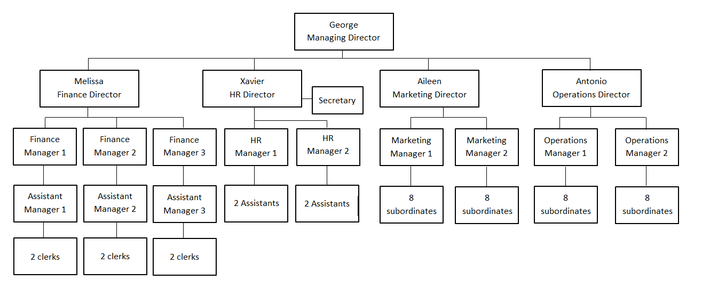

1. With reference to the organisational chart drawn above explain the following terms:
   * + - 1. Chain of command

Chain of command is the number of levels of hierarchy communication passes through e.g. George 🡪 Melissa 🡪 3 finance managers 🡪 3 assistant finance managers 🡪 6 junior clerks.

* + - * 1. Hierarchy

Hierarchy is the number of levels within an organisational structure. At Rosemary Ltd there is a hierarchical structure with 5 levels.

* + - * 1. Span of control

Span of control is the number of subordinates a manager is directly responsible for e.g. Aileen is directly responsible for two marketing managers.