**1.4.4 Motivation in theory and practice**

1. Match each term to the correct motivational theorist.

|  |  |  |  |
| --- | --- | --- | --- |
| Hierarchy of needs | Self-actualisation | Scientific management | Time & motion study |
| Economic man | Piecework | Psychological needs | Esteem needs |

|  |  |
| --- | --- |
| Maslow | Taylor |
| Hierarchy of needs  Self-actualisation  Psychological needs  Esteem needs | Economic man  Piecework  Scientific management  Time & motion study |

1. Complete the diagram to show your understanding of Herzberg's Dual Factor Theory.

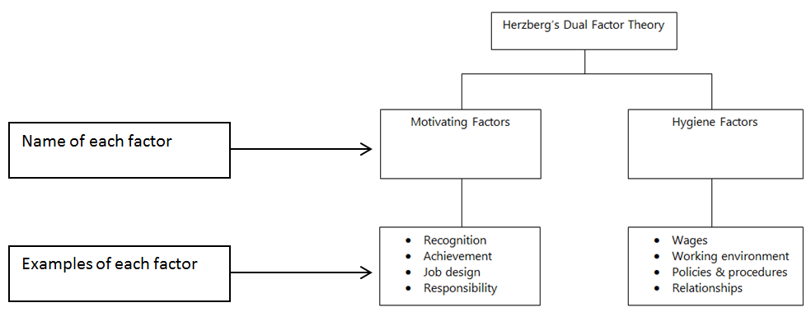

1. Name one other motivational theory – Mayo human relations
2. Complete the table below.

|  |  |  |
| --- | --- | --- |
| Method of motivation | Financial or non-financial | Definition |
| Piecework | Financial | Paying employees per item produced |
| Teamwork | Non-financial | Where employees are organised into groups and work together in order to meet set objectives |
| Performance related pay | Financial | Linking part of an employee’s remuneration package to the meeting of pre-agreed targets |
| Commission | Financial | An additional payment made to employees as a percentage of personal sales |
| Job enrichment | Non-financial | An increase in the level of responsibility that an employee has in order to increase motivation |