**2.2.3 Break-even**

1. Answer the following questions based on the break-even chart for a new bike shop.

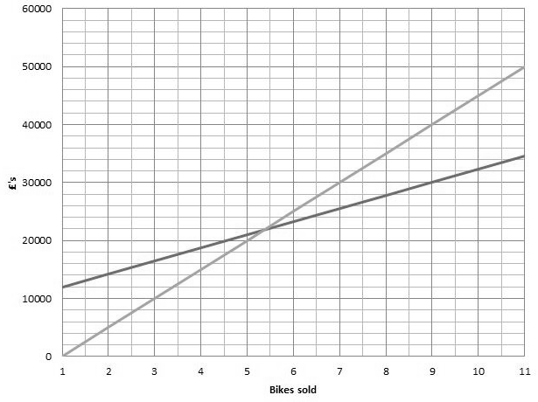

0 10 20 30 40 50 60 70 80 90 100 110

|  |  |
| --- | --- |
| What are the fixed costs? | £12 000 |
| What are the variable costs per bike? | 20 bikes TC = £16 000. TVC = £4 000/20 bikes  = £200 |
| What is the break-even level of bikes sold? | 45 bikes |
| What is the price per bike? | 20 bikes = £10 000 sales revenue  £10 000 / 20 = £500 per bike |
| What is the contribution per bike? | Contribution = Selling price – variable cost  £500 - £200 = £300 |
| What is the profit or loss if 25 bikes are sold? | Profit or loss = Total revenue – total cost  =£12 000 - £18 000 = £6 000 loss |
| What is the profit or loss if 90 bikes are sold? | Profit or loss = Total revenue – total cost  £45 000 - £32 000 = £13 000 profit |
| What is the margin of safety if 100 bikes are sold? | Margin of safety = Actual output – breakeven output  100 - 45 = 55 bikes |