**26. Productivity Mark: /19**

1. Calculate the productivity per worker per month of a factory making chairs if the company employ 108 staff and manufacture 45 639 chairs. /3 marks

45,639 = **422.58 chairs per worker per month**

108

1. Following an extensive staff training programme, output rises by 8.6%. Calculate the change in productivity per worker per month. /3 marks

45,639 x 1.086 = 49,564

49,564 = 458.92 chairs per worker per month

108

458.92 – 422.58 = **Increase of 36.34 chairs per worker per month**

1. In an effort to reduce costs, the company decides to make 17 workers redundant. If output per worker remains unchanged after the training programme, calculate the percentage change in the new level of total output for the firm. /5 marks

108 – 17 = 91 workers

91 x 458.92 = 41,761 chairs per month

Percentage change in output = (41,761 – 49,564) x 100 = **- 18.68% fall in output**

41,761

1. Complete the table and on graph paper plot an average cost curve. Mark the point where the firm achieves maximum efficiency. /6 marks

|  |  |  |
| --- | --- | --- |
| **Output (Units)** | **Total Cost (£)** | **Cost Per Unit (£)** |
| 0 | 200 |  |
| 50 | 230 | **4.60** |
| 100 | 290 | **2.90** |
| 150 | 335 | **2.23** |
| 200 | 360 | **1.80** |
| 250 | 380 | **1.52** |
| 300 | 400 | **1.33** |
| 350 | 480 | **1.37** |
| 400 | 600 | **1.50** |
| 450 | 750 | **1.67** |
| 500 | 1,000 | **2.00** |

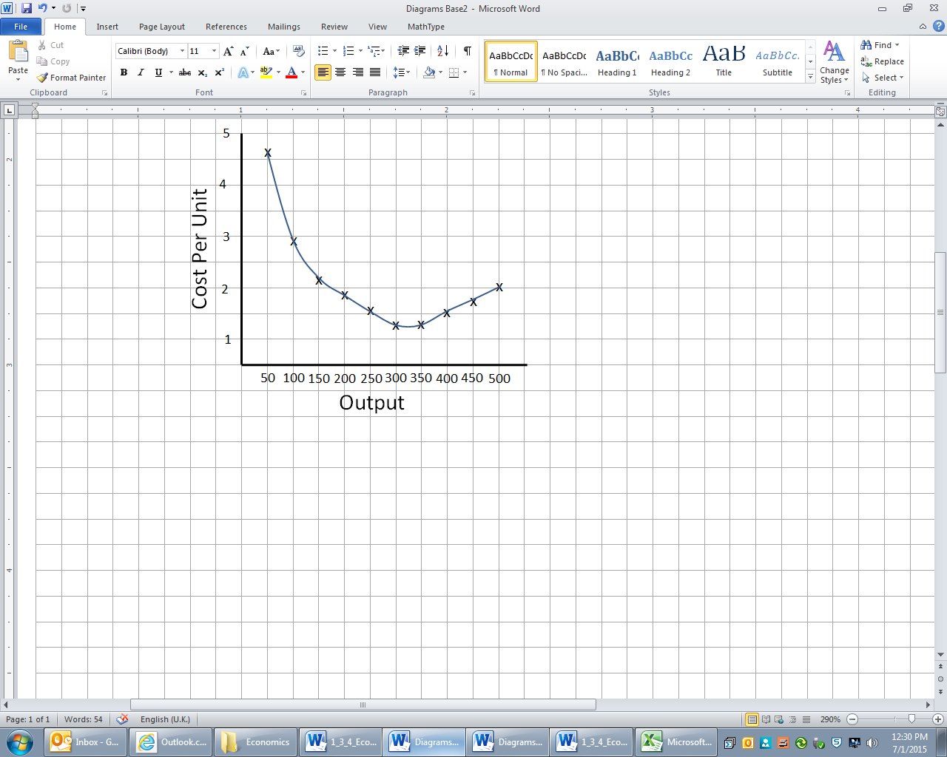

Maximum efficiency