

BTEC Subsidiary Diploma in Music Technology

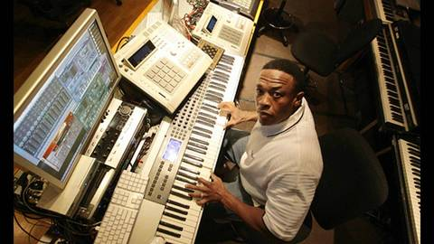**Introduction to**

**BTEC Music Technology**

***To be completed before the first lesson***

**Name:**

**1. Using research identify the following microphones**:

*You should use retail sites such as Thomann, Studiospares, GAK and DV247 to help you.*

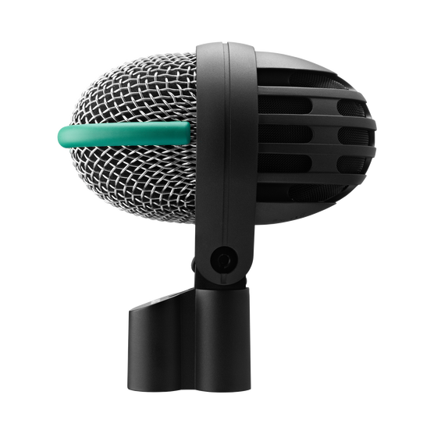

Manufacturer:

Model:

What instrument would you record with it?

___________________________________________________________________________

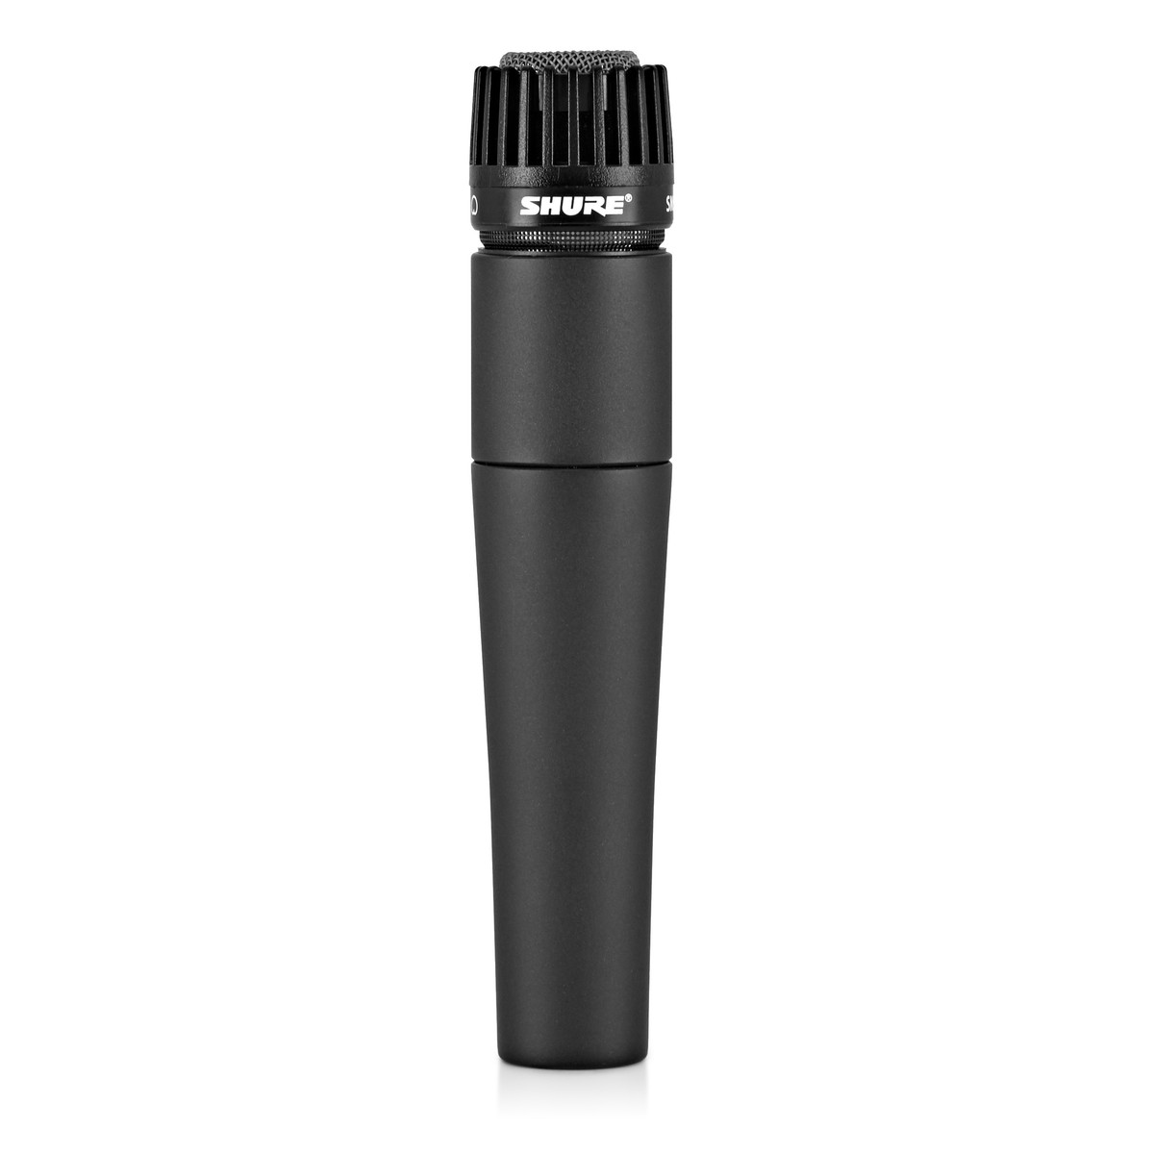

Manufacturer:

Model:

What instrument would you record with it?

___________________________________________________________________________

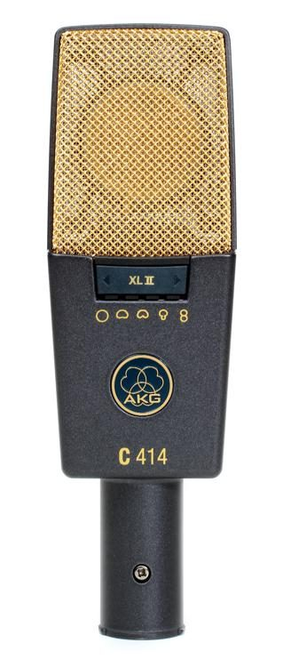

Manufacturer:

Model:

What instrument would you record with it?

___________________________________________________________________________

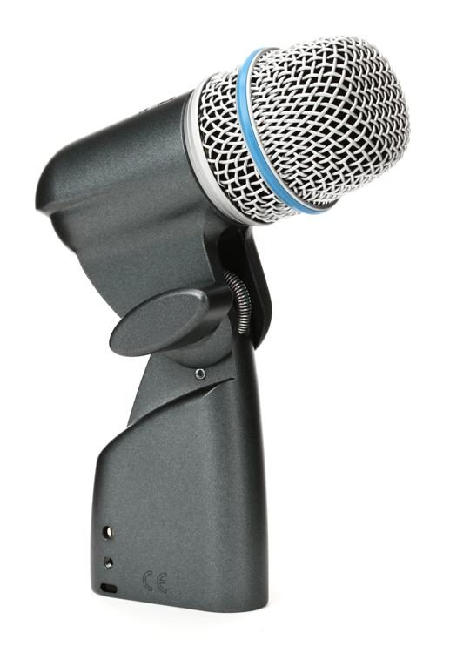

Manufacturer:

Model:

What instrument would you record with it?

___________________________________________________________________________

**2. Add descriptions to the following Music Technology terminologies so that you have a basic understanding of what they mean.**

1. Frequency Range:

____________________________________________________________________________________________________________________________________________________________________________________

2. Frequency Response:

____________________________________________________________________________________________________________________________________________________________________________________

3. Dynamic Range:

____________________________________________________________________________________________________________________________________________________________________________________

4. Sound Pressure Level:

____________________________________________________________________________________________________________________________________________________________________________________

5. Polar Pattern:

____________________________________________________________________________________________________________________________________________________________________________________

**3. Add descriptions to the following Music Technology effects so that you have a basic understanding of what they mean.**

1. Equaliser:

____________________________________________________________________________________________________________________________________________________________________________________

2. Reverb:

____________________________________________________________________________________________________________________________________________________________________________________

3. Delay:

____________________________________________________________________________________________________________________________________________________________________________________

4. Compressor:

____________________________________________________________________________________________________________________________________________________________________________________

5. Limiter:

____________________________________________________________________________________________________________________________________________________________________________________