**Godalming College**

Booklet Checked by: _____________

Grade: U/S 1 2 3

Comment: _______________________________________________________________________________________________________________________________________________________

**Sociology Department**

**Patterns, trends and explanations of inequality and difference:**

**GENDER**

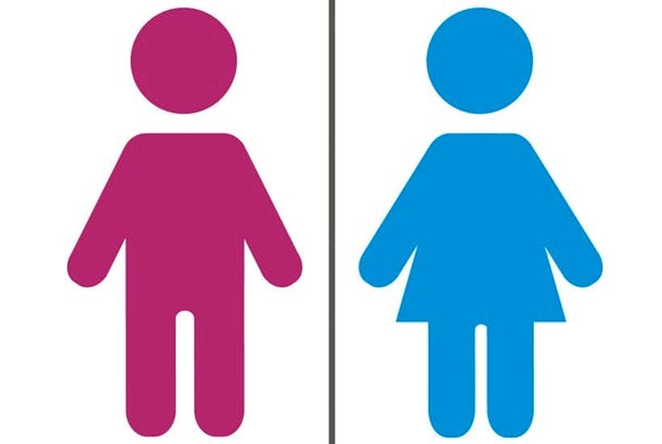

**STRATIFICATION WORKBOOK 1**

|  |  |  |
| --- | --- | --- |
| Name: | Set: | Group: |

**Gender Equality Legislation:**

Using your first year textbook and research from the internet make notes on the legislation that exists in the UK in an attempt to prevent gender inequalities within our society:

|  |  |
| --- | --- |
| Equal Pay Act 1970 |  |
| Sex Discrimination Act 1975 |  |
| Changes in maternity/ paternity leave 2015 |  |
| ‘Positive action’ legislation |  |
| Equalities Act 2010 |  |
| Other… |  |

**Inequalities relating to gender:**

Gender is considered to be the main site of inequality in the UK. In both public and private domains there are social differences between men and women. Using the powerpoint, knowledge from other modules and your own research consider how gender inequality exists in following areas:

|  |  |
| --- | --- |
| Workplace |  |
| Home |  |
| Politics |  |
| Education |  |
| Health |  |
| Crime |  |

In which of these areas are women more advantaged (arguably):

In which of these areas are men more advantaged (arguably):

**Theoretical explanations of patterns and trends in gender inequality:**

Using the information on pages 214-218 of the OCR textbook (at the end of this booklet) summarise how the different theories explain patterns and trends in gender inequality:

|  |  |
| --- | --- |
| **Theory:** | **Explanation** |
| Functionalism |  |
| Marxism |  |
| Weberian |  |

**Theoretical explanations of patterns and trends in gender inequality:**

|  |  |
| --- | --- |
| **Theory:** | **Explanation** |
| Feminism (General) |  |
| Liberal Feminism |  |
| Marxist Feminism |  |

**Theoretical explanations of patterns and trends in gender inequality:**

|  |  |
| --- | --- |
| **Theory:** | **Explanation** |
| Radical Feminism |  |
| Black Feminism |  |
| Third Wave Feminism |  |

**Theoretical explanations of patterns and trends in gender inequality:**

|  |  |
| --- | --- |
| **Theory:** | **Explanation** |
| Preference Theory |  |

**Key Terms:**

All of these words will be covered within your lessons. You should define these key terms in your own words to ensure your understanding. Wherever possible use an example to illustrate the term.

|  |  |
| --- | --- |
| **KEY TERM** | **DEFINITION** |
| Gender |  |
| Inequality |  |
| Feminism |  |
| Liberal Feminism |  |
| Marxist Feminism |  |
| Radical Feminism |  |
| Black Feminism |  |
| Second-wave feminism |  |
| Third-wave Feminism |  |
| Preference Theory |  |
| Patriarchy |  |
| Pay gap |  |
| Capitalism |  |

**Key Terms:**

|  |  |
| --- | --- |
| **KEY TERM** | **DEFINITION** |
| Post feminism |  |
| Horizontal segregation |  |
| Vertical segregation |  |
|  |  |
|  |  |
|  |  |
|  |  |
|  |  |
|  |  |
|  |  |
|  |  |
|  |  |
|  |  |
|  |  |

**Key Studies:**

To achieve top AO1 (Knowledge and Understanding) marks, as well as AO2 (Interpretation and Analysis) marks you will also need to show awareness of relevance sociological studies, that can be applied to each area of the course. As we go through this topic note down details of these studies:

|  |  |  |  |  |
| --- | --- | --- | --- | --- |
| **Study:** | **Perspective (and methodological approach if known)** | | | **Summary of study:** |
| Oakley  p.214 OCR and previous knowledge |  | | |  |
| Beechey (1976), p.214 OCR |  | | |  |
| Ansley (previous knowledge) |  | | |  |
| Parsons (previous knowledge) |  | | |  |
| Engels (previous knowledge) |  | | |  |
| Zaretsky (previous knowledge) |  | | |  |
| Willmott and Young (previous knowledge) |  | | |  |
| Barron and Norris (1976), p.215 OCR |  | | |  |
| Friedan (1963), p.215 OCR |  | | |  |
| Firestone (1971), p.217 OCR | |  |  | |
| Walby (1990), p.217 OCR | |  |  | |
| Hakim (2000), p.218 OCR | |  |  | |

**Examination Questions:**

Outline two ways men may be advantaged in society. **[10]**

Outline two ways women are disadvantaged in society. **[10]**

Outline two ways men may be disadvantaged in society **[10]**

Item O

Social mobility refers to the movement of individuals between social classes. In a meritocratic society there is equal opportunity for all, and anyone can achieve social mobility by working their way up the occupational ladder.

In practice, there may be factors that prevent women from being socially mobile.

Applying material from Item O, analyse two factors that may prevent women from being socially mobile. [10]

… Evaluate feminist explanations of gender inequality in society. **[20]**

**Item B**

It is claimed by some sociologists that the social class of birth is the key determinant of many aspects of an individual’s life, such as their health, educational achievement, employment prospects and even the likely cause of death. Others, such as feminists, suggest that factors such as gender play an equally important part, particularly in explaining the differential position of women in contemporary society.

Applying material from Item B and your knowledge, evaluate the usefulness of feminist approaches in explaining the position of women in society today **[20]**

**Item C**

Despite greater equality of opportunity between young women and men, gender inequalities still exist in employment and earnings. Functionalists see this as a ‘normal’ state of affairs and as the result of correct socialisation, whilst Marxists suggest that class affects different groups in different ways.

Applying material from Item C and your knowledge, evaluate the usefulness of functionalist theories in understanding the position of women in society today **[20]**

… Evaluate the view that there are natural roles that men and women undertake in society **[20]**

… Evaluate sociological explanations of gender inequality in the contemporary UK **[20]**