Godalming College Physics Department

Centripetal force experiment- whirling rubber bung

Your lab report will be assessed for CPAC5: ‘y = mx + c’ analysis

Apparatus/Diagram

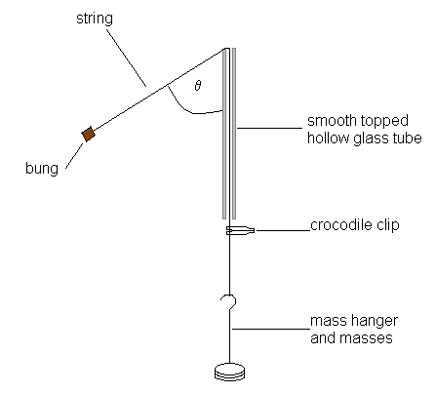
Balance
Metre rule

Theory

The bung will be rotated in a circle. The horizontal radius of the circle is rsinθ. The centripetal force is provided by the tension in the string, whose horizontal component is Mgsinθ.

Mgsinθ = 4π²mrsinθ M = hanging mass/kg
T² g = gravitational field strength/Nkg⁻¹
The sinθ terms cancel giving: r = rotating string length/m
m = mass of bung/kg
Mg = 4π²mr T = period of rotation/s T²

If the radius of rotation is constant then:
M = 4π²mr . 1
g T²

So a plot of M against 1/T² should be a straight line.
If the hanging mass is constant then:

r = Mg . T²
m4π²

So a plot of r against T² should be a straight line.

Method

Determine the mass of the bung. Record it. Place 100g on the hanger. Set the radius of the string to 80cm (measure the length from the tube to the centre of mass of the bung). Place the crocodile clip just below the base of the tube. This is a marker so that the radius can be kept constant. Carefully rotate the bung above your head in a clear space. When the rotation is constant and the radius at the preset length, the crocodile clip will stay at a point just below the tube. Time 20 revolutions of the bung three times. Repeat this for a number of different masses, increasing the mass by 20g each time. Obtain 8 sets of results.

Next keep the hanging mass constant and vary the radius of rotation. Obtain 8 sets of results.

Analysis

The following table formats should be used to record your results:

Fixed radius of rotation, r:

Hanging mass M/g | 20T/s | 20T/s | 20T/s | Average 20T/s | T/s

Fixed hanging mass, M:

Radius r/cm | 20T/s | 20T/s | 20T/s | Average 20T/s | T/s

For each set of data, process the results and draw up the following tables for plotting your graphs:.

Hanging mass M/kg | T/s | T²/s² | 1/T² /s ⁻²

Plot a graph of M against 1/ T²

Radius r/m | T/s | T²/s²

Plot a graph of r against T².

Are the graphs the shape you expect?

In each case measure the gradient of the graph and compare it with the expected value calculated from the appropriate ‘y = mx + c’ analysis and the constant values. Don’t forget these quantities will have a unit.

Calculate the percentage difference between the actual and expected gradients in each case and discuss whether any discrepancies are reasonable given experimental uncertainties and the nature of this experiment.

