Godalming College Physics Department

Measurement of the focal length of a converging lens

Theory

The focal length of a lens is given by the formula $\frac{1}{v}+\frac{1}{u}=\frac{1}{f}$

Where f is the focal length, u is the object distance (distance from object to lens) and v is the image distance (distance from image to lens).

From a series of values of u and v a graph can be plotted of 1/v against 1/u.

$\frac{1}{v}=−\frac{1}{u}+\frac{1}{f}$

From a “y = mx + c” analysis of the above rearranged equation it is clear that a straight line of gradient -1 and y intercept 1/f should be produced.

Apparatus required

Optical bench and various holders Converging lens of approximate focal length 15 cm
Mounted wire grid to act as object Lamp
Converging lens of approximate focal length 10 cm Screen

Method

Set up the components on the optical bench as shown in the diagram below using one of the lenses.

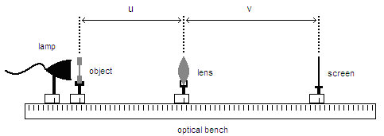

Adjust the position of the components until a focussed image of the grid is formed on the screen. Note that it will not be possible to form a ‘real’ image on the screen if the object distance is less than the focal length of the lens.

Record the positions of the object, lens and screen from the scale on the optical bench and hence deduce the values of u and v. Using the full range of the optical bench, find as many different positions as you can where a clear image is produced and repeat the readings.

Now repeat the process for the second lens.

Processing of results

For each of your lenses, plot a graph of 1/v against 1/u.

Measure the gradients of each line and check that this is equal to -1.

A little thought should convince you that the intercept on the x axis is also 1/f. Hence you should measure both intercepts to give an average value for 1/f and then use this to find your final value for the focal length.

For each graph, measure the intercepts on both the x and the y axis and calculate average value.

The intercepts should both equal 1/f. Use your average intercept values to calculate the focal length of each lens.

Discussion and Conclusion

Did you obtain reasonable straight-line graphs with a gradient of -1?

Calculate the percentage difference between your experimental values and the nominal values for the focal length in each case.

Estimate the uncertainties in your experimental method and compare the percentage uncertainties with the percentage differences.

