Godalming College Physics Department
Pressure Law
While conducting this experiment, you will be assessed for CPAC3: Working Safely.
Apparatus
This method uses a straightforward piece of apparatus called the ‘Jolly bulb’, which consists of a sealed bulb of air connected to a pressure gauge.
What are the main safety precautions you need to take with this experiment? Write these below and discuss with your teacher before starting.

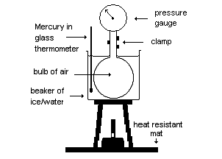
Theory
For a fixed mass of gas: P α T at constant Volume.
Where: T is the kelvin temperature,
P is the total pressure – there are two types of Jolly bulb. Some measure the total pressure directly. For others you need to add the reading from the pressure gauge to atmospheric pressure, found from the barometer in the prep. room.
Make sure you check carefully which type you have.
Method

Start with an ice water mixture surrounding the glass bulb. When this has reached equilibrium, record the pressure (initially negative, if an excess pressure reading) and the corresponding celsius temperature from the thermometer. Now heat the beaker gently and once the ice has melted, record a series of values for temperatures up to the boiling point of water. Don’t forget to read today’s atmospheric pressure, if you have the appropriate type of gauge.

Results and Analysis

You should now be able to plot a graph of total pressure against celsius temperature.

You need to extrapolate the graph back to find the intercept on the x axis, however you should not do this graphically. The following diagram shows what the graph would look like if not plotted with a false origin.

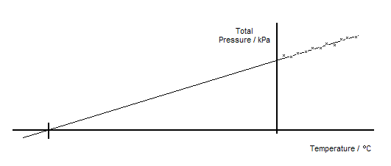
Can you explain why you would not expect a very good result if you plotted the graph with these axes?

Use a false origin and a larger scale to only include the values you have measured, however you should ensure that your temperature axis starts at 0 ºC.

From your graph measure the gradient, m and the intercept on the y axis, c.

You should then be able to use the equation ‘y = mx + c’ to calculate the value of x when y = 0.

What significance can you attach to this temperature? Look up the accepted value and compare it with your result. Remember to reference your research appropriately.

