Godalming College Physics Department

**Resonance Experiment – Mass on a Spring**

### Theory

The time period for free oscillations of a mass, m on a spring of stiffness, k is given by: 

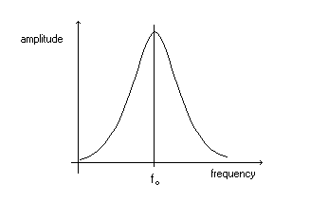

This experiment uses two oscillators side by side. The two masses are different, but the ratio of m / k is arranged to be similar, so that the larger mass can drive the smaller one. When the frequencies are exactly the same the phenomenon of **resonance** will occur and the smaller mass will oscillate strongly. The phase of the driven oscillator can also be compared with the driver. At low driving frequency they are nearly in phase. At resonance the phase difference becomes π / 2 and at higher frequency it tends towards π.

### Apparatus

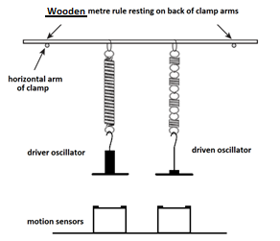

### Method

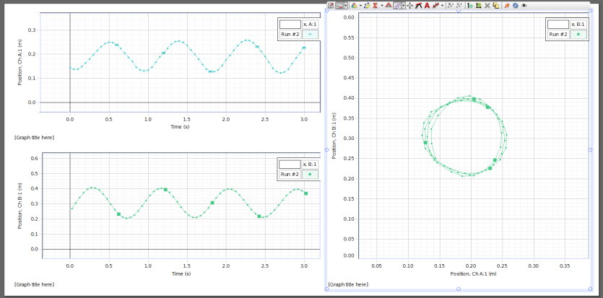Set up the arrangement shown in the diagram and plug the motion sensors into two of the USB ports on the computer. This will probably cause the ‘PASPortal’ dialogue box to open. Close this and instead run the datalogging program ‘Capstone’ from the icon on the desktop. Choose the option that displays 2 small graphs and one large graph, as shown in the example diagram below. Click to select the axes – the 2 small graphs should be set to show displacement time graphs for the oscillators and the large graph should show the displacement of the driven oscillator against the displacement of the driver. Start with the largest mass (600g) on the driver. Set the driver oscillating and after 5 oscillations start the datalogging. Collect data for about 5 oscillations and then stop the logger. Take a screen dump of the graph of driven displacement against driver displacement and save it in a word document. You will also need to measure the frequency of the driver each time – this is best done by timing several oscillations with a stopwatch. Now repeat with smaller driver masses, going down in 50g intervals to 300g – this will give readings in increasing driver frequency. The mass of the driven oscillator stays constant at just the 100g mass hanger.

### Processing of Results and Discussion

For each driver mass, work out the frequency from the average time period (f = 1/T).

From each of the graphs of driven displacement against driver displacement, estimate the average amplitude of each oscillator and calculate the ratio driven amplitude / driver amplitude. This represents the relative response of the driver at each frequency.

Now plot a graph of this amplitude ratio against driver frequency and discuss how effectively it shows the phenomenon of resonance.

The phase relationship between the two oscillators is also represented by this graph. To help understand this, answer the following questions in your write up:

* Sketch the form of the driven v driver displacement graph when both oscillators are exactly in phase.
* Sketch the form of the driven v driver displacement graph when both oscillators are exactly in antiphase.
* The graph below shows the plot produced when the response was close to resonance, so there is a phase difference of π/2 or 900. Can you explain the shape of the graph?

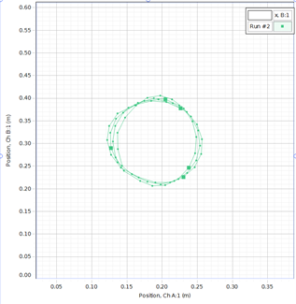

Now examine the graphs produced in the experiment:

* Do they show the expected phase relationships as the frequency of the driver is increased?
* Does the graph produced when the system is close to resonance have the expected shape?

You should also be able to see the phase relationship between the 2 displacement – time graphs.

### Conclusion

Did the experiment perform as expected? Write an appropriate conclusion about the form of the amplitude and phase relationship as you increase the frequency through the resonance condition.