Revision Homework 1 Answer Sheet

|  |  |  |  |  |  |  |
| --- | --- | --- | --- | --- | --- | --- |
|  | A | B | C | D | E | F |
| A |  | 600 | 500 | 800 | 700 |  |
| B | 600 |  |  | 900 | 800 | 400 |
| C | 500 |  |  |  | 600 |  |
| D | 800 | 900 |  |  |  | 900 |
| E | 700 | 800 | 600 |  |  | 700 |
| F |  | 400 |  | 900 | 700 |  |

2.

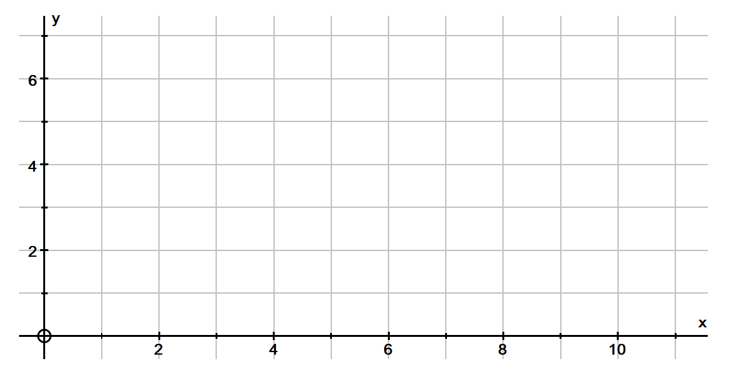

4.

5.

Bury (B) 8 Rochdale(R)

**.j**

**7**

Eccles (E) 12 13

5

6 11

Manchester(M)

11

Oldham(O)

7

Trafford(T)

9 12 6

3

Sale(S) 5 Ashton(A)