D1 Revision Homework 2 Answer Sheet

**1.** (*a*) *You may not need to use all the rows in this table.*

|  |  |  |  |  |  |
| --- | --- | --- | --- | --- | --- |
| *a* | *b* | *c* | Integer? | Output  List | *a* = *b*? |
|  |  |  |  |  |  |
|  |  |  |  |  |  |
|  |  |  |  |  |  |
|  |  |  |  |  |  |
|  |  |  |  |  |  |
|  |  |  |  |  |  |
|  |  |  |  |  |  |
|  |  |  |  |  |  |
|  |  |  |  |  |  |
|  |  |  |  |  |  |

Output List:..............................................................................................

**2. Figure 1 Figure 2**

**A • • 1 A • • 1**

**B • • 2 B • • 2**

**C • • 3 C • • 3**

**D • • 4 D • • 4**

**E • • 5 E • • 5**

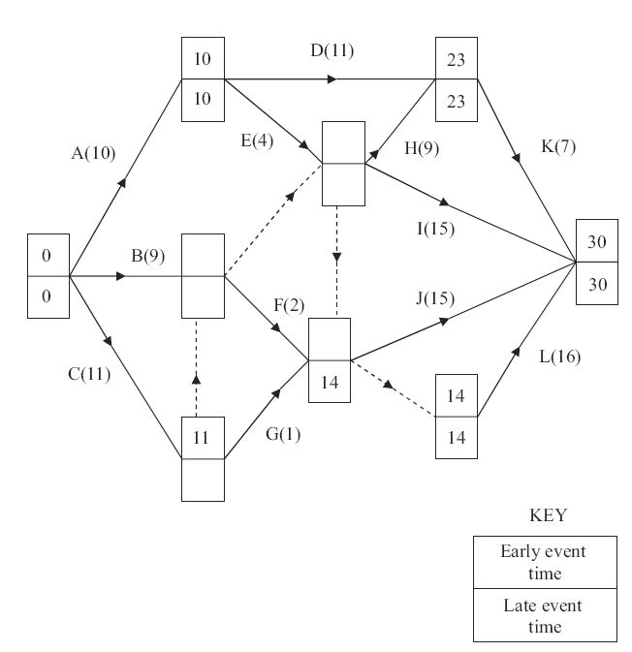**4.**

|  |  |  |  |  |  |  |  |  |  |  |  |  |  |  |  |  |  |  |  |  |  |  |  |  |  |  |  |  |  |  |  |  |
| --- | --- | --- | --- | --- | --- | --- | --- | --- | --- | --- | --- | --- | --- | --- | --- | --- | --- | --- | --- | --- | --- | --- | --- | --- | --- | --- | --- | --- | --- | --- | --- | --- |
|  | 0 | | 2 | | 4 | | 6 | | 8 | | 10 | | 12 | | 14 | | 16 | | 18 | | 20 | | 22 | | 24 | | 26 | | 28 | | 30 | |
|  |  |  |  |  |  |  |  |  |  |  |  |  |  |  |  |  |  |  |  |  |  |  |  |  |  |  |  |  |  |  |  |  |  |
|  |  |  |  |  |  |  |  |  |  |  |  |  |  |  |  |  |  |  |  |  |  |  |  |  |  |  |  |  |  |  |  |  |  |