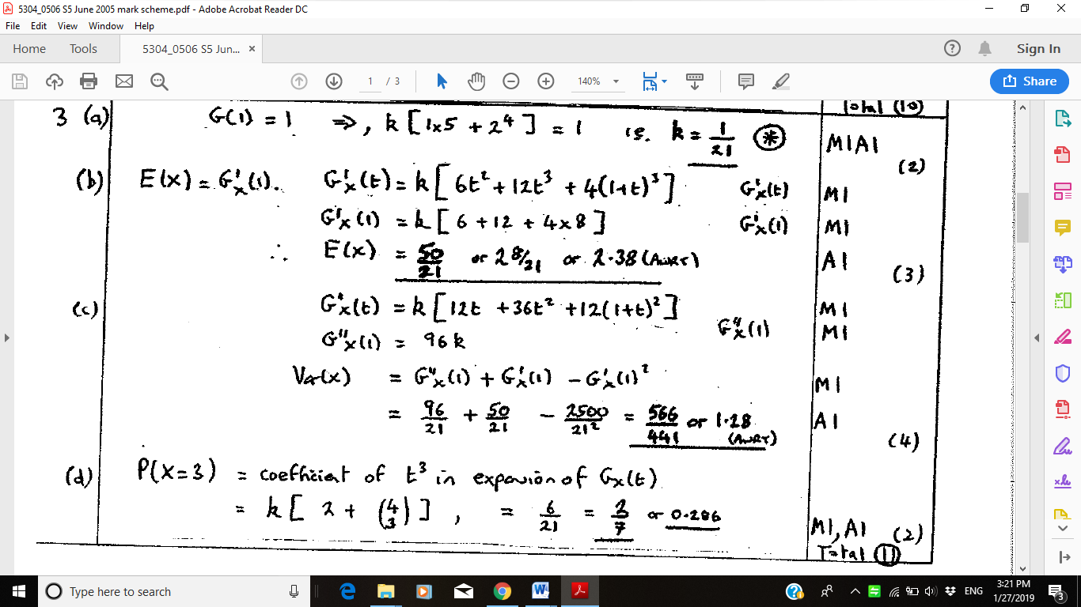

|  |  |  |
| --- | --- | --- |
| **2.** (*a*)(i) | P(*X* = 2) =  = 4.5e–3 | M1 A1 |
| (ii) | P(*X* ≥ 4) = 1 – P(*X* ≤ 3), = 1 – e–3 | M1, A1 |
|  | = 1 – 13e–3 | A1 (5) |
| (*b*) | *y*: 0 1 2 3 4 |  |
|  | *x*: 0 1 2 3 ≥4 |  |
|  | P(*Y* = *y*): e–3 3e–3 4.5e–3 4.5e–3 1– 13e–3 | B1 |
|  | G*Y* (*t*) = e–3(*t* 0 + 3*t* + 4.5*t* 2 + 4.5*t* 3) + (1 – 13e–3)*t*4 | M1 |
|  | = e–3(1 + 3*t* + 4.5*t* 2 + 4.5*t* 3 – 13*t*4 (*) | A1 cso (3) |
| (*c*) | G′*Y* (*t*) = e–3(3 + 9*t* + 13.5*t* 2 – 52*t* 3 + 4*t*4 | M1 A1 |
|  | *μ* =E(*Y*) = G′*Y* (1) = 4 – 26.5e–3 or 2.68 | A1 |
|  | G″*Y* (*t*) = e–3(9 + 27*t* – 156*t* 2) + 12*t* 2 | M1 A1 |
|  | G″*Y* (1) = e–3(–120) + 12 = 12 – 120e–3 | A1 |
|  | *σ* 2 = G″*Y* (1) + G′*Y* (1) – [G′*Y* (1)]2 (= 1.52...) | M1 |
|  | *σ* = √*σ* 2 = 1.23 | A1(8) |
|  |  | **(15 marks)** |

|  |  |  |  |  |  |  |
| --- | --- | --- | --- | --- | --- | --- |
|  | **Mark scheme** | | | | | **Marks** |
|  |  | | |  | |  |
| **3.**  (*a*) | G*x*(1) = 1 | | | Use of G*x*(I) = 1 | | M1 |
|  | *k* = (1 + 1 + 3)2 = 1, | | | | |  |
|  | *k* =  (*) | | | | Fully correct | A1 (2) |
| (*b*) | (1 + *t* + 3*t*2) (1 + *t* + 3*t*2) = (1 + 2*t* + 7*t*2 + …) | Attempt to find coefficient of *x*2 | | | | M1 |
|  | Coefficient of *x*2 = | | | | | A1 (2) |
| (*c*) | G′*X* (*t*) = (1 + 6*t*) (1 + *t* + 3*t*2) | | | | | M1 A1 |
|  | G′*X* (1) = 2 E(*X*) = 2 | | Must say E(*x*) = G′*X*(1) | | | A1 |
|  | G′′*X* (*t*) = (1 + 6*t*) (1 + 6*t*) + (1 + *t* + 3*t*2) | | | | | M1 A1 |
|  | G″*X* (1) = 6 | | | | | A1 |
|  | Var (*X*) = 6 + 2 − (2)2 | | | | | M1 |
|  | = 1 | | | | | A1 (8) |
| (*d*) | ; (1 + *t*2 + 3*t*4)2 | | | | | B1; B1 (2) |
|  |  | | | | | **(14 marks)** |

