# Logo longerline

# 

# BTEC Extended Certificate Health and Social Care

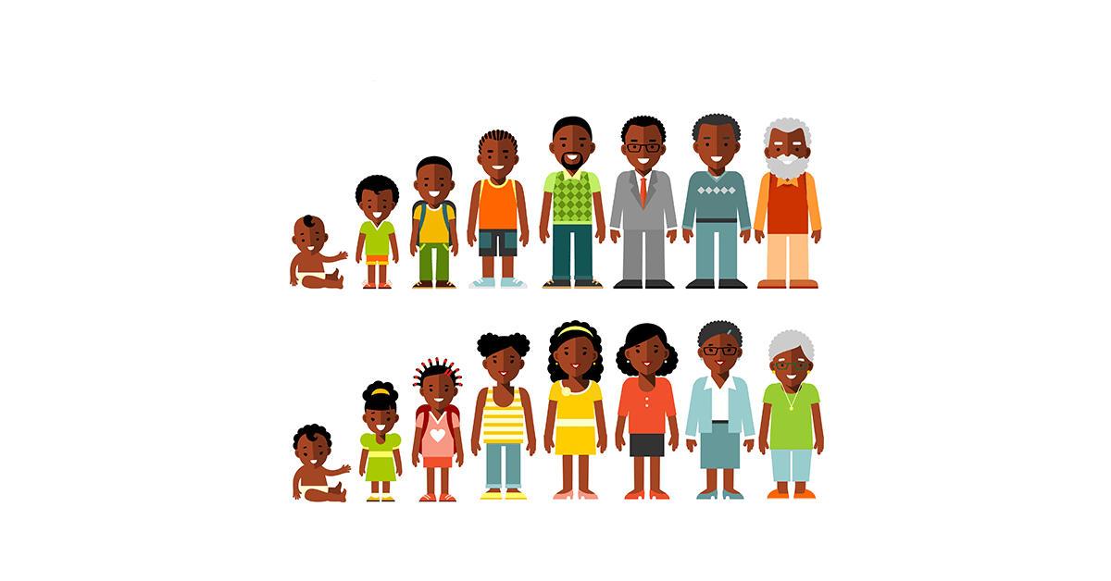

**Handbook**

# Welcome to BTEC Health and Social Care!

We have a committed team that will support and work with you on this course to provide you with the best opportunities to achieve your best.

**For your part we expect you to:**

* **Attend all lessons on time**
* **Complete all homework set**
* **Hand in work on time – deadlines are crucial to you being a successful student.**

Keep this handbook in a safe place as it has all the information you need throughout the two years**!**

If you need any help you can contact:

Harriet Broughton [hgb@godalming.ac.uk](mailto:hgb@godalming.ac.uk)

Sarah Fassam [sef@godalming.ac.uk](mailto:sef@godalming.ac.uk)

Contents

The BTEC Course 3

Course Structure 3

Grades 4

Grade boundaries 5

Coursework (assignments in unit 5 and TBC) 5

Before you submit the assignment 5

Deadlines 6

To keep work safe you need to do the following: 6

Plagiarism Policy 7

Plagiarism and how to avoid it by referencing your work 7

Direct Quote and Paraphrasing 7

What you will need for your lessons 9

FAQs 9

What happens if I miss a deadline? 9

Can I resubmit my work to improve on my grade? 9

Can I achieve a merit in a unit if I achieve all the merit criteria but miss out on one pass? 9

Content for units in year 1 10

# The BTEC Course

Pearson/Edexcel provides the following qualifications:

Two year qualification - **BTEC Extended Certificate in Health and Social Care**

One year qualification - **BTEC Certificate in Health and Social Care**

Both courses are designed to provide a practical work-related qualification, to either prepare you for employment or progression to higher education.

## Course Structure

You will study 2 units during each year (4 units in total for the two year course).

The first year comprises of

* **Unit 1: Human Lifespan Development**

This unit covers human lifespan and how different factors affect how people develop throughout their lifetime. This will be examined at the end of the first year in May/June

* **Unit 5: Meeting Individual Care and Support Needs**

This is the coursework unit which will cover the principles and practicalities that underpin meeting individual care and support needs.

If you decide to leave the course are the first year you will gain the **BTEC Certificate which is roughly equivalent to one AS-level.**

The second year comprises of:

* **Unit 2: Working in Health and Social Care**

You will explore what it is like to work in the health and social care sector, including the roles and responsibilities of workers and organisations. You will be examined on this in May/June

* **Unit X: TBC**

**This will be the coursework unit during the second year.**

After you finish the second year you will have gained a **BTEC Extended Certificate which is equivalent to one A-level.**

# Grades

For each internally assessed unit (unit 5 and TBC) you will conduct a number of assignments. Each assignment will be graded as a pass, merit or distinction (P, M D). This goes towards your grade for that particular unit.

E.g. For unit 5 there is one assignment, you will be required to gain all of the pass and merit levels in all parts of the assignment to gain a merit for unit 5.

**In order to pass a unit you must achieve all the pass criteria**, otherwise you will fail this unit and potentially the course.

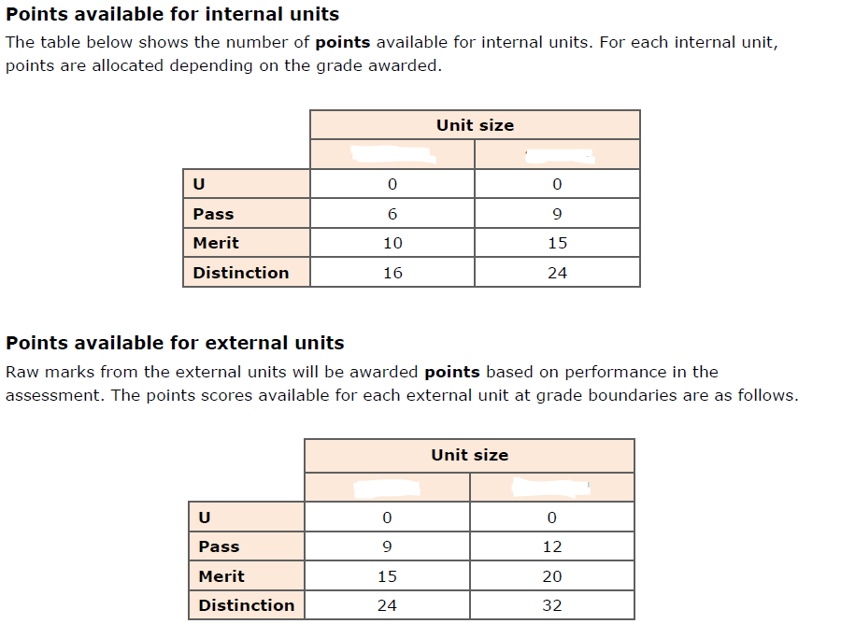

First year

Unit 5

First year

Unit 1

Second year

Unit 2

Second year

Unit TBC

## Grade boundaries

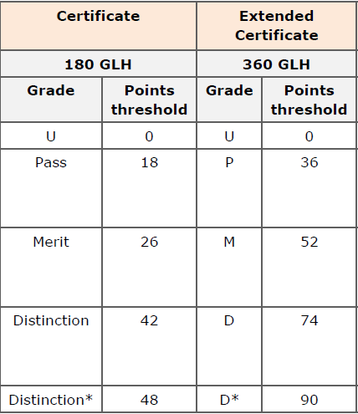

# Coursework

Before each assignment you will be taught about the unit content through group work, class activities and homework. At the end of the topic you will be set an assignment. **It is imperative that you complete all the work set as this will help you to achieve your best on the assignments.**

You will receive assignments throughout the year. If you are disorganised and do not complete the work to the highest standard by the deadline it may mean that for your next deadline you have other work due in for other teachers. **It is in your interest to complete the work as thoroughly as possible so you do not have to resubmit.**

**You will be expected to do a lot of independent research and study. This means you need to be self-disciplined, and organised to meet deadlines.**

It is also your responsibility to keep your work safe. If you miss a deadline because you have not saved your work correctly it will not be accepted as an excuse and you will fail that assignment.

When your teacher thinks you are ready you will be given the assignment. It will reflect tasks that you have been working on previously and you will be expected to work **independently** to complete it. You may use any of your classwork to help you.

Before you submit the assignment:

* Check that the work actually addresses the criteria accurately.
* Check; spelling, punctuation and grammar.
* Check your work is appropriately labelled with your name and sign the plagiarism declaration.

Once your work has been submitted it will be marked. If you have not been successful in achieving the criteria in the assignment you *may* be allowed ONE resubmission but this will depend on the following:

1. You handed the **first submission in on time**.
2. You will be able to achieve the criteria **without any further help**.
3. You **submit the resubmission within the timeframe the teacher allows.**
4. The **lead internal verifier** all the above with your teacher.

A spreadsheet of your marks will be shown to you regularly so you can monitor your progress and maintain good grades.

# Deadlines

Unit 5 and TBC will be assessed through completing assignments.

Each assignment has its own final deadline – which will be shown on the front cover of the assignment.

To be successful it is very important that you meet these deadlines.

**If you miss a deadline you cannot achieve a grade for that work.**

Final work will be kept by the teacher.

If you have not submitted at pass level we cannot mark the merit and then distinction work so those criteria cannot be achieved.

## To keep work safe you need to do the following:

1. Set up a ‘BTEC Health and Social Care’ folder on your home drive on a college computer. This will mean you can access your work from college or home.

2. You can back up data on a USB stick, however do not rely on this as they can become corrupt.

3. If another student loses your work YOU will be held accountable so keep your work safe and secure at all times.

4. Do not delete any work until you finish the qualification.

# Plagiarism Policy

Plagiarism is the presentation of another person’s words or thoughts as if they were your own. This includes; work from another student, internet sources or work copied from text books. **This is an offence that the exam board take very seriously, and may lead to withdrawal from the course**. The college also has a strict disciplinary procedure that will be undertaken.

Remember – all assignments submitted must be written in your own words and include your own ideas and judgements.

If you are including someone else’s ideas or words it must be acknowledged using correct referencing procedures.

Unfortunately plagiarism has in the past resulted in students’ marks being lowered, which has in in turn prevented them from progressing onto the second year of the course.

### **Plagiarism and how to avoid it by referencing your work**

In order to have an accurate record of what you have researched and therefore an accurate reference, it is important that you write down the details of your sources as you study. When you use a new source, clearly record the following information for future reference.

When you reference a source for the first time, you must provide full bibliographic information (information about the source). This includes:

* author(s) initial(s) and surname(s)
* name of the article, book or journal
* editors (if applicable)
* publisher name and location
* year published

You should give exact page numbers if your reference is a direct quotation, a paraphrase, an idea, or is otherwise directly drawn from the source.

## Direct Quote and Paraphrasing

When paraphrasing, use the same referencing style and conventions as you would for direct quotes, but with the material from the source put into your own words, and the inverted commas omitted. Below is a comparative example of the direct quote versus paraphrasing.

**Direct quote and paraphrasing from a source**

The DfEE suggest that each year ‘some have estimated the cost to the country of poor literacy and numeracy skills to be as high as £10 billion’1.

**OR - paraphrase**

The effect of low levels of adult numeracy and literacy skills could be costing Britain around £10 billion each year1.

1Department for Education and Employment (DfEE), (2001) *Skills for life: The national strategy for improving adult literacy and numeracy skills*, Nottingham: DfEE Publications.

**Paraphrasing** and **summarizing** are very similar. Both involve taking ideas, words or phrases from a source and crafting them into new sentences within your writing. In addition, summarizing includes condensing the source material into just a few lines. Whether paraphrasing or summarizing, credit is always given to the author.

Below is a passage taken from Raymond S. Nickerson's "How We Know - and Sometimes Misjudge -What Others Know” *Psychological Bulletin* 125.6 (1999): p737.

“In order to communicate effectively with other people, one must have a reasonably accurate idea of what they do and do not know that is pertinent to the communication. Treating people as though they have knowledge that they do not have can result in miscommunication and perhaps embarrassment. On the other hand, a fundamental rule of conversation, at least according to a Gricean view, is that one generally does not convey to others information that one can assume they already have.”

**Here is an example of what would be considered plagiarism of this passage:**

For effective communication, it is necessary to have a fairly accurate idea of what our listeners know or do not know that is pertinent to the communication. If we assume that people know something they do not, then miscommunication and perhaps embarrassment may result (Nickerson, 1999).

The writer in this example has used too many of Nickerson's original words and phrases such as "effective communication," "accurate idea," "know or do not know," "pertinent," "miscommunication," and "embarrassment." Also note that the passage doesn't have an opening tag to indicate where use of the Nickerson's material begins. A citation at the end of a paragraph is not sufficient to indicate what is being credited to Nickerson.

**Here is an example that would be considered acceptable summarizing of this passage:**

Nickerson (1999) argues that clear communication hinges upon what an audience does and does not know. It is crucial to assume the audience has neither too much nor too little knowledge of the subject, or the communication may be inhibited by either confusion or offense (p. 737).

Notice that the writer both paraphrases Nickerson's ideas about effective communication and compresses them into two sentences. Like paraphrasing, summarizing passages is a tricky endeavour and takes lots of practice.

# What you will need for your lessons

1. A ring binder
2. Stationary
3. Calculator

# FAQs

## What happens if I miss a deadline?

You must make every effort to meet a deadline. If you cannot meet a deadline you must talk to your teacher or course leader BEFORE the work is due in, they will explain what happens next.

## Can I resubmit my work to improve on my grade?

You will be allowed one resubmission if you meet the criteria outlined on page 5. But no further guidance will be given.

## Can I achieve a merit in a unit if I achieve all the merit criteria but miss out on one pass?

No. you must achieve all pass and all merit criteria in order to gain a merit for the unit overall.

# Content for units in year 1

## Unit 1

**A Human growth and development through the life stages**

**A1 Physical development across the life stages**

Growth and development are different concepts:

oprinciples of growth – growth is variable across different parts of the body and is measured using height, weight and dimensions

oprinciples of development – development follows an orderly sequence and is the acquisition of skills and abilities.

In infancy (0–2 years), the individual develops gross and fine motor skills:

o the development of gross motor skills

o the development of fine motor skills

o milestones set for the development of the infant – sitting up, standing, cruising, walking.

In early childhood (3–8 years), the individual further develops gross and fine motor skills:

o riding a tricycle, running forwards and backwards, walking on a line, hopping on one

foot, hops, skips and jumps confidently

o turns pages of a book, buttons and unbuttons clothing, writes own name, joins up writing.

In adolescence (9–18 years), the changes surrounding puberty:

o development of primary and secondary sexual characteristics

o the role of hormones in sexual maturity.

In early adulthood (19–45 years), the individual reaches physical maturity:

o physical strength peaks, pregnancy and lactation occur

o perimenopause – oestrogen levels decrease, causing the ovaries to stop producing an egg each month. The reduction in oestrogen causes physical and emotional symptoms, to include hot flushes, night sweats, mood swings, loss of libido and vaginal dryness.

In middle adulthood (46–65 years), the female enters menopause:

o causes and effects of female menopause and the role of hormones in this

o effects of the ageing process in middle adulthood.

In later adulthood (65+ years), there are many effects of ageing:

o health and intellectual abilities can deteriorate.

**A2 Intellectual development across the life stages**

In infancy and early childhood there is rapid growth in intellectual and language skills:

o Piaget’s model of how children’s logic and reasoning develops – stages of cognitive development, the development of schemas, his tests of conservation, egocentrism and how his model may explain children’s thoughts and actions

o Chomsky’s model in relation to how children acquire language – Language Acquisition Device (LAD), the concept of a critical period during which children may learn language, which may explain how children seem to instinctively gain language.

In early adulthood, thinking becomes realistic and pragmatic, with expert knowledge about the practical aspects of life that permits judgement about important matters.

The effects of age on the functions of memory:

o memory loss in later adulthood.

**A3 Emotional development across the life stages**

Attachment to care-giver in infancy and early childhood:

o theories of attachment, to include types of attachment and disruptions to attachment.

The development and importance of self-concept:

o definitions and factors involved in the development of a positive or negative self-esteem

o definitions and factors involved in the development of a positive or negative self-image.

**A4 Social development across the life stages**

The stages of play in infancy and early childhood:

o solo play, parallel play and co-operative play.

The importance of friendships and friendship groups:

o the social benefits of friendships

o the effects of peer pressure on social development.

The development of relationships with others.

The development of independence through the life stages:

o peer influence in adolescence, starting employment, leaving home, starting a family.

**B Factors affecting human growth and development**

**B1 The nature/nurture debate related to factors**

• Development across the lifespan is a result of genetic or inherited factors – Gesell’s maturation theory.

• Development across the lifespan is a result of environmental factors – Bandura’s social learning theory.

• Both factors may play a part – stress-diathesis model.

**B2 Genetic factors that affect development**

• Genetic predispositions to particular conditions – cystic fibrosis, brittle bone disease, phenylketonuria (PKU), Huntington’s disease, Klinefelter’s syndrome, Down’s syndrome, colour blindness, Duchenne muscular dystrophy, susceptibility to diseases such as cancer, high blood cholesterol and diabetes.

• Biological factors that affect development – foetal alcohol syndrome, effects of maternal infections and lifestyle/diet during pregnancy, congenital defects.

**B3 Environmental factors that affect development**

• Exposure to pollution – respiratory disorders, cardiovascular problems, allergies.

• Poor housing conditions – respiratory disorders, cardio vascular problems, hypothermia, and anxiety and depression.

• Access to health and social care services – availability of transport, opening hours of services, ability to understand the needs and requirements of particular services.

**B4 Social factors that affect development**

• Family dysfunction – parental divorce or separation, sibling rivalry, parenting style.

• Bullying – effects of bullying on self-esteem, self-harm, suicide.

• Effects of culture, religion and belief – beliefs that may prevent medical intervention, dietary restrictions.

**B5 Economic factors that affect development**

• Income and expenditure.

• Employment status.

• Education.

• Lifestyle.

**B6 Major life events that affect development**

Predictable events:

o these are events that are expected to happen at a particular time. While expected, they may still have an effect on a person’s health and wellbeing. This effect can be positive or negative, regardless of the event.

Unpredictable events:

o these are events that happen unexpectedly and can have serious physical and psychological effects on an individual. These effects can be positive or negative, regardless of the event.

Many events can be either predictable or unpredictable depending on the life course of the individual. They can include:

o starting school/nursery

o moving house

o marriage and divorce

o starting a family

o beginning employment

o retirement

o death of a relative/partner/friend

o accidents or injury

o changing employment

o leaving home

o promotion or redundancy

o serious illness.

• The effects of life events on health.

• Holmes-Rahe social readjustment rating scale and the effects of life events on a person’s stress levels and health.

**C Effects of ageing**

**C1 The physical changes of ageing**

• Cardiovascular disease – age can increase the risks of cardiovascular disease. This can be exacerbated by lifestyle choices.

• The degeneration of the nervous tissue.

• Osteoarthritis.

• Degeneration of the sense organs.

• The reduced absorption of nutrients.

• Dementia, to include Alzheimer’s disease.

• Effects of illnesses that are common in ageing.

**C2 The psychological changes of ageing**

• Effects on confidence and self-esteem.

• Effects of social change:

o role changes

o loss of a partner

o loss of friends

o increase in leisure time.

• Financial concerns.

• Effects of culture religion and beliefs.

• Social disengagement theory.

• Activity theory.

**C3 The societal effects of an ageing population**

• Health and social care provision for the aged.

• Economic effects of an ageing population.

## Unit 5

**Learning aim A: Examine principles, values and skills which underpin meeting**

**the care and support needs of individuals**

**A1 Promoting equality, diversity and preventing discrimination**

• Definition of equality, diversity and discrimination.

• Importance of preventing discrimination.

• Initiatives aimed at preventing discrimination in care, e.g. the use of advocacy services.

**A2 Skills and personal attributes required for developing relationships with individuals**

To include:

• the 6Cs – care, compassion, competence, communication, courage and commitment

• people skills – empathy, patience, engendering trust, flexibility, sense of humour, negotiating skills, honesty and problem-solving skills

• communication skills – communicating with service users, colleagues and other professionals, e.g. active listening and responding, using appropriate tone of voice and language, clarifying, questioning, responding to difficult situations

• observation skills, e.g. observing changes in an individual’s condition, monitoring children’s development

• dealing with difficult situations.

**A3 Empathy and establishing trust with individuals**

Learners require an overview of the different theories of empathy and the various methods of establishing positive relationships with individuals in their care.

• Attachment and emotional resilience theory, to include the effect of secure attachments and support on emerging autonomy and resilience.

• The triangle of care.

• Empathy theories, e.g. Johannes Volkelt, Robert Vischer, Martin Hoffman and Max Scheler.

**Learning aim B: Examine the ethical issues involved when providing care and**

**support to meet individual needs**

**B1 Ethical issues and approaches**

• Ethical theories, to include consequentialism, deontology, principlism and virtue ethics.

• Managing conflict with service users, carers and/or families, colleagues.

• Managing conflict of interests.

• Balancing services and resources.

• Minimising risk but promoting individual choice and independence for those with care needs and the professionals caring for them.

• Sharing information and managing confidentiality.

**B2 Legislation and guidance on conflicts of interest, balancing resources and minimising**

**risk**

• Organisations, legislation and guidance that influence or advise on ethical issues. All legislation and guidance must be current and applicable to England, Wales or Northern Ireland.

• Organisations, e.g. National Health Service (NHS), Department of Health (DH), National Institute for Care Excellence (NICE), Health and Safety Executive (HSE).

• Legislation, e.g. Mental Health Act 2007, Human Rights Act 1998, Mental Capacity Act 2005, National Health Service Act 2006 Section 140, Equality Act 2010, Care Act 2014.

• Guidance, e.g.:

o the DH Decision Support Tool

o five-step framework

o NICE and NHS guidance on Care Pathways and Care Plans

o *Managing Conflicts of Interest: Guidance for Clinical Commissioning Groups* (2013) (NHS)

o HSE guidance on risk assessments.

• How this guidance may be counterbalanced by other factors, e.g. religion, personal choice,

government policies.

**Learning aim C: Investigate the principles behind enabling individuals with care**

**and support needs to overcome challenges**

**C1 Enabling individuals to overcome challenges**

• Different types of challenges faced by individuals with care and support needs, to include:

o awareness and knowledge

o practical challenges

o skills challenges

o acceptance and belief challenges

o motivational challenges

o communication challenges.

• Methods of identifying challenges, to include observation, focus groups, talking to individuals informally or via questionnaires.

• Strategies used to overcome challenges, to include educational information materials, training courses, opinion leaders, clinical audits, computer-aided advice systems, patient-mediated strategies.

• Role of policy frameworks in minimising challenges, including:

o NHS Patient Experience Framework, in particular understanding of the eight elements that are critical to the service users' experience of NHS services

o Health Action Plans and how they are used to minimise challenges

o Adult Social Care Outcomes Framework (ASCOF)

o Common Assessment Framework (CAF).

• Impact of not enabling individuals to overcome challenges.

**C2 Promoting personalisation**

• Personalisation – ensuring that every person receiving care and support is able to set their personal goals and has choice and control over the shape of their care and support.

• Methods of recognising preferences, to include care plans, learning plans, behavioural plans, specialist support from health and social care professionals.

• The importance of promoting choice and control and the financial impact of this on= care provision.

**C3 Communication techniques**

• Different approaches for effective communication, to include humanistic, behavioural, cognitive, psychoanalytical and social.

• Types of communication examples, to include verbal, body language, written, formal and informal.

• Alternative communications, to include Makaton, British Sign Language (BSL), braille, communication boards and symbol systems.

• Theories of communication, to include Argyle, Tuckman, Berne.

• New technologies and communication techniques.

**Learning aim D: Investigate the roles of professionals and how they work together to provide the care and support necessary to meet individual needs**

**D1 How agencies work together to meet individual care and support needs**

• Role of organisations responsible for commissioning healthcare services, e.g. Clinical Commissioning Groups in England, Local Health Boards in Wales, Health and Social Care Board in Northern Ireland; formation, organisation roles and members.

• Role of organisations responsible for commissioning social care services, e.g. local authorities.

• Role of bodies responsible for integrating health and social care, e.g. Health and Wellbeing Boards (HWB).

• Role of assessment and eligibility frameworks, to include Common Assessment Framework (CAF), the National Eligibility Criteria (Care Act 2014), Department of Health, National Framework for NHS Continuing Healthcare.

• The Education, Health and Care plan (EHC).

**D2 Roles and responsibilities of key professionals on multidisciplinary teams**

• Multidisciplinary teams, members and formation.

• Specific roles and responsibilities relating to meeting individual needs of a variety of health and care professionals in a multidisciplinary team, to include:

o healthcare professionals, e.g. GP, nurse, paediatrician, clinical psychologist

o social care professionals, e.g. social worker, occupational therapist

o education professionals, e.g. special educational needs co-ordinator (SENCO), educational psychologist

o allied health professionals, e.g. speech and language therapist

o voluntary sector workers, e.g. Macmillan nurses, family support workers.

• How multi-agency and multidisciplinary teams work together to provide co-ordinated support, e.g. an autistic child may have involvement with the following agencies and professionals: NHS (GP, paediatrician, clinical psychologist, counsellor, speech and language therapist), local authority and education services (social worker, SENCO, educational psychologist), and the voluntary sector (family support officers from the National Autistic Society).

**D3 Maintaining confidentiality**

• Definition of confidentiality.

• Working practices to maintain confidentiality, to include:

o keeping yourself informed of the relevant laws

o keeping information locked away or password protected

o sharing information only with people who are entitled to have access to the information, e.g. other people in the multidisciplinary team, service users and their carers or families (depending on the situation)

o being professional about how information is shared.

• Codes of practice for care workers establishing importance of confidentiality.

• Relevant aspects of legislation, e.g. Health and Social Care Act 2012.

• Role of the Health and Social Care Information Centre (HSCIC).

**D4 Managing information**

• Working practices for managing information, to include:

o identifying why the information is needed

o identifying what information is needed

o searching for the information

o using information legally and ethically.

• The importance of sharing information with colleagues, other professionals, the individual with care needs and their family.

• Impact of new technologies on managing information.

• Bodies that control the management of information, e.g. the National Adult Social Care

Intelligence Service (NASCIS).

• Legislation and codes of practice that relate to the storage and sharing of information in health and social care. Legislation and codes of practice must be current and applicable to England, Wales or Northern Ireland, e.g.:

o Data Protection Act 1998

o The Freedom of Information Act 2000

o Mental Health Act 2007

o Mental Capacity Act 2005

o Care Quality Commission (CQC) codes of practice

o The Health and Care Professions Council (HCPC) codes of practice.