**BTEC First Award Health and Social Care**

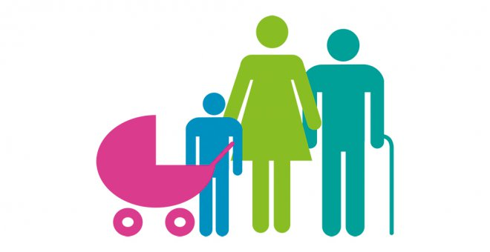

**Enrolment work**

**Task 1:** Fill in the table below outlining the main life stages and what happens in them

|  |  |  |
| --- | --- | --- |
| **Life stage** | **Age range** | **Brief description of what happens** |
|  | ____ - ____ |  |
|  | ____ - ____ |  |
|  | ____ - ____ |  |
|  | ____ - ____ |  |
|  | ____ - ____ |  |
|  |  |  |

Useful sources:

<https://prezi.com/3hx111llwlfz/6-life-stages/>

<https://www.pearsonschoolsandfecolleges.co.uk/FEAndVocational/HealthAndSocialCare/BTEC/BTEC-Firsts-Health-and-Social-Care-2012/Samples/BTECHSCRevisionGuideandWorkbook/Revise-BTEC-Health-and-Social-Care-Revision-Guide.pdf>



**Task 2**: Research what care values are. Make a list of Care Values describing what they mean

|  |  |
| --- | --- |
| **Care Value** | **Description** |
|  |  |
|  |  |
|  |  |
|  |  |
|  |  |
|  |  |
|  |  |

Write any sources you find useful below:

……………………………………………………………………………………………………………………………………………………………

……………………………………………………………………………………………………………………………………………………………

……………………………………………………………………………………………………………………………………………………………

……………………………………………………………………………………………………………………………………………………………

……………………………………………………………………………………………………………………………………………………………

……………………………………………………………………………………………………………………………………………………………