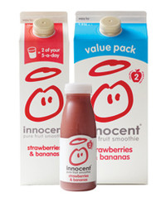****

# Lesson Objectives

* To introduce the Business Studies AS / 1st year linear course
* To introduce research skills
* To highlight the 4 assessment objectives: AO1, AO2, AO3, AO4.

**Activities**

*Firstly*, as a class watch [this film](http://estream.godalming.ac.uk/View.aspx?ID=3200~4f~EhD2uTCe) on Innocent Smoothies.

Duration: 30 mins. (E-Stream ID: 3200)

*Then*, answer the questions overleaf.

Use the following link to further your research of Innocent Smoothies.

<http://www.innocentdrinks.co.uk/us/our-story>

**Questions:**

1. What is unique about Innocent and its smoothies? **AO1, AO2**
2. How does Innocent promote its business? **AO1, AO2**
3. How did Innocent raise the necessary finance for its business venture?

**AO1, AO2**

1. Why does Innocent put jokes on its packaging and AstroTurf on its floors? **AO1, AO2, AO3**
2. Explain how Innocent can charge a high price for its products.

**AO1, AO2, AO3**

1. Discuss the extent to which the soft drinks industry is ethical.

**AO1, AO2, AO3, AO4**

Structure your argument in the following way:

3 arguments FOR the soft drinks industry being ethical

3 arguments AGAINST the soft drinks industry being ethical

Conclusions / Final decision with 2 justification points.