**Task 1: Using the table below fill in the advantages and disadvantages of the various types of production.**

|  |  |  |
| --- | --- | --- |
| **Production method** | **Advantages** | **Disadvantages** |
| **Job production** | **.**  **.**  **.**  **.**  **.** | **.**  **.**  **.**  **.**  **.** |
| **Batch production** | **.**  **.**  **.**  **.**  **.** | **.**  **.**  **.**  **.**  **.** |
| **Flow production** | **.**  **.**  **.**  **.** | **.**  **.**  **.**  **.** |

**Task 2: Read *From Rain to Sunshine* case study overleaf and answer the question below**

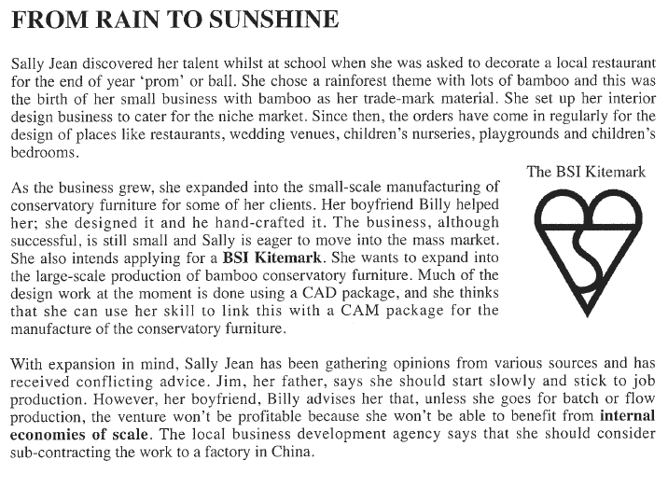

**QUESTION: Evaluate the suitability of job, batch and flow production methods for Sally Jean’s proposed new venture (10)**

**To do this:**

* + **analyse the advantages and disadvantages of using each method in Sally Jean’s business (specific application)**
  + **conclude your answer with a decision as to which is the most appropriate method, justifying your answer and considering short term vs long term impacts of choice**