**Business Essay Technique - Big Mac or Hamburger & Fries?**

Which two of these images represents the best format for an effective essay in the business exams?

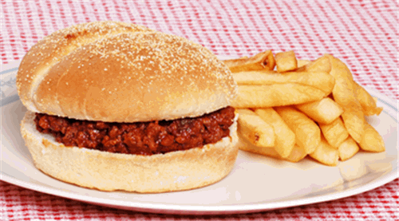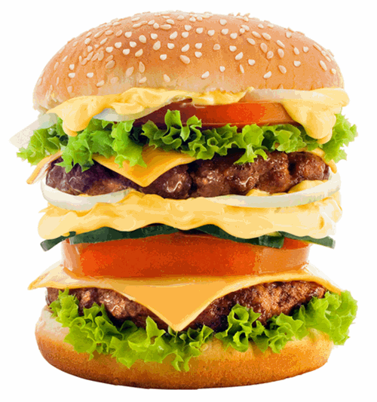First up we have an inviting plate containing a burger and some fries:

or perhaps the better option is this calorie-busting Big Mac-style option?

**The answer?  Go for the Big Mac every time.**

Think of your business essay answers as needing to be like a double or triple-layered burger.

The two halves of the bread bun are the vital **INTRODUCTION** and the **CONCLUSION**.  Without both parts of the bread bun, the burger falls apart.  **Without an effective introduction and, most importantly a strong conclusion, so too will your essay.**

The layers in the bread bun between are the well-constructed paragraphs which contain all the content (calories), analysis and evaluation. The contents inside your burger are determined by your ability to combine relevant business studies knowledge, real-life examples and discussion to create something appetising for the examiner.

Each layer is there for a purpose - it adds to the answer; it makes the burger taste even better and satisfying.  Some of the layers taste different too - in the same way that your paragraphs explore different approaches, arguments and options.  Sometimes a layer is just a bit of dressing, which leads onto another chunky part. But most importantly, each layer is an integral part of the burger.  Just as each paragraph is an integral and linked part of a well-constructed essay.

So what about that tempting plate of burger and fries.  Take a look at the burger.  Not enough meat.  There’s not enough content to make it appealing.  There’s only one layer too - how can that provide any contrast or argument?  And the fries?  The fries are just a side issue.  A bit like padding out an essay with irrelevant business theory, or simply repeating what you’ve learned from your lesson or revision notes.

There is no place in a good business essay answer for fries. Stick to the BURGER!