Harrison Business & Economics

EEL: Business Ethics

# What are business ethics? *Ethics are moral guidelines which govern good behaviour*

So behaving ethically is **doing what is morally right**

Behaving ethically in business is widely regarded as good business practice.

Ethical principles and standards in business:

* Define acceptable conduct in business
* Should underpin how management make decisions

An important distinction to remember is that behaving ethically is not quite the same thing as behaving lawfully:

* **Ethics** are about what is right and what is wrong
* **Law** is about what is lawful and what is unlawful

An ethical decision is one that is **both legal** and **meets the shared ethical standards** of the community.

Businesses face ethical issues and decisions almost every day – in some industries the issues are very significant. For example:

* Should businesses profit from problem gambling?
* Should supermarkets sell lager cheaper than bottled water?
* Is ethical shopping a luxury we can’t afford?

You will probably note the link between business ethics and **corporate social responsibility** (CSR). The two concepts are closely linked:

* A socially responsible firm should be an ethical firm
* An ethical firm should be socially responsible

However there is also a distinction between the two:

* CSR is about responsibility to all stakeholders and not just shareholders
* Ethics is about **morally correct behaviour**

How do businesses ensure that its directors, managers and employees act ethically? A common approach is to implement a **code of practice.** Ethical codes are increasingly popular – particularly with larger businesses and cover areas such as:

* Corporate social responsibility
* Dealings with customers and supply chain
* Environmental policy & actions
* Rules for personal and corporate integrity

Ethics in practice

You’ll find lots of examples of business ethical decisions and dilemmas in areas such as:

* Advertising
* Personal selling
* Business contracts
* Pricing
* Dealing with suppliers

Let’s take one of the above – *suppliers.*

A business cannot claim to be ethical firm if it ignores unethical practices by its suppliers – e.g.

* Use of child labour and forced labour
* Production in sweatshops
* Violation of the basic rights of workers
* Ignoring health, safety and environmental standards

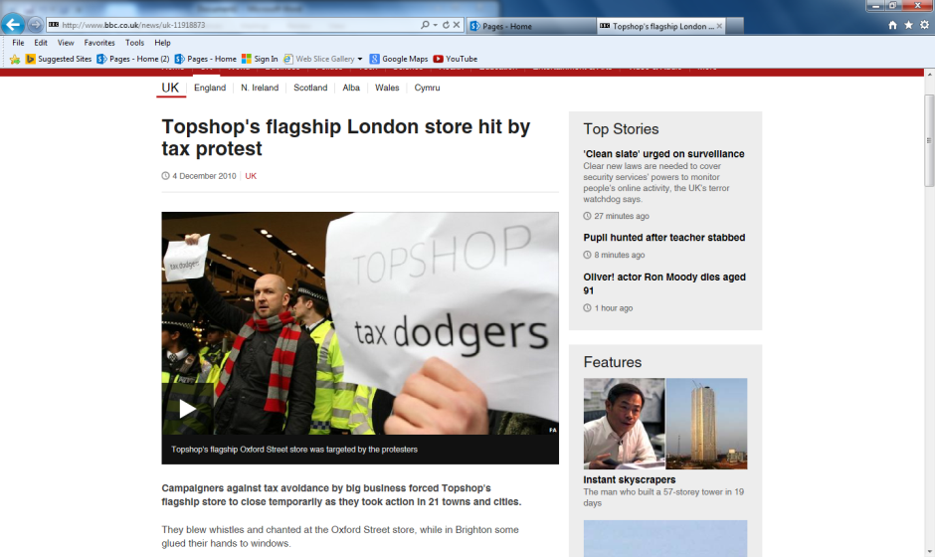An ethical business has to be concerned with the behaviour of all businesses that operate in the supply chain – i.e.

* Suppliers
* Contractors
* Distributors
* Sales agents

# Pressure for businesses to act ethically

Businesses and industries increasingly find themselves facing **external pressure** to improve their ethical track record. An interesting feature of the rise of consumer activism online has been increased scrutiny of business activities. Pressure groups are a good example of this. Pressure groups are external stakeholders they

* Tend to focus on activities & ethical practice of multinationals or industries with ethical issues
* Combine direct and indirect action can damage the target business or industry

**Direct consumer action** is another way in which business ethics can be challenged. Consumers may take action against:

* Businesses they consider to be unethical in some ways (e.g. animal furs)
* Business acting irresponsibly
* 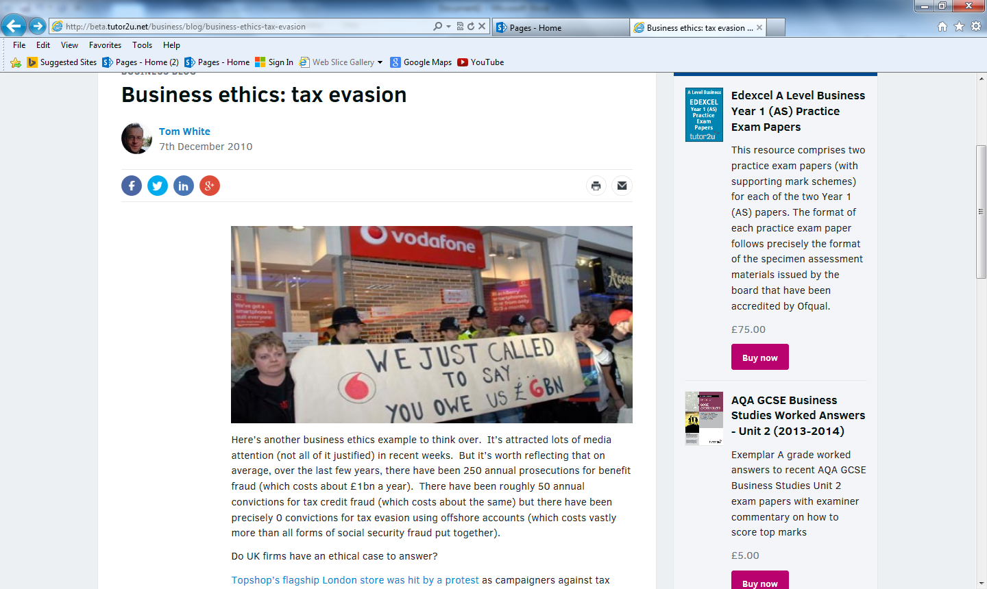Businesses that use business practices they find unacceptable

Consumer action can also be positive – supporting businesses with a strong ethical stance & record. A [good example of this is Fairtrade](http://www.fairtrade.org.uk/).

# Is ethical behaviour good or bad for business?

You might think the above question is an easy one for businesses to answer? Surely acting ethically makes good business sense? As with all issues in business studies, there are two sides to every argument:

**The advantages of ethical behaviour include:**

* Higher revenues – demand from positive consumer support
* Improved brand and business awareness and recognition
* Better employee motivation and recruitment
* New sources of finance – e.g. from ethical investors

**The disadvantages claimed for ethical business include:**

* Higher costs – e.g. sourcing from Fairtrade suppliers rather than lowest price
* Higher overheads – e.g. training & communication of ethical policy
* A danger of building up false expectations

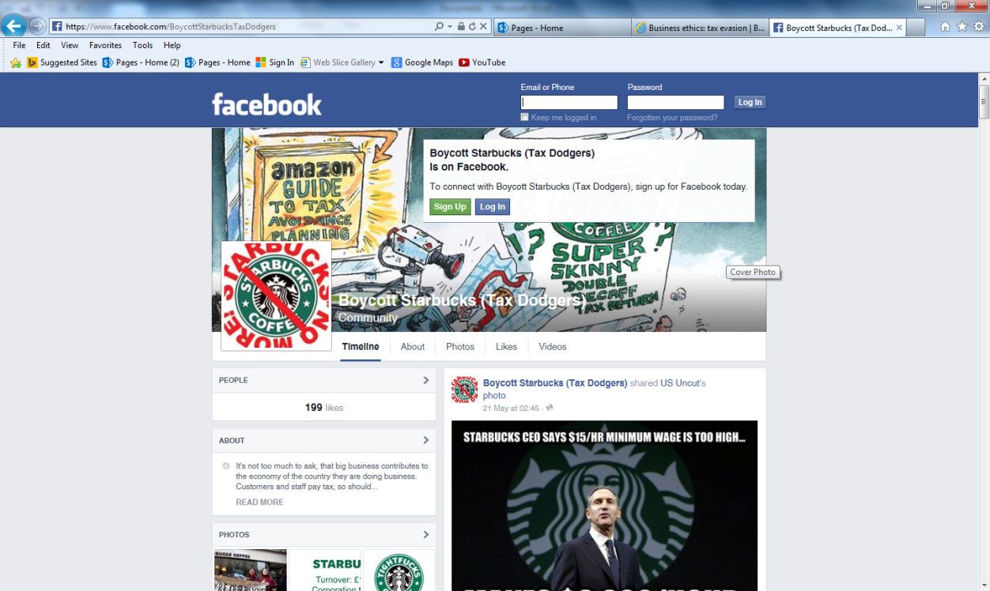

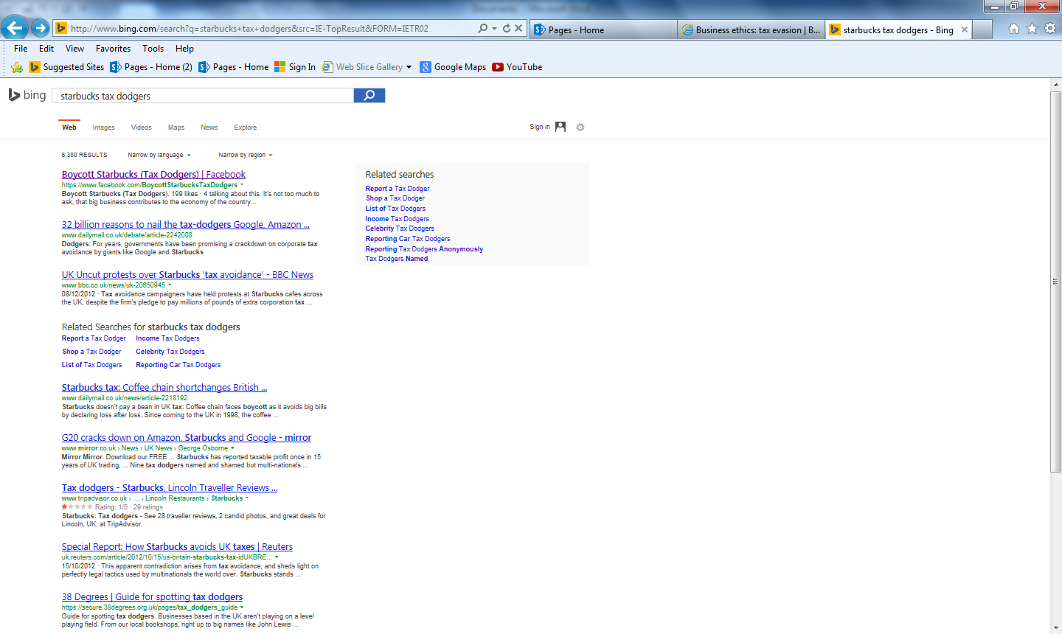

Source: Adapted from Yutor2u articles

***NOTES ON TYPES OF ETHICAL ISSUES***

**Explain, using examples, each of the ethical issues below**

**Use the exam board notes and lesson slides to help you**

|  |
| --- |
| **ANIMAL RIGHTS** |
| **TREATMENT OF WORKERS** |
| **TREATMENT OF SUPPLIERS** |
| **TREATMENT OF CUSTOMERS** |

***RESEARCH TASK***

|  |
| --- |
| **MY ORGANISATION IS:**  **THE TYPES OF ETHICAL ISSUES FACING IT ARE:**  **RESPONSES OF THE ORGANISATION:**  **OVERALL HOW SUCCESSFUL IT HAS BEEN AT DEALING WITH ETHICAL ISSUES:** |

|  |
| --- |
| [Image result for STARBUCKS](https://www.google.co.uk/url?url=https://en.wikipedia.org/wiki/File:Starbucks_Coffee_Logo.svg&rct=j&frm=1&q=&esrc=s&sa=U&ved=0ahUKEwibirym-vLMAhWKF8AKHfh1BZEQwW4IGDAB&usg=AFQjCNG28gqtmnpIItbJsaTI20mGGYG2rg) |

|  |
| --- |
| [Image result for BAT TOBACCO](http://www.google.co.uk/url?url=http://www.forbes.com/companies/british-american-tobacco/&rct=j&frm=1&q=&esrc=s&sa=U&ved=0ahUKEwiPqdvA-vLMAhUICMAKHbqOB74QwW4IGDAB&usg=AFQjCNGpegX9KQLoNWEBxjwEdSIdPg2xEQ) |

|  |
| --- |
| *ADD YOUR OWN NOTES HERE* |
|  |

|  |  |
| --- | --- |
| **MY UNETHICAL BUSINESS IS:**  **EXAMPLES OF ETHICAL OBJECTIVES**  **EXAMPLES OF UNETHICAL PRACTICES**  **POSSIBLE IMPACTS ON PROFIT** | **MY ETHICAL BUSINESS IS:**  **EXAMPLES OF ETHICAL OBJECTIVES**  **EXAMPLES OF ETHICAL PRACTICES**  **POSSIBLE IMPACTS ON PROFIT** |

|  |
| --- |
| [Image result for MONSANTO](http://www.google.co.uk/url?url=http://www.eatdrinkpolitics.com/2012/08/21/top-10-lies-told-by-monsanto-on-gmo-labeling-in-california/&rct=j&frm=1&q=&esrc=s&sa=U&ved=0ahUKEwiW85a1_PLMAhXTFsAKHdnWAXYQwW4IGjAC&usg=AFQjCNEbMXu32fV4mv0onT9f30uHRnxsng)WHO ARE MONSANTO? |

Ethics Case Study: Starbucks

# Coffee College – staff training (03.39)

<http://www.tutor2u.net/blog/index.php/business-studies/comments/a-great-example-of-off-the-job-training-starbucks-coffee-college>

# Schultz talks about creating a community around coffee: (start 11.35, End 14.17)

<http://www.tutor2u.net/blog/index.php/business-studies/comments/starbucks-up-close-and-personal-with-howard-schultz>

Key words / phrases

* *Ethical Sourcing, ethical behaviour*
* *Attract and retain great people*
* *Demonstrate to the customer, and to Wall Street*
* *Trying to share the profit with the people who grow the coffee*
* *Café practices: raise the quality of the bean and the market price increases*
* *40 years of projects in Africa (especially Rwanda)*
* *Build a company with a conscious*
* *Balance between profit and benevolence*

# CSR and Starbucks meet their Chief Community Officer (2.31)

<http://www.tutor2u.net/blog/index.php/business-studies/comments/csr-and-starbucks-meet-their-chief-community-officer>

# Starbucks brews up big tax breaks (3.47)

<http://www.tutor2u.net/blog/index.php/business-studies/comments/starbucks-brews-up-big-tax-breaks>

# Starbucks tax avoidance – ethical or legal issue? (2.53)

<https://www.youtube.com/watch?v=w-P3tovVapI>

ETHICS – ideas about what is morally correct or not

ETHICAL CODE OF PRACTICE – a statement about how employees in a business should behave in particular circumstances where ethical issues arise

Is the behaviour of Starbucks towards its stakeholders ethical or unethical?

Some, all, none and who decides?

|  |  |
| --- | --- |
| Stakeholder | Behaviour ethical or unethical, your views? |
| **Customers** |  |
| **Employees** |  |
| **Coffee Farmers** |  |
| **Dairy Farmers** |  |
| **Coffee machine suppliers** |  |
| **UK government** |  |
| **Competitors (e.g. Café Nero or Ma & Pa’s neighbourhood café)** |  |
| **Your choice** |  |
| **Your choice** |  |