Business

EEL: Business and the Environment

# What are the costs and benefits of business activity?

# When businesses produce and sell products or services it is relatively easy for them to see the costs involved and the benefits they will gain.

# These are known as PRIVATE COSTS (e.g. wages paid to employees, costs of advertising) and PRIVATE BENEFITS (e.g. Total revenue earned from sales, any resulting profit and the dividends paid to shareholders).

# However, businesses may also create SOCIAL COSTS due to EXTERNALITIES. Externalities occur when private costs are different to social costs and private benefits are different to social benefits.

# Social costs are made up of the private costs of the business plus NEGATIVE EXTERNALITIES (the costs to the rest of society).

# There may also be POSITIVE EXTERNALITIES which result from the business. It may create other jobs in the area. SOCIAL BENEFITS are the private benefits to business plus positive externalities (the benefits to the rest of society).

# There are obvious problems that result from negative externalities. Many externalities affect the environment

# Taken from HJR page 734

# Environmental Issues (negative externalities)

# Air pollution

# Water pollution

# Congestion and noise pollution

# Destruction of the environment

# Waste disposal

# Environmental pressures on firms

# Government intervention, activists and consumers can all pressure firms to be more environmentally friendly (e.g. to reduce emissions, to recycle, reduce waste etc.). This can:

# Affect the way the good or service is produced

# Affect what is produced

# Increase costs

# Prevent certain production processes/products

# Provide market opportunities e.g. for firms producing environmentally friendly goods

# NOTES ON TYPES OF ENVIRONMENTAL COSTS

**(Negative externalities)**

**Define /explain each environmental cost and provide examples**

|  |
| --- |
| **AIR POLLUTION** |
| **WATER POLLUTION** |
| **NOISE POLLUTION** |
| **CONGESTION** |
| **DESTRUCTION OF THE ENVIONMENT** |
| **WASTE DISPOSAL** |
| **CLIMATE CHANGE** |

# Controlling environmental costs

# Government regulation

# Environment Act 1995 (set up Environment Agency to monitor and control pollution)

# Air Quality Limit Values Regulations 2007 (sets targets for reductions in level of ozone in the air)

# Kyoto Protocol (agreement between countries to cut greenhouse gas emissions)

# Taxation

# Make firms pay for social costs of their activities

# Charge extra 5 pence to a firm for using ‘environmentally unfriendly’ packages

# UK government introduced, in 1990, a landfill tax

# Business charged extra for dumping waste in a landfill site

# Compensation

# Airport give grants to nearby residents for double glazing their windows

# Government subsidies

# Grant may be given to a business to build a recycling plant for plastics

# Councils encouraging use of bicycles.

# Road pricing and changes

# In 2005, Congestion Charge introduced to take cars into Central London

# Park and Ride schemes to reduce car use in city areas

# Pollution permits

# USA, EU – allows businesses to emit a certain amount of emissions

# Education: inform customers about pollution (e.g. anti-litter)

# Consumer pressure on firms

# Environmental audit (check amount of emissions produced by a business)

# Conservation

# Many businesses rely on using non-renewable resources (e.g. oil, iron, aluminium). Hence we could ban the use of some resources or use them sparingly (e.g. Marks and Spencer fishing cod)

# Recycling schemes – bottles, paper, aluminium

# Multilateral agreements – limits use of natural resources

# Government subsidies – encourage farmers to conserve countryside (maintain hedgerows)

# NOTES ON CONTROLLING POTENTIAL ENVIRONMENTAL COSTS

**GOVERNMENT INTERVENTION ACTIVITY:**

Research 3 government interventions.

Explain how each helps to control environmental costs.

**EDUCATION ACTIVITY:**

Research 2 education examples.

What is the purpose of the group/campaign/promotion?

How will it help to educate about environmental costs?

# Controlling potential environmental costs

**PRESSURE GROUPS:**

**What is a pressure group?**

* A pressure group is an organised group that seeks to influence government (public) policy or protect or advance a particular cause or interest.
* Groups may promote a specific issue and raise it up the political agenda or they may have more general political and ideological objectives in mind when they campaign.

**The effects of pressure groups on business**

Successful campaigns can lead to legal and ethical changes in business practice e.g.

* + The increasing practice of environmental audits by businesses
  + The movement to the use of synthetic fur in the fashion industry
  + The compulsory use of seat belts
  + The decrease in the use of CFCs

**PRESSURE GROUP ACTIVITY**

Investigate 2 environmental pressure groups from the following list:

* Greenpeace
* Friends of the Earth
* Environmental Welfare Group
* Amazon Watch
* Countryside Alliance
* Compassion in World Farming

1. Outline what type of pressure group they are.
2. the type of action they take (e.g. direct/indirect, include specific examples)
3. Explain the influence/effect these groups have had on businesses/government.

**PRESSURE GROUP 1:**

Continue over page

**Pressure Group 2:**

# BUSINESS RESPONSE TO ENVIRONMENTAL ISSUES

# Marketing

# Companies use environmental policies as part of their marketing campaigns (e.g. Body Shop)

# Finance

# Being environmentally friendly can lead to cost savings (energy savings)

# Could increase costs too: introducing new machinery would decrease CO2 production levels, but there are introduction costs.

# Operations Management

# Pollution controls will affect how a product is made eg. May change raw materials used, production methods and after-sales service

# HR

# Staff need to be recruited and trained to comply with environmental regulations.

# Tensions between financial targets and meeting environmental targets may arise.

**Be a sustainable business**

* For many businesses, going 'green' is a lot more than a popular trend. It's part of a strategy to improve business sustainability.
* Sustainable businesses seek to minimise negative environmental and social impacts and ensure that future generations will have adequate resources to meet their needs.
* Becoming a sustainable business is not only good for the environment but can also enhance the competitiveness and reputation of a business.

# Top 10 sustainable businesses 2017

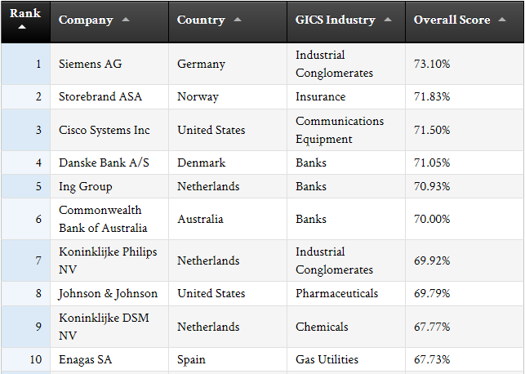

**Environmental Case Study: McDonalds

*Evaluate the impact on a business of implementing environmentally friendly policies*

You need to research and prepare a short presentation (around 5 minutes) on ONE of the topics below. The presentation should include answers to the following questions:

1. How could McDonalds be said to have a negative environmental impact in relation to your topic area?
2. What positive environmental policies do McDonalds have in place (relating to your topic)?
3. Can McDonalds’ environmental impact easily be quantified in monetary terms (£s)?
4. Analyse whether environmental impact is important to McDonalds. Give reasons for your answer: you may want to consider McDonalds’ stakeholders e.g. suppliers, consumers, employees, shareholders, the Government
5. *[Optional]* If you were McDonalds, what would you do differently?

**Topics**

* Packaging and waste at McDonalds
* Beef supply at production at McDonalds
* Energy and water use at McDonalds
* Litter and recycling at McDonalds

**Some links to help you get started**

<http://www.aboutmcdonalds.com/mcd/sustainability/library/policies_programs.html>

<http://www.guardian.co.uk/sustainable-business/blog/environmental-impact-on-the-balance-sheet>

<http://www.mcdonalds.co.uk/ukhome/Ourworld/Environment.html>

<http://www.greenbiz.com/blog/2012/04/30/can-mcdonalds-lead-green>

<http://www.youtube.com/watch?v=ut3URdEzlKQ>

What is the impact on stakeholders of a business like McDonalds trying to reduce the effect of its activities on the environment?

|  |  |
| --- | --- |
| Stakeholder | Impact |
| **Customers** |  |
| **Employees** |  |
| **Farmers (i.e. suppliers)** |  |
| **Investors** |  |
| **Local communities** |  |
| **Competitors (e.g. Burger King, KFC)** |  |
| **Your choice** |  |
| **Your choice** |  |

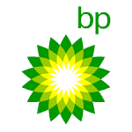Environmental Case Study: BP

*Evaluate the impact of business activity on the environment*

Watch the video BP: $30 Billion Blowout video on Estream and make notes around the following:

**Environmental costs:**

**Controlling environmental costs:**

**BP’s response to the environmental issues:**

**Impact on stakeholders:**