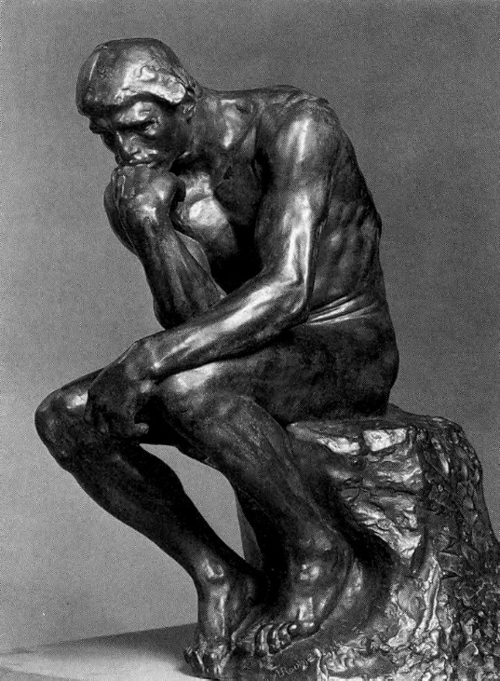50:50 Expectations for Lower Sixth **History of Art**

Welcome to the departmental and congratulations on finding this wonderful subject!

We have a mass of evidence to prove that the more you put in to your studies, the more you will get out: both in terms of enjoyment and results. Therefore, we would strongly encourage you to make the most of every opportunity you get.

1. **Books/podcasts/GOL**

There is a good selection of books both in our teaching room (413) and in the college library (ILC). Please use these on a weekly basis to consolidate and extend your knowledge and understanding as we go through the course. You can also access a huge range of films via e-stream (both in college and from home if you have a good wi-fi connection) and we will recommend good podcasts to support your learning too.

1. **Key work booklets (estimated 2 hours)**

As this is a two year course, it is vitally important that you maintain clear and coherent notes for each of your key works in each module. We have prepared a series of key work booklets and you will be expected to complete one of these each week for both sides of the course. Please ensure that these are filled in to the very best of your ability: you won’t want to revise from them if they are a mess or incomplete.

1. **Thought for the Week (estimated 1 hour)**

Each week we send you a blog round up of current topics relevant to our field by e-mail. We include 1 to watch (a TV, film or podcast) 1 to see (an exhibition) and 1 to read (an article or book chapter) with appropriate links. Although these may not link to the specific key work being studied that week, they are fundamental to your broader understanding of the field, the career and life opportunities this subject offers and to your development as an individual.

1. **Class preparation/consolidation (estimated 2 hours)**

Each week, we will both set tasks to be completed within the week. It is essential that you always complete these on time. This work will vary between research, writing and practical tasks but all are designed to build the community of learners as well as to maximise your individual progress. If you fail to do the assigned work, you will be unable to participate fully in our discussions: holding back yourself and your peers – not to mention our very tight marking schedules (think landing slots at Heathrow!) Your consistent cooperation is very much appreciated.