Ben Nicholson Examples

Start with simple shapes – white with a shadow Add sections of colour

[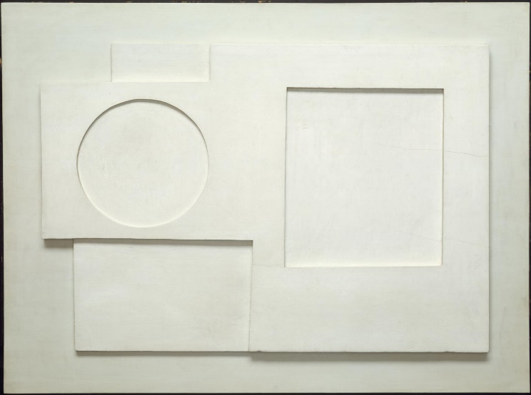](https://www.google.co.uk/url?sa=i&rct=j&q=&esrc=s&source=images&cd=&cad=rja&uact=8&ved=2ahUKEwiI0t240NPdAhXrCcAKHbKGCtYQjRx6BAgBEAU&url=https%3A%2F%2Fwww.tate.org.uk%2Fart%2Fartworks%2Fnicholson-1934-relief-t02314&psig=AOvVaw2beJtdMyJnPFqwAiejakzH&ust=1537877947374888)**[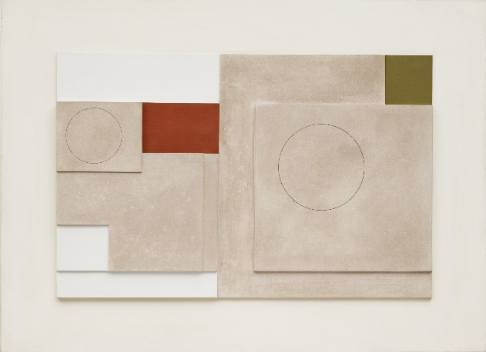](https://www.google.co.uk/url?sa=i&rct=j&q=&esrc=s&source=images&cd=&cad=rja&uact=8&ved=2ahUKEwj78Jas0NPdAhVL1hoKHVEzBgUQjRx6BAgBEAU&url=https%3A%2F%2Fwww.moma.org%2Fcollection%2Fworks%2F82050&psig=AOvVaw2beJtdMyJnPFqwAiejakzH&ust=1537877947374888)**

Add more structured formations to this design – small sections of colour

[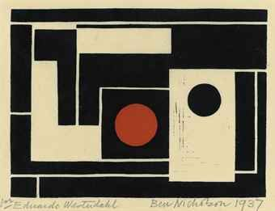](http://www.google.co.uk/url?sa=i&rct=j&q=&esrc=s&source=images&cd=&cad=rja&uact=8&ved=2ahUKEwiq2MzF0NPdAhVCyoUKHYtbB9YQjRx6BAgBEAU&url=http%3A%2F%2Fwww.findartinfo.com%2Fenglish%2Fart-pictures%2F4%2F144%2F1%2FLinocut%2Fpage%2F267.html&psig=AOvVaw2beJtdMyJnPFqwAiejakzH&ust=1537877947374888)

More organic shapes using the pen tool – add textures and sections of colour against muted undertones

[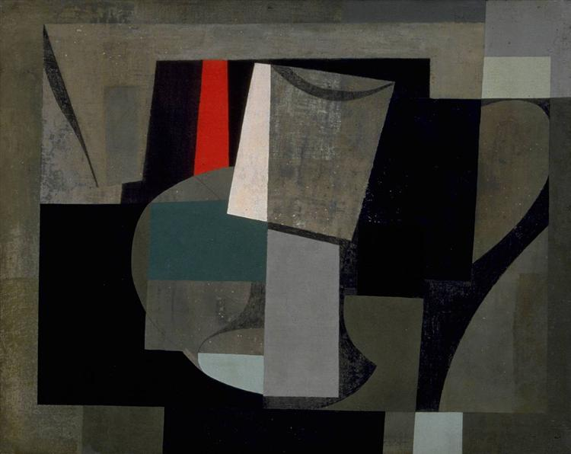](https://www.google.co.uk/url?sa=i&rct=j&q=&esrc=s&source=images&cd=&cad=rja&uact=8&ved=2ahUKEwi48dmh0NPdAhVDaBoKHX83AS4QjRx6BAgBEAU&url=https%3A%2F%2Fwww.cornwalls.co.uk%2Fhistory%2Fpeople%2Fben_nicholson.htm&psig=AOvVaw2beJtdMyJnPFqwAiejakzH&ust=1537877947374888)[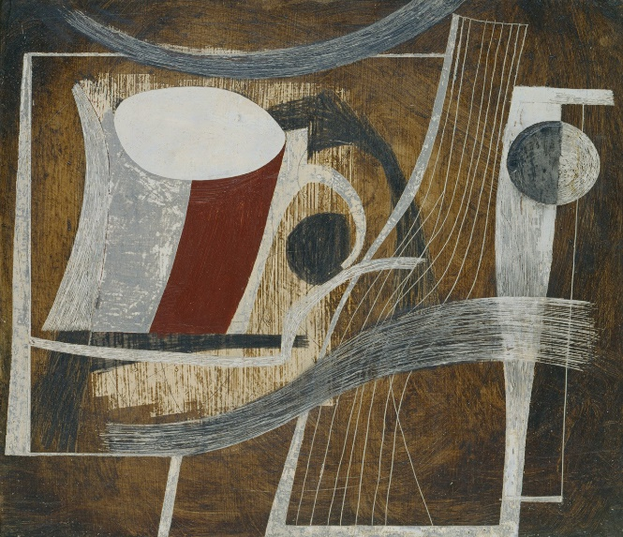](https://www.google.co.uk/url?sa=i&rct=j&q=&esrc=s&source=images&cd=&cad=rja&uact=8&ved=0ahUKEwi95Oevx8rWAhVHlxoKHfO2CrYQjRwIBw&url=https://www.guggenheim.org/artwork/artist/Ben-Nicholson&psig=AFQjCNE3bQWE59hOg59hqvdnd4HgGzpUHA&ust=1506779976346860)[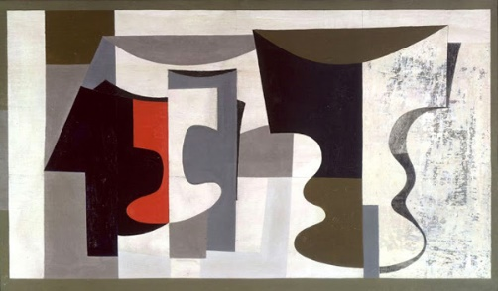](http://www.google.co.uk/url?sa=i&rct=j&q=&esrc=s&source=images&cd=&cad=rja&uact=8&ved=2ahUKEwiq2MzF0NPdAhVCyoUKHYtbB9YQjRx6BAgBEAU&url=http%3A%2F%2Fwww.arte-essentia.eu%2Fcreative-blog-artifacts%2Ftag%2Fcornwall%2F&psig=AOvVaw2beJtdMyJnPFqwAiejakzH&ust=1537877947374888)