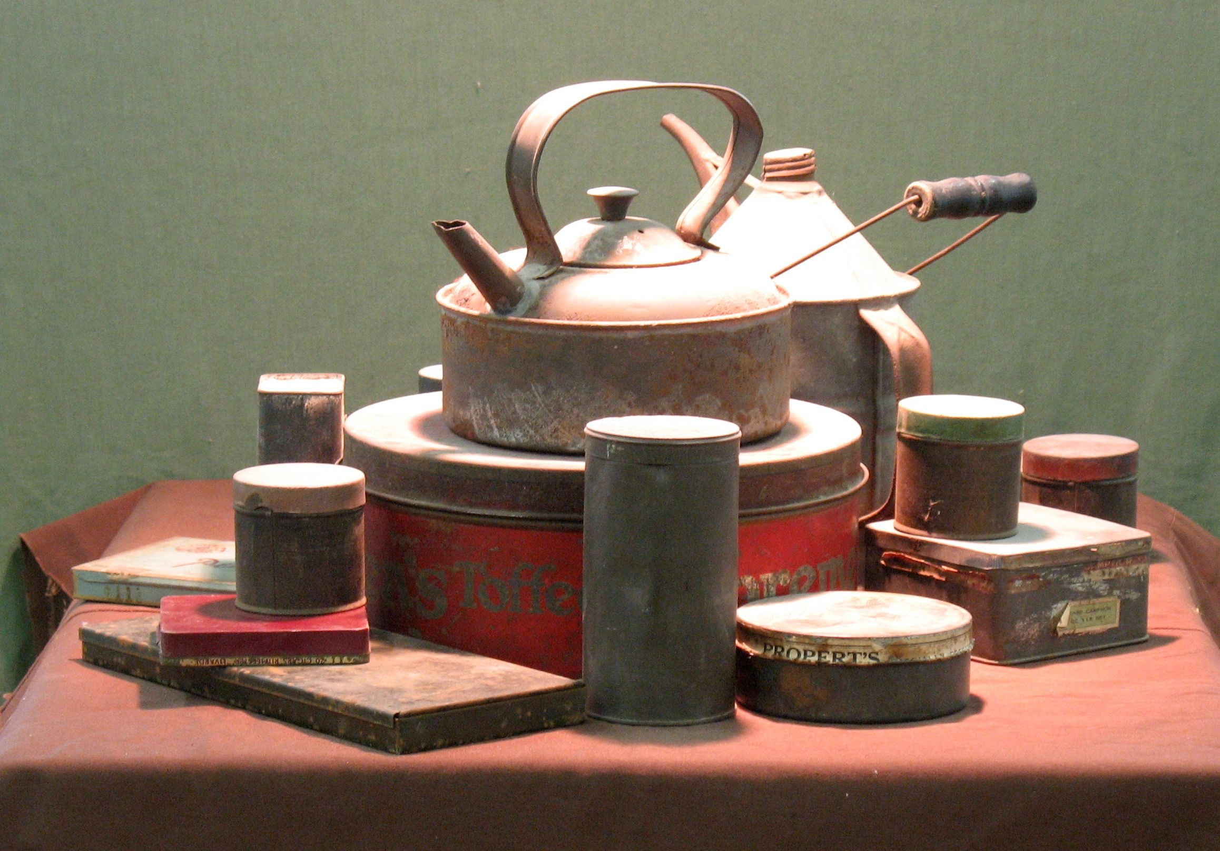

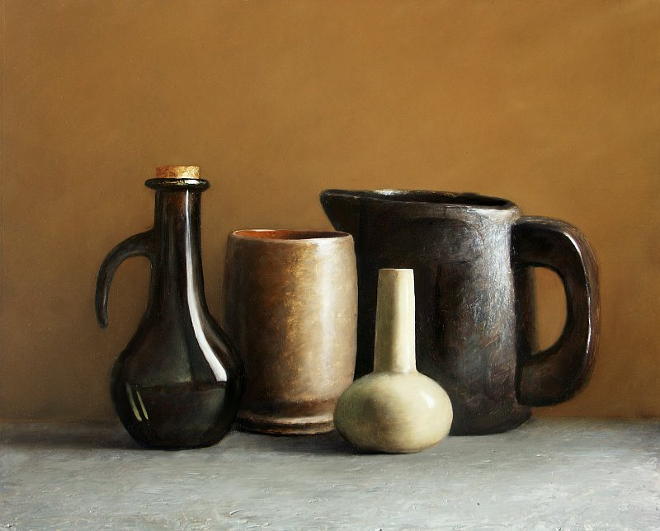

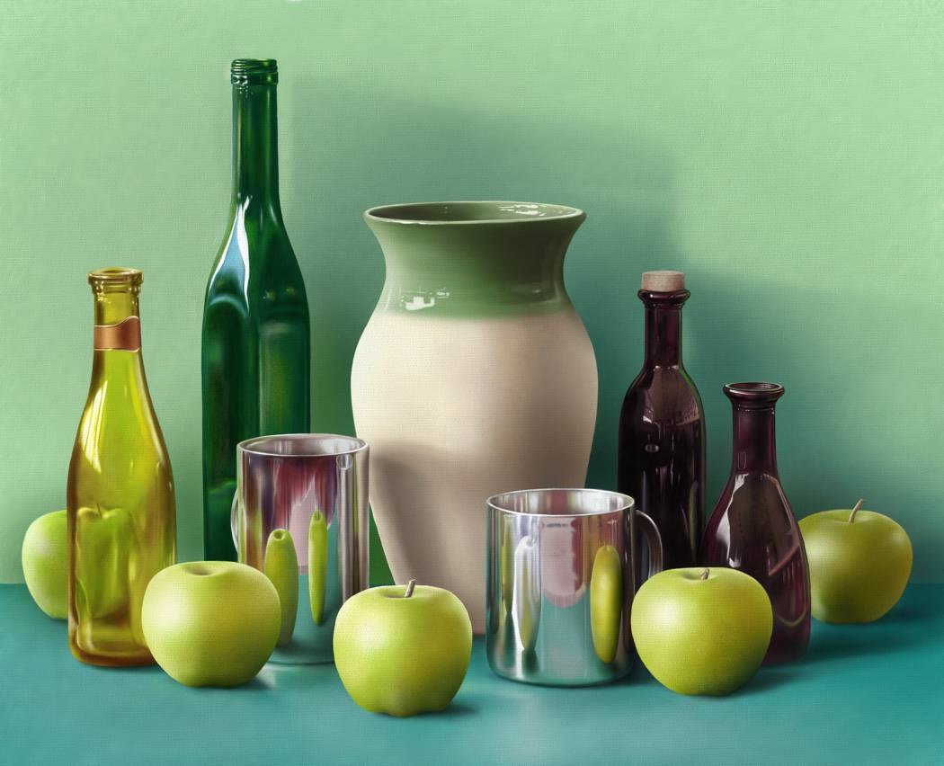

[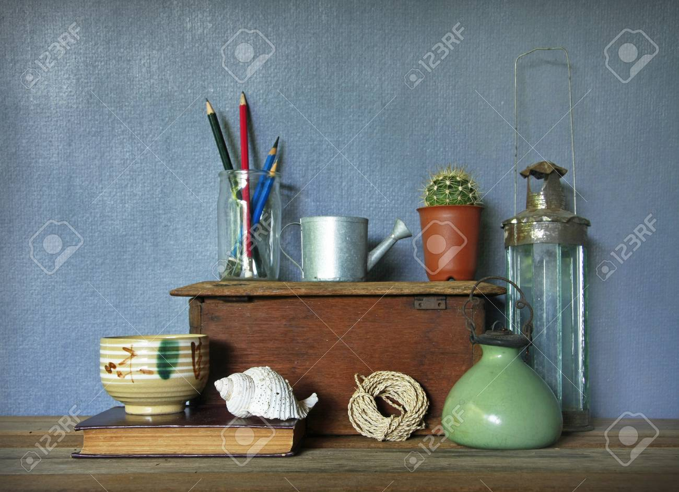](https://www.google.co.uk/url?sa=i&rct=j&q=&esrc=s&source=images&cd=&cad=rja&uact=8&ved=2ahUKEwiFkvm_hfjkAhULHxoKHUzYAVgQjRx6BAgBEAQ&url=https%3A%2F%2Fwww.123rf.com%2Fphoto_40835128_still-life-with-tea-cup-and-vintage-objects-on-wooden-table-.html&psig=AOvVaw1GswAziLCyiB1M9SvOOiaH&ust=1569915573484334)

[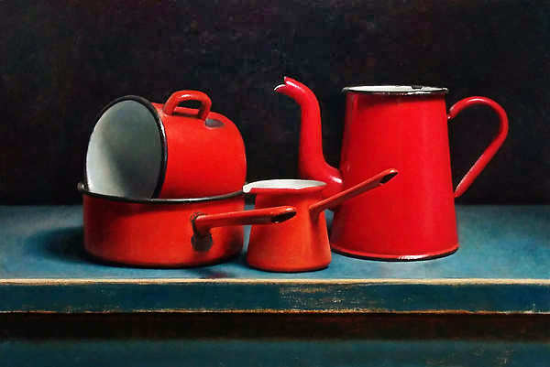](http://www.josvanriswick.com/images/rode-kannen-emaille.jpg)