TITLE OF ARTICLE??
By Richard Partington, Economics Correspondent for the Guardian – Wednesday 28th August

Boris Johnson is heading into the crunch period for Brexit negotiations with the UK economy potentially on the brink of recession and as global economic growth falters, according to a Guardian analysis of economic news over the past month.  The prime minister faces the challenge of breaking the deadlock with Brussels to avoid a no-deal Brexit on Halloween, just as the outlook for the economy deteriorates at home and abroad.  The latest phase of talks came as Britain recorded the first fall in quarterly GDP since 2012 and as Donald Trump engages the US in a trade war with China, dragging down global trade volumes and economic growth. | 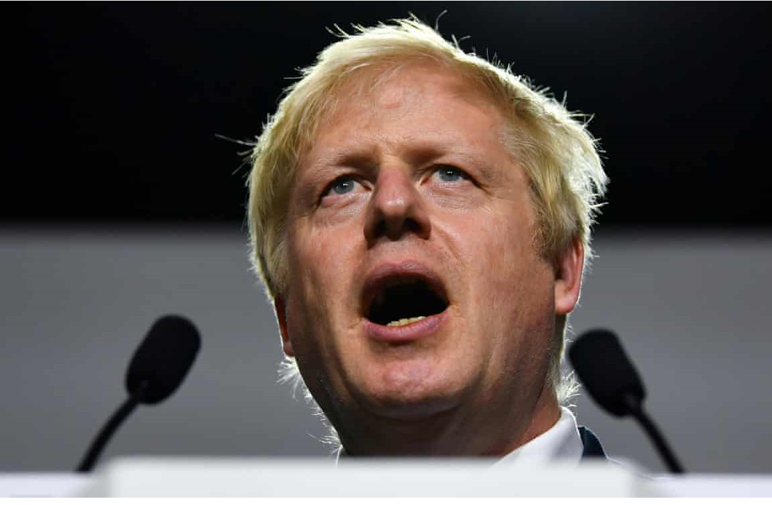  A no-deal Brexit under Boris Johnson would coincide with weaker global demand. Photograph: Dylan Martinez/Reuters

Economists warned that the wider global slump raised the chances of a prolonged downturn in Britain and made it more difficult for the UK to rely on trade with other nations to boost the economy after leaving the EU.

Writing in the Guardian, David Blanchflower, a former member of the Bank of England’s monetary policy committee (MPC), said the UK’s withdrawal from the EU “couldn’t have come at a worse time” as the world economy slows. “Businesses remain largely unprepared for a disastrous cliff-edge no deal and are in sit-and-wait mode while business groups continue to speak out against the economic chaos,” he added.

To gauge the impact of Brexit on a monthly basis, the Guardian monitors eight economic indicators, along with the value of the pound and the performance of the FTSE 100. City economists made forecasts for seven of those barometers before their release, and in four cases the outcome was worse than expected. Three beat the forecasts.

This month there were some bright spots as consumers continued to prop up the UK economy by raising their spending, helped by record employment levels, a relatively steady inflation rate and rising wage growth. Concerns still remain however with the high level of household and business debt.

Despite expectations of a downturn in sales volumes, consumer spending rose last month by 0.2% from June. UK workers’ average pay packets also rose at the fastest rate in 11 years, according to figures from the Office for National Statistics.

Unemployment rose slightly to 3.9% in a sign that weaker economic growth and the rising risk of a no-deal Brexit could be starting to have an impact on the job market, although the jobless rate still remains at the lowest level since the mid-1970s.

Despite the pockets of strength for Britain, the economy plunged into reverse in the second quarter for the first time since 2012. Brexit uncertainty, car plant shutdowns and companies running down their stockpiles built up before the original 29 March deadline led GDP to shrink by 0.2% in the three months to the end of June. Two consecutive quarters of falling GDP – which could only be confirmed after Britain has left the EU when official figures are published in November – are regarded by economists as the definition of a technical recession.

Johnson has begun to increasingly brace the UK economy for no-deal Brexit, ramping up public spending by £2.1bn on preparations including stockpiling of medicines, an extra 500 border officials and a public awareness campaign about disruption. However, the latest snapshot from the public finances showed the prime minister is likely to overshoot the government’s budget target for the year by about £8bn, as he increases public borrowing.

Stock markets have been plunged into a tailspin over the past month amid a rise in trade protectionism around the world, which could spell trouble for the UK seeking trade deals outside the EU, analysts said. According to surveys compiled by the research firm IHS Markit from businesses in 44 countries accounting for about 89% of global GDP, world manufacturing output has plunged into recession territory as the US-China trade war weighs on export demand.

Writing in the Guardian, Andrew Sentance, a former member of the MPC, said rising trade tensions were making the climate for British exporters more difficult as the UK prepares to leave the EU.

“The risk of no deal and the uncertainty surrounding Brexit more generally is likely to continue to be a drag on investment and trade. So we are likely to see a growing imbalance in the UK economy alongside very weak growth,” he added.

