BTEC Health and Social Care Name………………………………………………….

Unit 1: Human Lifespan Development

**A: Human Growth and Development through the Life Stages** [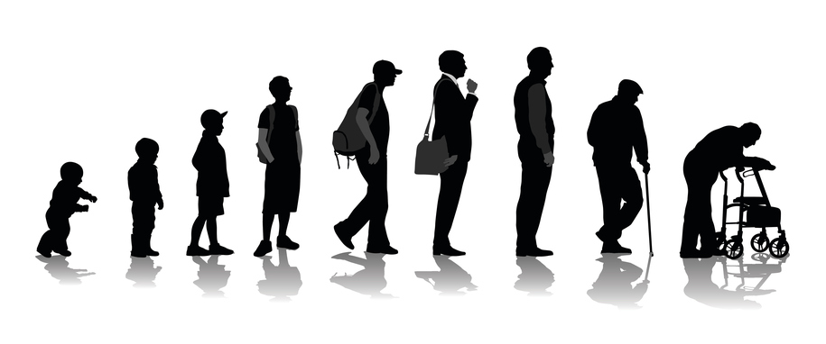](https://www.google.co.uk/url?sa=i&rct=j&q=&esrc=s&source=images&cd=&ved=2ahUKEwjDsJWEj7fkAhVNfMAKHbuyA-EQjRx6BAgBEAQ&url=https%3A%2F%2Fwww.become.co%2Fblog%2Funderstanding-key-changes-business-life-cycle%2F&psig=AOvVaw3X0cuHT0sYCX8pLxQiMz6u&ust=1567684712619669)

Contents

A1: Physical Development across the Life stages 2

Principles of Growth: 2

Principles of Development 4

Physical Development in Infancy (0-2 years) 5

Physical Development in Early Childhood (3-8 years) 6

Physical Development in Adolescence (9-18 years) 8

Physical Development in Early Adulthood (19-45 years) 10

Physical Development in Middle Adulthood (46-65 years) 11

Physical Development in Later Adulthood (65+) 13

A2: Intellectual Development across the Life Stages 14

Stages of Intellectual Development across the Lifespan 14

Intellectual and Language Skills in Infancy and Early Childhood 15

Piaget’s Theory of Intellectual Development (how children develop logical and reasoning) 16

Chomsky’s Model of Language Acquisition 20

Intellectual Development across Adulthood and Later Adulthood 21

A3: Emotional Development across the Life Stage 23

Attachment 23

Theories of Attachment: Bowlby 23

Schaffer and Emerson’s Sequence of Attachment Stages 24

Factors Affecting Whether an Attachment is Made Easily 25

Mary Ainsworth Types of Attachment 27

The Development and Importance of Self-Concept 29

What is self-concept? 29

How is self-esteem developed? 29

A4: Social Development across the Life Stages 33

The stages of play in infancy and early childhood 33

The Importance of Friendships and Friendship Groups 35

The Development of Social Relationships: 37

Development of independence 38

# A1: Physical Development across the Life stages

Why do you think people grow and develop differently?

**Growth:**…………………………………………………………………………………………………………………………………………….

………………………………………………………………………………………………………………………………………………………….

**Development: :**…………………………………………………………………………………………………………………………………

………………………………………………………………………………………………………………………………………………………….

## Principles of Growth:

………………………………………………………………………………………………………………………………………………………….

………………………………………………………………………………………………………………………………………………………….

………………………………………………………………………………………………………………………………………………………….

………………………………………………………………………………………………………………………………………………………….

………………………………………………………………………………………………………………………………………………………….

Sarah is a 1 year old girl who is developing normally. Her health visitor has come to visit her for a one year check. When she was born, Sarah weighed around 3kg, the health visitor finds that she now weighs 9kg. Sarah’s mother mentions that Sarah has recently begun to use words such as ‘dada’ and ‘moo,’ the health visitor says that this is normal language development and Sarah won’t move on to two-word phrases until around 2 years old. Next, the health visitor measures Sarah and finds that she is 74cm long; the health visitor reassures Sarah’s mother that this is normal for her weight and age. Finally, the health visitor gives Sarah some toys to play with and monitors her abilities; Sarah can build a tower with three blocks, point to a picture of a sheep in a book and can sit herself up after lying down.

How has Sarah…

|  |  |
| --- | --- |
| Grown? | Developed? |
|  |  |

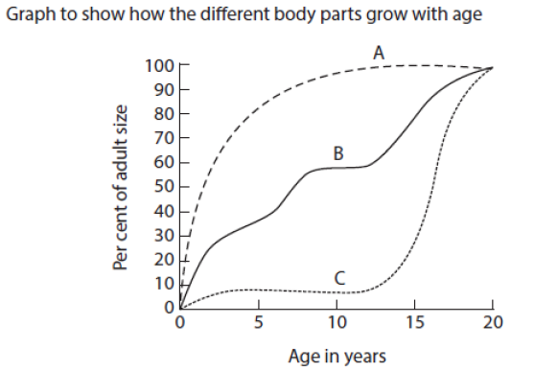Which part of the body is illustrated by lines A, B and C on the graph?

A____________________________________

B____________________________________

C____________________________________

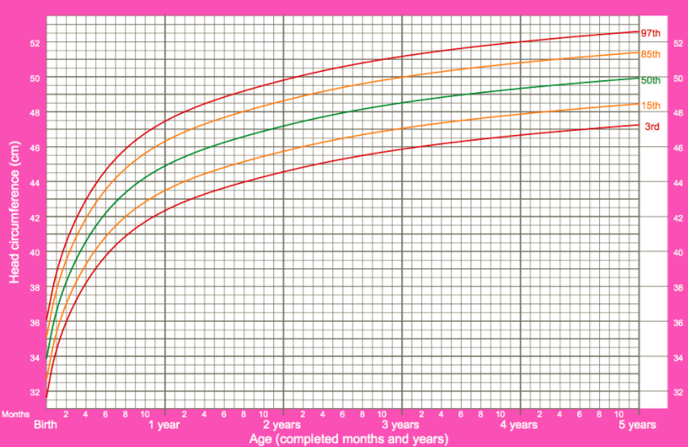

1. Using the graph above answer the following questions:
2. Ella is 1 year 2 months old. She is on the 50th centile line of growth. What is her head circumference? ______________________________
3. Josie is 3 years old and her head circumference is 50cm.

What centile line of growth is she on? _______________________________

What does this mean? ________________________________________________________

___________________________________________________________________________

## Principles of Development

Milestone………………………………………………………………………………………………………………………………………..

………………………………………………………………………………………………………………………………………………………..

Developmental norm ……………………………………………………………………………………………………………………..

………………………………………………………………………………………………………………………………………………………..

How people develop can fit into 4 different categories:

………………………………………………………………………

………………………………………………………………………

………………………………………………………………………

………………………………………………………………………

## The Life Stages

|  |  |  |
| --- | --- | --- |
| Life Stage | Age Range | Key features |
|  |  |  |
|  |  |  |
|  |  |  |
|  |  |  |
|  |  |  |
|  |  |  |

## Physical Development in Infancy (0-2 years)

|  |  |
| --- | --- |
| **Gross Motor Skills Definition** | **Fine Motor Skills Definition** |
|  |  |

### Gross and Fine Motor Skill Developmental Milestones

|  |  |  |
| --- | --- | --- |
| Age | Gross Motor Skills | Fine Motor Skills |
| Newborn |  |  |
| 1 month |  |  |
| 3 months |  |  |
| 6 months |  |  |
| 9-10 months |  |  |
| 12-13 months |  |  |
| 18 months |  |  |
| 2 years |  |  |
| 2.5 years |  |  |

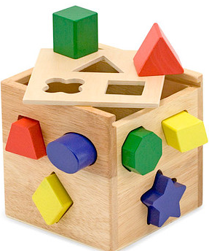Question: How can this toy help improve both gross and fine motor skills for an infant?

|  |
| --- |
|  |
|  |
|  |
|  |

## Physical Development in Early Childhood (3-8 years)

Children continue to grow and put on weight during this life stage.

Gross and Fine Motor Skill Developmental Milestones

|  |  |  |
| --- | --- | --- |
| Developmental Milestone | Age | Gross or Fine Motor Skill? |
| Skip |  |  |
| Ride a 2 wheeled bike |  |  |
| Use a knife and fork |  |  |
| Walk along a thin line |  |  |
| Use joined up handwriting |  |  |
|  |  |  |
|  |  |  |
|  |  |  |
|  |  |  |
|  |  |  |
|  |  |  |
|  |  |  |

Exam style question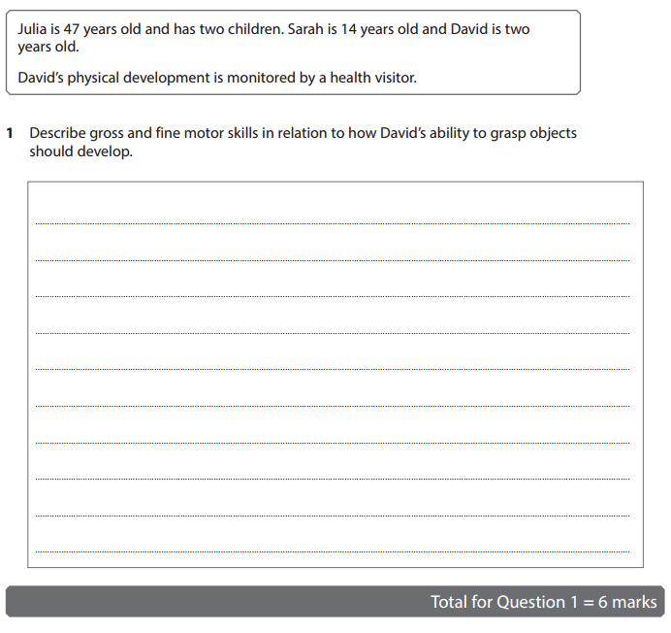

(6 marks)

## Physical Development in Adolescence (9-18 years)

Getting you thinking…

Adolescence is often defined as a period of transition- why do you think this is?

|  |
| --- |
|  |
|  |

How could we define **‘puberty**?’

|  |
| --- |
|  |
|  |
|  |
|  |

### Primary Sexual Characteristics are…

|  |  |
| --- | --- |
| Males | Females |
|  |  |

### Secondary Sexual Characteristics are…

|  |  |
| --- | --- |
| Males | Females |
|  |  |

### The Role of Hormones in Puberty

Females Males



## Physical Development in Early Adulthood (19-45 years)

Young adults are usually at the peak of their physical performance between the ages of 19-28 years old. By this time they are at their full height and strength and have peaked in terms of manual dexterity and reaction time. After this age, adults lose some strength and speed but these declining capabilities are only exacerbated if the adult does not have a healthy diet or take regular exercise.

One of the biggest physical changes in this life stage is pregnancy….

What hormonal changes occur during pregnancy?

|  |
| --- |
|  |

How does the body change during pregnancy?

|  |
| --- |
|  |
|  |
|  |
|  |
|  |
|  |

Challenge: Can you think of specific changes to the breasts? (Hint: They are needed for lactation.)

|  |
| --- |
|  |
|  |
|  |

### Perimenopause

What is the perimenopause?

What are the symptoms?

## Physical Development in Middle Adulthood (46-65 years)

### Menopause

Women are most fertile (able to conceive children) in their late teens and early twenties. The risk of miscarriage and pregnancy complications rises with age. Between 45-55 years old age, fertility reduces and then comes to an end in a process called the menopause. It can take several years to complete.

The menopause involves:

* Gradual ending of menstruation (or stopping having periods) and a large reduction of fertile eggs in the ovaries.
* An increase in the production of hormones called gonadotropins that try to stimulate egg production, which can cause irritability, hot flushes and night sweats.
* A reduction in the sex hormones (oestrogen and progesterone) produced by a woman’s ovaries, resulting in some shrinkage of sexual organs and sometimes reduction in sexual interest (libido.)
* Associated problems such as osteoporosis, which can be caused by a reduction in the production of sex hormones.

For some women, the general hormone changes, especially reduction in oestrogen levels experienced during the perimenopause and menopause, can lead to mood changes, depression and anxiety. This can make a woman feel that she is on an emotional rollercoaster. Some women experience overwhelming sadness that they are no longer able to have children and this can affect their self-image of being a ‘desirable’ woman. Self-esteem and self-image can become low, which may impact on self-confidence and the quality of life during this transitional stage of the lifespan. Some women may try hormone replacement therapy (HRT) where oestrogen is prescribed in order to replace the decline and relieve the symptoms.

Task:

1. Read through the information above- highlight or underline any key terms.
2. The information concerns how menopause affects women physically and emotionally- use notes in the margin/highlighters/underlining to show which information concerns which area of development.

Challenge:

How is menopause different to perimenopause?

|  |
| --- |
|  |
|  |
|  |
|  |

### Other effects of the aging process in middle adulthood:

1._________________________________________________________________________________

2. _________________________________________________________________________________

3._________________________________________________________________________________

4._________________________________________________________________________________

Example Exam Question Responses for Peer Marking

Question: Describe 3 physical symptoms of perimenopause (6 marks)

|  |  |
| --- | --- |
| Student 1 | Student 2 |
| Hot flushes due to a hormonal imbalance in the body can cause the metabolism to increase causing the woman to feel hot frequently when others feel that it is cold. She may feel that her body temperature rises and in the night may experience sweating known as night sweats.  Fatigue; this is when the muscles become overtired and can no longer keep going without more energy. She may feel that she needs to rest more and find everyday tasks exhausting. It is known as crashing fatigue and is caused by changes in the hormonal balance.  Julie will also experience urinary urgency, needing to empty her bladder more frequently. She may also find that her bladder leaks when she coughs or sneezes. | When a woman starts to feel the physical symptoms of perimenopause she may find that she feels fatigue all of the time and she has no energy to work or do anything because she feels drained all the time.  Another symptom is mood swings. This will be confusing for a woman as she may be happy one minute and then angry or sad the next minute.  Another symptom of perimenopause is vaginal dryness so when she wants to have fun in bed with her partner or whatever she will find it uncomfortable. To this extent she may stop doing this activity and do other things instead, this could lead to her avoiding sex altogether. |
| Mark out of 6: | Mark out of 6: |
| Comment/Suggestion for improvement: | Comment/Suggestion for improvement: |
| Examiner’s mark and comment: | Examiner’s mark and comment: |

## Physical Development in Later Adulthood (65+)

It is difficult to predict development in old age because, as life expectancy has risen, people’s ideas about what is ‘old’ are also changing. Life expectancy is an estimate of the number of years, on average, that a person can expect to live. It is sometimes called longevity. Male life expectancy has risen however it is still lower than female life expectancy.

### Deterioration of Health

Most body systems continue to function fairly well however, the heart becomes more susceptible to disease. Individuals may begin to lose height in middle adulthood which continues into later life. By the age of 80, individuals may have lost as much as 5cm in height. This is caused by changes in posture and compression of the spinal discs and joints. The aging process also continues with further loss of strength and muscle loss, as well as a reduction in stamina. Mobility (gross motor skills) and dexterity (fine motor skills) become more difficult. There are small changes to the brain which include loss or shrinkage of nerve cells and a general slowing of movement and responses. Visual and hearing problems may interfere with daily life. Older people can be more susceptible to accidents and falls due to a lack of muscular strength and problems with balance or reaction time. However, not all older people experience the same deterioration, especially if they have a healthy diet and exercise regularly.



# A2: Intellectual Development across the Life Stages

There are 5 important aspects associated with intellectual development. What are they and why are they important?

|  |  |
| --- | --- |
| Aspect of Intellectual Development | Why is it Important? |
| Language |  |
| Problem solving |  |
| Memory |  |
| Moral |  |
| Abstract and creative thinking |  |

## Stages of Intellectual Development across the Lifespan

|  |  |  |
| --- | --- | --- |
| Stage |  | Development |
| Infancy and early childhood |  | Stages of rapid intellectual development |
| Adolescence to early adulthood |  | Development of logical thought, problem solving and memory recall skills |
| Middle adulthood |  | Can think through problems and make sound judgements using life experiences. |
| Later adulthood |  | Changes in the brain can cause short term memory decline and slower thought processes and reaction times. |

## Intellectual and Language Skills in Infancy and Early Childhood

|  |  |
| --- | --- |
| **Age** | **Language Development** |
| Around 3 months | Infants begin to make babbling noises as they learn to control the muscles associated with speech |
| Around 12 months | Infants begin to imitate sounds made by carers such as ‘da da’. This develops into single words. |
| Around 2 years | Infants begin to make two word sentences, such as ‘cat goed’ (meaning the cat has gone away.) The infant begins to build their vocabulary. |
| Around 3 years | Children begin to make simple sentences, such as ‘I want drink.’ This develops into the ability to ask questions. Knowledge of words (vocabulary) grows rapidly. |
| Around 4 years | Children begin to use clear sentences that can be understood by strangers but may make mistakes of grammar. ‘We met lots of peoples at the shops’ |
| 5 years | Children use full adult grammar. Although vocabulary continues to grow, most children are using language effectively by 5 years old. |

How can carers promote language development?

|  |  |  |
| --- | --- | --- |
| Infants | Young Children | Adolescence |
|  |  |  |

## [Image result for piaget](http://www.google.co.uk/url?sa=i&rct=j&q=&esrc=s&source=images&cd=&ved=2ahUKEwjB1anA96LkAhWS4YUKHRulANUQjRx6BAgBEAQ&url=http://childpsych.umwblogs.org/developmental-theories/jean-piaget/&psig=AOvVaw12iuhB4IPRcDFhCH1j3I9z&ust=1566991257770741) Piaget’s Theory of Intellectual Development (how children develop logical and reasoning)

* Piaget believed that children passed through a series of stages in cognitive development.
* Although the stages are described in terms of age, Piaget did not claim that all children would reach a stage at a particular time but he did think the sequence of stages was universal.
* Piaget focused his research on how children develop the ability to think; he concluded that children think differently to adults. He theorised that very young children cannot use **abstract logical thinking** (the ability to solve problems using imagination) because they are not mature enough.

[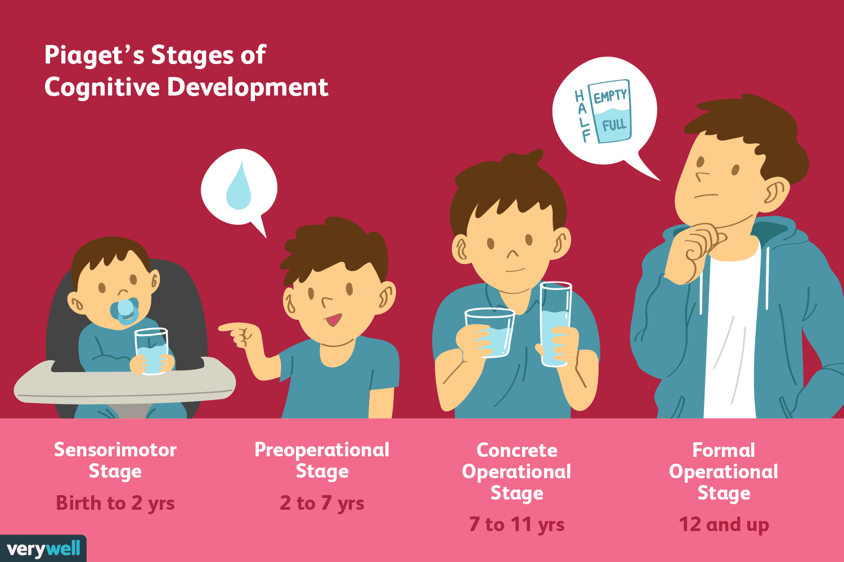](https://www.google.co.uk/url?sa=i&rct=j&q=&esrc=s&source=images&cd=&ved=2ahUKEwjqjYbt96LkAhUlxYUKHVkLBA8QjRx6BAgBEAQ&url=https://www.verywellmind.com/piagets-stages-of-cognitive-development-2795457&psig=AOvVaw2TIjP_Rd4ybGTeu2spSUvR&ust=1566991358907628)

* Instead infants use **egocentric thinking** (they understand the world only from their own perspective and cannot imagine that other people will see, hear or feel things differently.)
* At around 7 years old children can use **concrete logical thinking** to solve problems; this means they can use logic as long as they can physically see or handle the issues involved.

### Stages of Development

|  |  |  |
| --- | --- | --- |
| Age and Stage | What Occurs?  (How do children think and act?) | Experiment |
| Sensorimotor  (0-2 Years) |  | Blanket and Ball Study (1963) |
| Preoperation  (2-7 Years) |  | Three Mountains (1956) |
| Concrete Operational  (7-11 Years) |  | Conservation of Number (1954) |
| Formal Operational  (11+ Years) |  | Pendulum Task (1958) |

The Development of Schemas

An important aspect of Piaget’s cognitive development theory was the idea that children go through a series of stages of intellectual development; he referred to these stages as schemas.

Schemas are cognitive frameworks that help us to organise and interpret information. They are developed through experience and can affect our cognitive processing.

Piaget viewed schemas as the basic unit or building block of intelligent behaviour. He described them as mental structures that help to organise past experiences and provide a way of understanding future experiences. According to Piaget, a schema is a category of knowledge as well as the process of acquiring knowledge.

A child develops concepts about the world around them (a state of **equilibrium**.) As they experience situations where new information is presented, their schemas are upset and they reach a state of **disequilibrium**. As the new information is **accommodated**, the original schemas are modified or changed so they again reach a stage of equilibrium.

Task:

**Define these key terms**

|  |  |  |
| --- | --- | --- |
| **Equilibrium** | **Disequilibrium** | **Accommodation** |
|  |  |  |

Tests of Conservation

If you are given an exam question about Piaget’s test of conservation, refer back to the ‘conservation of number’ experiment you researched

Task

Create a short comic strip or doodle to represent Piaget’s test of conservation:

|  |
| --- |
|  |

Homework:

Shona is 4 years old. Shona’s new school provides children with time for free play to explore a range of natural materials that they can use in construction activities and artwork. There are areas with resources for imaginative and role play, and a natural outdoor area.

In the context of Piaget’s theories of cognitive development, justify free play provision for the children. (10 marks)

*Hint:*

*You need to make clear links between experience-based activities and Piaget’s theory of how children develop their thought processes by accommodating their new experiences.*

### Arguments against Piaget

## Chomsky’s Model of Language Acquisition

[](https://www.google.co.uk/url?sa=i&rct=j&q=&esrc=s&source=images&cd=&ved=2ahUKEwjoqKKK_KLkAhVEL1AKHRQECeEQjRx6BAgBEAQ&url=https://truthout.org/articles/noam-chomsky-trumps-economic-boom-is-a-sham/&psig=AOvVaw3vu9WZD6KGRKzBFI84Sto-&ust=1566992487385134)

Chomsky believed that the ability to develop a signed or spoken language is genetically programmed into individuals.

This means all individuals have the ability to understand and use language, regardless of their other abilities, and to become fluent in their first language by the age of 5 or 6.

Chomsky states that all individuals are born with a **language acquisition device (LAD**) that allows children to recognise and develop languages- they are pre-programmed to acquire language and it evolves naturally.

Questions:

1. What is the language acquisition device?

___________________________________________________________________________________________________________________________________________________________________________________________________________________________________________________

1. Can language be learned rapidly at any age? Why?

____________________________________________________________________________________________________________________________________________________________________________________________________________________________________________________________________________________________________________________________________

1. What evidence is there for the LAD?

_______________________________________________________________________________________________________________________________________________________________________________________________________________________________________________________________________________________________________________________________________________________________________________________________________________________________________________________________________________________________________________________________________________________________________________________

1. Why can’t children learn language simply through imitation?

____________________________________________________________________________________________________________________________________________________________________________________________________________________________________________________________________________________________________________________________________

1. Challenge: How can Chomsky’s theory of language acquisition be criticised?

__________________________________________________________________________________________________________________________________________________________________________________________________________________________________________________________________________________________________________________________________________________________________________________________________________________________________________________________________________________________________________________________________________________________________________________________________________________________________________________________________________________________________________________________________________________________________________________________________________________________________________

## Intellectual Development across Adulthood and Later Adulthood

Early to Middle Adulthood

In early adulthood, individuals apply the knowledge, skills and experience they have gained during their life. This helps them to think logically and find realistic answers. At this life stage, they are likely to be in job roles which require them to think through problems and make decisions, sometimes relating to complex situations. New brain cells will continue to develop even though, in middle adulthood, there may be a gradual decline in the speed of processing information.

Memory Loss in Later Adulthood

The brain produces new brain cells at any age and lifestyle, health activities and daily activities have an impact on the brain. Age-related memory lapses are frustrating but are not always a sign of dementia.

There are different parts of memory, for example procedural (how to do something) and episodic (remembering an event.) These types of memory are most likely to decline with age.

Deterioration of Intellectual Abilities

Aging involves the natural loss of nerve cells in the brain and the reduction in their ability to transmit electrical signals. This doesn’t mean that older people lose their ability to think logically or to reason because they have their life experience to help them. However, older people may have difficulty with memory recall and may feel it takes longer to do things (as if they are ‘slowing down.’) They may also take longer to respond to questions. Furthermore, reaction times may be slower but older people often compensate for these changes, for example by driving more carefully.

Some older people develop more serious diseases and conditions that can affect health and wellbeing; for example Parkinson’s disease and Alzheimer’s disease, are more common in older people. As people are living longer, Alzheimer’s disease has become more prevalent, an early symptom may be mild cognitive impairment (when a person has trouble remembering, learning new skills, concentrating or making decisions that affect their everyday life.)

Check your understanding:

Draw a life pathway, labelling each life stage along the route.

You must include: Age ranges for each life stage and one example of physical and intellectual development at each life stage.

# A3: Emotional Development across the Life Stage

Summary Table:

|  |  |
| --- | --- |
| Life Stage | Emotional Development |
| Infancy  0-2 Years | Attachment:  Bowlby- infants have an inbuilt need to bond with a caregiver.  Securely attached infants grow up with the emotional resources needed to cope with uncertainty in life. |
| Early Childhood  3-8 Years | Understanding self and others:  Children use imagination to understand social roles that other people play.  Begin to imagine a ‘me,’ an idea of self-concept.  Relationships with family members may influence how valued a child feels. |
| Adolescence  9-18 Years | Identity:  Sense of self continues to develop.  Self-esteem may depend on developing identity. |
| Early and Middle Adulthood  19-65 Years | Intimacy:  Self-esteem is influenced by lifestyle (e.g. job, marital status)  Self-image is affected by personal appearance and how others see you.  Need to learn to cope with emotional attachment to a sexual partner. |
| Later Adulthood  65+ Years | Making Sense of Your Life:  Older people need a secure sense of self to cope with physical changes associated with ageing and death. |

## Attachment

**A strong emotional connection between a child and caregiver.**

Why is attachment important?

## Theories of Attachment: Bowlby

Bowlby suggested that children were biologically pre-programmed to form attachments and that infancy is a critical period in which a secure attachment must be formed.

Bowlby observed that children experience separation anxiety (intense distress when separated from their mother.) He said that the child’s distress and anxiety did not disappear when they were being fed by another carer- therefore infant attachment must be about more than just food for survival.

Bowlby believed that attachment evolved from the caregiver providing safety and security for the infant; infants have a universal need to seek out close proximity with their caregiver when under stress.

If attachment is disrupted then the child will suffer long term consequences; these could include delinquency, depression or aggression.

Criticisms of Bowlby

*Schaffer and Emerson*

Babies attach to caregivers that respond effectively to their signals. This is not necessarily the person who spends the most time with them- so it doesn’t have to be their main caregiver. They called this sensitive responsiveness and said that the most important factor in forming attachments is having someone to play and communicate with the baby.

*Rutter*

Argued that maternal deprivation on its own is not enough to lead to long term problems. Instead privation is more damaging; privation occurs when children have not had the opportunity to form any attachments or have a lack of social/intellectual stimulation.

*Learning Theory*

Attachment could be a learned process influenced by the environment, culture and/or the baby’s temperament.

## Schaffer and Emerson’s Sequence of Attachment Stages

|  |  |
| --- | --- |
| Age Range | Stage |
| Up to 3 months |  |
| 3-7 months |  |
| 7-9 months |  |
| 9+ months |  |

## Factors Affecting Whether an Attachment is Made Easily



Attachment may not go smoothly because..:

**Case Study:**

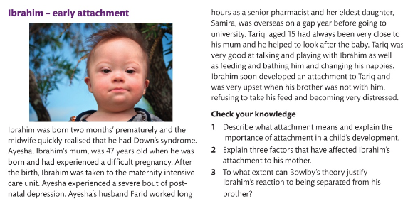

Exam Link

Jan is 48 years old, she has a daughter, Anna, who is 18 months old. Jan has been Anna’s main caregiver since she was born and has formed a strong bond with her. Anna will be starting nursery soon and Jan is worried that she may not want to stay at the nursery without him.

Outline the importance of the development of a strong attachment between Anna and Jan before she starts nursery, with reference to theories of attachment. (6 marks)

### Disrupted attachment

Roberston observed children in hospitals who had very little contact with their parents and he noted that they went through similar stages during their hospital stay, which reduced the strong bond that they had originally had with their parents. The stages they went through were protest, despair and then detachment.

## Mary Ainsworth Types of Attachment

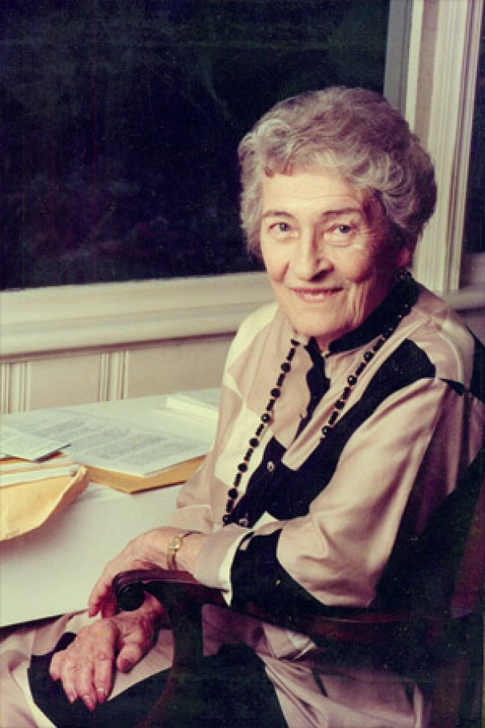Ainsworth (1978) built on Bowlby’s work.

She devised an experiment called the ‘strange situation’ which exposed the infant to both separation and stranger anxiety.

**The strange situation steps:**

1.

2.

3.

4.

5.

6.

7.

8.

### Types of Attachment

|  |  |  |
| --- | --- | --- |
| Type of Attachment | Explanation | Implicatins for the Child in Later Life |
| Secure | Distressed when caregiver leaves.  Not comforted by the stranger.  Calms down when care giver returns. | Able to make friends and meet new people.  Adolescents can manage the transition more successfully throughout school. |
| Insecure- Avoidant | Show no preference between caregivers and stranger. | Have difficulty maintaining relationships as have difficulty with emotions. |
| Insecure- Ambivalent | Distress when caregiver leaves.  Avoids stranger.  Child resists contact when caregiver returns. | May have difficulty trusting others in relationships. |
| Insecure- Disorientated (added later) | Displays avoidant or unsure behaviour.  May appear to be in a ‘daze’ | May have trouble with attachments in later life. |

### What happens if attachment is disrupted?

Disrupted attachment

Exam Link

Mark is 3 years old. His parents were alcoholics and Mark suffered from extreme neglect; he was placed into care at 18 months old and has been in several foster homes. Mark has now been accepted into a long term foster placement.

Justify to what extent Mark is likely to experience difficulties in forming relationships in his long term foster placement. (6 marks)

## The Development and Importance of Self-Concept

## What is self-concept?

Self-concept is a sense of identity. It is an awareness that you are a unique individual, different from everyone else. It is formed in early childhood and encompasses self-image and self-esteem.

Definitions and Factors involved in Developing Positive or Negative Self-Esteem

## How is self-esteem developed?

Positive self-esteem is an important part of emotional wellbeing. Self-esteem involves both self-confidence and self-acceptance. In children, self-esteem is shaped by what they think and feel about themselves. Children who have high self-esteem have an easier time in relationships, resisting peer pressure, making friends and handling conflicts. Children with a positive self-esteem have a generally optimistic view of the world and their life in general. Babies and infants can achieve a growing sense of self and a positive self-esteem through the attachments they develop with their main caregivers (see below)

|  |  |
| --- | --- |
| Age | Developmental Stage |
| 0-18 months | During infancy, babies start to build self-esteem by having their basic needs met (e.g. love, comfort, closeness.) Babies gradually become aware that they are loved as their primary caregiver provides them with attention, comfort, care and support. This shows the infant that they are important. |
| 18 months- 2 years | Although infants don’t yet have a clear understanding of self-esteem, every time they learn a new skill they learn things about themselves; what they can do, what they look like and where they belong. If infants are shown love by their primary caregivers and treated as special this impacts on their self-esteem. Infants who feel unloved find it more difficult to develop a sense of self-worth and to value themselves. |

By the time a child reaches the age of four, positive self-esteem is reinforced by what the child can do successfully and independently, and also by the feedback they receive from their carers. Parents can encourage self-esteem by teaching problem solving skills and including children in tasks that provide a sense of accomplishment, asking children for their opinions and introducing children to social settings. Parents should also encourage young children to accept failure as a learning experience and not a negative process.

### What happens when children have low self-esteem?

Children with low self-esteem can become passive, withdrawn and depressed. They often have difficulty dealing with problems, are very self-critical and speak negatively about themselves. Factors leading to low self-esteem include; bullying, have no friends at school, struggling with schoolwork, sibling rivalry, parental arguing. Children facing these problems become pessimistic, easily frustrated and see temporary problems as permanent issues.

### Self-esteem and Puberty

The physical and emotional changes which occur during puberty and adolescence can present new challenges to young people. Fitting in with peer groups and gaining acceptance is very important. Young people use this time to learn from their own mistakes and take responsibility for their actions. Self-esteem can become fragile and changeable. Teenagers may be overly concerned with their appearance and how they are viewed/accepted by peers. Body image is an essential part of young person’s self-esteem; poor body image can equal low self-esteem. Research indicates that low self-esteem at this time can lead to poor school achievement and behavioural problems. It may lead to bullying, teenage pregnancy, smoking, refusing to go to school, depression and thoughts of suicide.

Definitions and Factors involved in Developing Positive or Negative Self-Image

### What is self-image?

Self-image is the mental picture, a personal view that an individual has of themselves. It encompasses the characteristics an individual feels that they have (e.g. intelligent, talented, kind, selfish, ugly.) It is more than what an individual looks like or how they are seen by others; it is also how a person thinks, feels and reacts to self-perceived physical attributes.

### How does self-image develop?

Self-image is developed in early childhood by the quality of social interaction and the influence of parents or caregivers. A parent who makes positive comments about a child’s appearance in a consistent way lays the foundation for positive self-image. If a parent ignores a child or constantly makes negative comments then this can impact on the way the child begins to see and think about themselves. Experiences with other people (including teachers, family and friends) can reinforce what we think and feel about ourselves. If an individual is being made fun of for the way they look then this can lead to physical and psychological problems.

### What physical and psychological problems can occur due to negative self-image?

An individual’s self-image can be a real or distorted view of who they actually are. It does not necessarily reflect reality. Feelings about image can become internalised and affect how an individual acts. During adolescence, physical appearance becomes particularly important because young people have to come to terms with changes in their body shape as well as some unwanted physical changes such as acne. A young person with anorexia or bulimia who is thin may have a self-image in which they see themselves as fat. A negative body image can lead to psychological problems inducing anxiety, eating disorders and depression.

How is self-image affected by life events and social roles?

Life events and social roles influence how others see us and how we define ourselves. Roles such as learner, parent or member of a team not only help other to recognise the status of an individual but also provide guidelines for behaviour (e.g. now I am a parent I should stop smoking.)

Life events and social roles influence personal traits that can also be an important part of self-image; people may describe themselves with these traits; ‘I am impulsive,’ ‘I am caring,’ ‘I tend to worry a lot.’

How does self-image and self-esteem develop in adulthood?

Self-image: Younger people tend to describe themselves in terms of personal traits whereas, older people describe themselves in terms of social status (e.g. I am a midwife, I am a mother.) This may be why older people are so affected by changes to their roles (e.g. through divorce, redundancy or having a child.)

Self-esteem: Self-esteem is not fixed and fluctuates through the life stages. In adulthood, the factors that impact on self-esteem may change. Career development and other personal achievements will increase a person’s self-worth while stress ad life event that are difficult to cope with can result in a lack of confidence and negative self-image.

### Revision page on self-concept

To include: what it is (definitions) what can cause it being positive or negative (in children, adolescents and adults) and how it may affect people.

Exam Practice

Oscar is 8 years old. He has experienced bullying in school.

Outline how bullying may affect Oscar’s emotional development. 6 marks

# A4: Social Development across the Life Stages

What is social development?

Social development involves learning how to interact socially with other individuals in the family and society in general. Social development provides the opportunities and skills that enable people to develop relationships. Not all individuals will experience social relationships in the same way.

## The stages of play in infancy and early childhood

|  |  |  |
| --- | --- | --- |
| Type of Play | Age | Description of Play |
| Solo Play | 0-12  Months |  |
| Solo Play | 12-18 Months |  |
| Parallel Play | 18 months- 2 years |  |
| Associative Play | 3-4 years |  |
| Co-operative Play | 4-6 years |  |
| Co-operative Play | 6-8 years |  |

Questions:

1. What are the potential physical, intellectual and emotional benefits of play?
2. How does play help social development?

|  |
| --- |
|  |
|  |
|  |
|  |

1. How has play changed over the last two or three generations?

|  |
| --- |
|  |
|  |
|  |
|  |

Task:

Use Piaget’s stages of cognitive development to show how the theory helps to explain the stages of play.

Hint: Consider the importance of senses for infants when they are absorbed in solo play (sensorimotor stage) and of symbolic play and language for children during co-operational play (pre-operational stage.)

|  |  |
| --- | --- |
| Stage of Play | Link to Piaget’s stages of cognitive development |
| Solo Play |  |
| Parallel Play |  |
| Associative Play |  |
| Co-operative Play |  |

Extension:

Now try to link Chomsky’s model of language development in terms of the development of play

## The Importance of Friendships and Friendship Groups

Questions:

1. What are the social benefits of friendships?
2. Why do people lose friendships?
3. What effect does peer pressure have on social development?
4. What is the difference between formal and informal relationships?
5. How do young children develop friendships?

Challenge:

6a. Mia is 15 years old. Her parents have recently divorced and now she must move to a new area and a new school. Why would it be beneficial for Mia to make friends at her new school?

6b. Mia’s new friends are pressuring her to smoke and involve herself in underage drinking. Why is Mia likely to conform to her friends’ behaviour?

Fill in the gaps

## The Development of Social Relationships:

|  |  |
| --- | --- |
| Life Stage | Social Development |
| Infancy  0-2 Years | Interacting with Carers  Infants appear to have an in-built tendency to interact with carers. By 2 months they may start to smile at human faces. At 3 months, they will respond when adults talk. At 5 months, infants can distinguish between familiar and unfamiliar people. Infants, make their first relationships as they form an emotional _______________________ to carers. In the later stages of infancy, infants will _________ alongside other children (this is called _________________ play.) |
| Childhood  3-8 Years | First Social Learning  Young children are emotionally attached and dependent on the adults that care for them. Children begin to learn social __________ and behaviour within their family context (first or primary socialisation). A family environment might provide a safe base from which to explore social relationships with other children through play. Children will learn to co-operate with each other (______________ play.) As children grow older they become increasingly _______________ and begin to form relationships based on a sense of mutual trust. Friendships become increasingly important as children grow towards adolescence. Children may form social networks or circles of friends who like and agree with each other. |
| Adolescence  9-18 Years | Secondary Social Learning  During adolescence a person’s sense of _____________ may be more influenced by their peers than by their ______________. Adolescents copy the styles of dress, beliefs, cultural values and behaviours of their own network. Adolescence can by a time of stress and adolescents have to cope with the development of their own sexuality (the impact of sex ______________ at puberty) and the social transition to full independence from the family. Recent research suggests that this transition is likely to be smooth with little conflict with parents. |
| Adulthood  19-65 Years | Maturity  During early adulthood, friendship networks continue to be very important. For most people, early adulthood is dominated by forming intimate partnerships and by the need to find employment/establish a career. For many people, ____________and ______________ represent major social development in their life.  In middle adulthood individuals experience time pressures that may limit their social activity. Mature adults may have to split their time between work, caring for parents, other family commitments and wider social activities. Some adults report a reduction in the amount of social activity due to these pressures. |
| Older Adulthood  65+ Years | Following retirement, older adults have more free time to develop friendships through taking up new hobbies, pastimes and travel. Others may choose to increase their involvement with close friends and family rather than extend their network of social contacts. |

## Development of independence

|  |  |
| --- | --- |
| Stage of Life | Independence |
| Infancy and Childhood | In infancy, young children are totally dependent on others for their care but, towards the end of this life stage, they begin to assert their need to become independent and attempt to do more for themselves. This comes with increased skills and abilities in dressing and feeding themselves. In early childhood, although still very dependent on parents and carers, they are widening their experience- starting school and joining clubs and activities. Children gradually become less reliant on close family and start to make their own decisions. Initially, these may be limited to activities, food choices or which clothes to wear but, by the time they reach the end of this life stage, they will have developed clear likes and dislikes. |
| Peer Influence in Adolescence | In adolescence, young people begin to question their sense of identity and begin to see themselves as separate and independent from their family. Young people may begin to question their family’s values and become influenced by peer group norms and values. Peer influence can lead young people to question choices that have been made on their behalf. Young people can learn from real-life experiences about the consequences of making good or poor choices. |
| Starting Employment | Between the ages of 16 and 18, young people begin to make important decisions about their career options. They need to be realistic and empowered to make informed choices about their future career prospects. Starting employment is an important transition and is effectively the first step into an adult world as their status changes from learner to employed worker. It is important to adapt from the rules and routines of a school/college/university day to the policies and procedures of the workplace. The financial independence associated with starting employment is also a step towards full independence. Managing finances, from reading a wage slip, opening a bank account to developing budgeting skills are all important aspects of becoming independent. |
| Leaving Home | There is a clear relationship between leaving home, independence and adulthood. At some stage in their early 20s many young people decide to leave their family home. Although many now stay at home longer, because they are studying, unable to work or cannot afford to live independently. Leaving home could mean making certain sacrifices such as a lower standard of living. While this allows for a new level of independence and self-reliance, juggling household chores with work and managing household bills require young adults to develop a new set of skills. |

|  |  |
| --- | --- |
| Starting a Family | A new status and responsibilities associated with starting a family may be an important aspect of developing independence. Developing parenting skills and becoming part of a new family unit can provide a sense of identity and a feeling of achievement. Becoming a parent requires lifestyle changes and sometimes financial difficulties. New parents must put the needs of the new baby before their own, which can involve making sacrifices. For instance, a parent may choose to put their career on hold or change working patterns and this can impact on financial and emotional independence. Although family members may be able to offer support, the ultimate responsibility is with the new parents. |
| Middle Adulthood | People often have fewer family responsibilities and they can more easily pursue their hobbies and interests. Individuals in this life stage are more likely to reach the peak of their career and they may have more disposable income that gives them more independence, choice and freedom; leading to more travel and establishing new social networks. However, changes to the pension system may result in individuals working longer or taking on part-time work when retired. Furthermore, many people act as carers for grandchildren or provide support for elderly parents. |
| Older Adulthood | After retirement (between 65-75 years old,) many older people enjoy a busy social life due to freedom from their career. Many older people take advantage of free bus passes and concessionary entrance costs; this means independence can be maintained in later life. The internet and social media makes it easier to explore new interests and relationships However, some older people begin to disengage from society, especially if spouses and friends have died. Furthermore, accidents and illness may lead to relying on others for care. |

Task:

Create a timeline of factors affecting independence to show how it changes over the life span

Infancy and Early Childhood

Later Adulthood

Early Adulthood

Adolescence

Middle Adulthood

Case Studies:

Are these people independent? What factors affect independence?

Isabelle is 4 months old. Her parents care for her needs by feeding, bathing and changing her nappies. Her mother takes her to baby play group.

Marley is 5 years old. He puts his uniform on without help each morning and chooses his own pyjamas at night. He has free school meals and chooses what he wants from the canteen. Marley does not like vegetables, he doesn’t eat them when he is at school but his parents make him eat them at home.

Debbie is 31 years old and she has recently given birth to a daughter. Before giving birth, Debbie regularly went to the gym and took part in an amateur dramatics group on weekends. Debbie has been to the gym once since her daughter was born as she struggles to get a babysitter.

Louisa has recently had a baby. Louisa describes being a mother as ‘an important part of her identity’ and believes that becoming a parent has taught her a lot about herself. Louisa has given up work and the household has had to make many financial sacrifices as a result of the reduced income.

Mark is 16 years old. He will be leaving school in 5 weeks and will be beginning an apprenticeship in September. The apprenticeship will mean that Mark earns a small wage however, he must attend his work placement from 8-5 every day.

Phil is 48 years old. He works from 8-5 everyday however, he is well paid and enjoys several holidays a year. When Paul’s teenage son moved out of the family home Paul has turned his son’s old bedroom into a hobby room for his model trains. However, he keeps a spare bed so that his grandson can come and stay at the weekend.

Millie is 55 years old. She works as a shop assistant and would like to retire; however, the Conservative changes to the pension system mean that Millie cannot retire for another 10 years. Millie’s mother is disabled and so Millie goes to her house each evening to make her dinner and leave breakfast and lunch in the fridge for the morning.

Steven is 15 years old. He does not like school and regularly truants. Steven’s friends drink alcohol and pressure Steven to do the same.

Mabel is 70 years old. She is physically well and able to get around easily due to her free bus pass. Mabel enjoys visiting museums and is pleased that she only pays concessionary fare and can visit during the week when it is quieter. Mabel has a Facebook account and uses the chat function to speak to her children and see pictures of her grandchildren.

Terry is 82 years old. He is physically disabled and requires a wheelchair to get around. Terry’s council house is no longer suitable for his needs as he cannot get upstairs and there is no tracking for his hoist. The council has no disabled access flats available in Terry’s area therefore he must move 40 miles away to live in a house suitable for his needs. Terry’s son has offered to pay for a place in a care home so that Terry can live close to family.

Extension:

What aids and adaptations are available for older people and how can they be accessed?

Explain 3 examples you find on the internet and explain the different ways of accessing them.

Revision Questions:

1. Daisy and Alfred are 70 years old. What life stage are they in? What changes may occur in their life stage?
2. Aaron is 3 years old. What life stage is he in? What type of play might he engage in and what are the benefits?
3. Bhavisa is 14 years old. What changes will occur to her in her life stage?
4. Define ‘self-concept’ and outline two factors that can affect it.