Personality

“The sum total of the individuals’ characteristics that makes him unique.”
Hollander, 1971

Personality is an overall pattern of psychological characteristics that makes each person a unique individual.” Gill, 1986
Complete the personality questionnaires provided.

The tests used above presumes that personality can be measured, and, once measured, personality can be used to predict behaviour. This is part of the Trait perspective of personality. (You will study three different perspectives)

This theory states that:

- Personality is made up of a number of characteristics. Eg extrovert, calm etc that you inherited at birth.

- These characteristics are stable and enduring.

- These characteristics are not influenced by the environment / situation.

Personality Profiling in Sport & Exercise

According to the trait perspective, we can test personality using a number of different methods:

1, Inventory / questionnaire
2, Observation
3, Projective tests eg. Thematic apperception tests, Rorshach inkblot test.
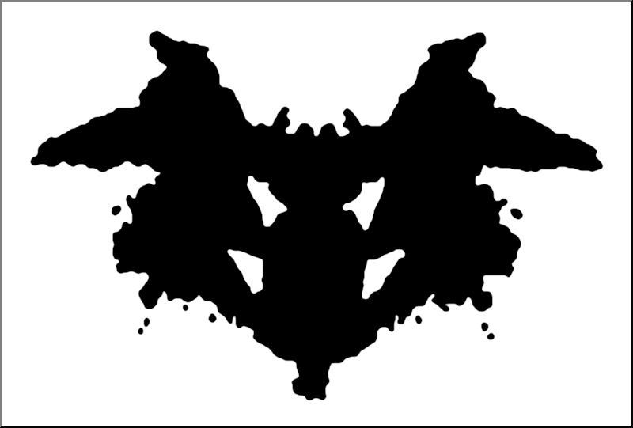

We can then use the results of these tests to determine if the person had the right personality for a sport and what the right sport is for their personality.

Can you think of reasons why this is not possible?

Recap

Trait perspective of personality. It stated that:

1, We are born with a number of personality characteristics. i.e personality is genetic.
2, These characteristics are enduring and stable
3, Our personality is not affected by the environment / situation we find ourselves in.

This if you like is the nature side of the nature – nurture debate.

However!
Social Learning Theory

Behaviour is influenced by the situation and often does change throughout life.

Bandura believed that all behaviour is learned through interaction with the environment. We studied this last year as Observational Learning, a way of learning new skills, although this year, for developing personality, it is often known as social learning theory.

Write down the four key aspects of observational learning

1,

2,

3,

4,

This if you like is the nurture side of the nature – nurture debate. You are just a product of the environment and your experiences.

The only trouble with this theory is that it takes little account of your inherited behaviour and does not explain why some people are fairly consistent with their behaviour.

Interactionist Theory

A third theory is the Interactionist Theory. This theory considers both inherited characteristics and the effect of the environment. It combines both the trait and social learning approaches to make a more realistic explanation of personality and human behaviour. An individual may have certain personality traits but it requires a trigger in the environment to create certain behaviour. For example, Mr Bonney has a personality trait of aggression which is hidden most of the time. It takes a trigger in the environment, for him often when Kevin takes his hole punch, to really hurt someone.

The examination board often use the following equation to explain interaction approach.
B = f(PxE)

Use the table below to summarise the three approaches to personality.

Trait Approach | Interactionist Theory | Social learning Theory

Profile of Mood States
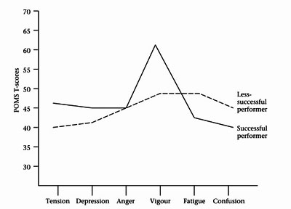
Describe POMS

Good or bad theory?

Jun 2013

