What is Peak Flow (Csikszentmihalyi)
Sounds goods! How do we get there?

Here are some athletes describing being in Flow:

- Complete satisfaction
- Focused
- In the zone
- On auto
- Everything clicks
- Nothing else matters
- Total composure and confidence
- Super alive
- Effortless & unbeatable

Components of Flow
Challenge – skill balance
Athletes have to strike a balance between being bored because they can do the task easily and being anxious because they feel they cannot cope with the demands of the task (Check notes & syllabus on Anxiety) They need to control the level of arousal / anxiety to enter flow.
Concentration has to be on exactly the right things at the right time – check your notes on Nideffers attentional control and Easterbrooks cue utilisation
Have clear process goals – helps them know exactly what they should be doing and provide focus
Clear feedback – performers need to know that what they are doing is perfect. Remember that the best source of feedback for elite athletes is intrinsic (remember kineathesis) Obviously other sources of feedback help too.
The motivation for peak flow becomes intrinsic – it feels so good to be in flow that you work hard just to experience it again – it is just a happy coincidence that this state often helps you win!
You need to fully enjoy the the activity if you are going to enter flow.
Other components include
A sense of control - “I know I am going to win this race”
Loss of self consciousness & action-awareness merging – “the racquet felt like part of my arm”
Transformation of time – “is it half time already”

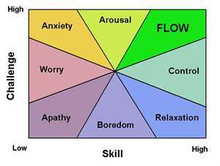
What is Anxiety?

Spielberger identified two types of anxiety:

Trait Anxiety (A-Trait)
State Anxiety (A-State)

The Multidimensional Approach suggests that anxiety can be in two forms:
Cognitive State Anxiety
Somatic State Anxiety

What causes Anxiety?

List all the things that have made you anxious.

Now look at page 257 of the text book provided and copy figure 4.32 into the box below. Which of your things fits under each heading?

Jun 2011
Identify and explain the different types of anxiety that may affect a performer.
(3 marks)

Jun 2010
Using the ‘catastrophe theory’, describe how over-arousal may affect a player’s
performance. (4 marks)

