Anxiety Management

Somatic Techniques

Progressive Muscular Relaxation

Read the following instructions and then choose a quiet place to work through them practically. Alternatively, you can use a reputable relaxation tape of PMR rather than the following text.

Instructions:

- Lie down and relax your entire body. If you hear noises, don't try to block them out but focus on your breathing - inhaling, then exhaling slowly. If you want to move slightly, that's OK. Close your eyes, take it easy and relax.

- Tense the muscles of your right lower leg and foot by pointing your toe. Hold the tension for five to six seconds and then relax. You should be able to feel the tension in the foot and the calf and then totally relax. When you relax, feel the warmth in the muscles. Repeat this procedure again on the right leg and then repeat it twice for the left leg.

- After tensing and relaxing the lower leg and foot, tense (for five seconds) and relax the thigh and buttocks region (twice for each leg). Tense the buttocks and thighs by pushing down with your buttocks.

- Tense and relax the forearm and hand by making a fist. Do this twice for each arm. Tense and relax the bicep of each arm by bending at the elbow and pretending you are doing a chin up. Repeat twice for each arm.

- Tense (for five seconds) and relax the back muscles by arching the back up. Tense and relax the back twice. Tense the stomach and chest muscles by breathing in and releasing - relaxing. Do this twice.

- Tense the neck and shoulders by shrugging your shoulders (pulling them together) and then releasing them and relaxing. Tense the face and forehead by gritting your teeth and pulling your eyebrows together, then relax. Do this twice.

- Mentally scan your body for any tension and release it. Focus on the relaxed feelings in your muscles and the calming thoughts of your mindset.

- When you wish to return to a higher level of consciousness, count upwards from one to seven, counting one number on each exhalation, gradually experiencing greater alertness and awareness of the external environment. When you reach seven, you should feel fully awake, relaxed and refreshed.

After you have worked through this exercise, slowly flex, stretch, inhale and open your eyes before you sit up. Take time to evaluate how well you were able to relax during this exercise.

Biofeedback

In biofeedback athletes use physiological measuring equipment to help them learn how to control their physiological responses. For example, when athletes can hear their heartbeat, they can try to think of something calming in order to find out which thoughts lead to a slowing down of the heart rate. With practice, they will be able to use these thoughts, and heart rate (and arousal) should decrease. Try the following task

1 Check your pulse (use heart rate monitor). Place your hands on the base of your rib cage (your diaphragm), breathe in deeply (Inhale) to a count of three and feel the rib cage expand, hold for a count of three and then breathe out (exhale) to the count of three. Repeat a number of times and notice the effect on your physiological and mental state. You may feel more mentally calm and focused and, if you retake your pulse, you will probably find it has lowered.

2 The effect will be even more marked if you try the same deep breathing exercise following some physical exertion (eg running up a flight of stairs or some form of exercise that induces mild fatigue) or when feeling under some mental pressure. Try the same exercise under these conditions (NB This is quite easy to do in a break in training and gets the message across to performers in their sport environment).

3 You may wish to experiment with different inhale/hold/exhale ratios - some people may prefer a longer or shorter breathing pattern to gain the relaxation effect.

Other measures which can be used are:

- Thermometer attached to a finger: because high arousal causes less blood to go to the fingers, they become cold. The athlete watches the thermometer as he tries to control his or her responses;

- Electromyogram to measure muscular tension: the measures taken by the electromyogram can be shown on a meter, which, for example, makes a loud sound when muscle-tension is high. The athlete tries to reduce the sound level by reducing muscle tension. This can be done using some of the other techniques mentioned such as rhythmical breathing and imagery.

Meditative Relaxation

First read the following instructions and then choose a quiet place and a comfortable position to work through them practically. Select some relaxing or calming music - baroque music (such as Bach's Air on a G String) is particularly suitable as it coincides perfectly with the average resting heart rate. Play this music quietly as you work through the exercise. Select your mantra (key word such as calm, relax, focus, one).

Instructions:

- Switch on the music, lie down and relax your entire body.

- If you hear noises, don't try to block them out but focus on your breathing - inhaling, then exhaling slowly. As you breathe out, repeat the mantra to yourself.

- Continue for about five minutes or until you feel you can block out all internal and external distractions. If you lose it, focus your attention back on your mantra.

- If you wish to gain a deeper level of relaxation, try counting down from ten to one with successive exhalations (ie count ten on the first breath, nine on the second). When you reach one, start the process again from ten.

- When you wish to return to a higher level of consciousness, count upwards from one to seven - again counting on each exhalation. When you reach seven, you should feel fully awake, relaxed and refreshed. Slowly flex, stretch, inhale and open your eyes before you sit up.

- Take time to evaluate how well you were able to relax during this exercise.

If you found this a useful form of relaxation, you may wish to construct your own tape using your chosen music and a set of scripted instructions written specifically for you. You might choose to use someone else's voice. You can vary the length of the taped relaxation session according to the situation, your own needs and the level of relaxation you require.

Cognitive Techniques

Imagery (taken from Building Self-confidence by Chris Sellars)

When faced with a challenging task (eg learning or changing a specific technique, using a new tactic), it often helps to see others perform it successfully, especially if they possess similar skills. How often have you heard children when attempting a difficult task say 'You go first... no, you go first'? This is probably because each wants to see someone else try the task first. This is especially the case when the task is new or perceived to be difficult.
Alternatively, if you have successfully achieved something in the past, watching a replay of it helps you believe you can do it again. If there is no video record, you can of course review it in your mind. This skill of visualising past (or future) performances is referred to as imagery although you may also find the terms visualisation and mental rehearsal used.

Imagery involves creating a clear mental picture - of the venue, the performance, the conditions, the people. Often it relies most strongly on the visual image. This type of visual imagery can be created in two forms:

- External imagery where the performer sees the performance as if it was a video recording (ie through the eyes of an observer such as the coach).

- Internal imagery where the performer views the performance through his or her own eyes (le as if actually performing).

Each type of imagery can be beneficial for different purposes. It is generally accepted, however, that internal imagery is the most useful and perhaps the most powerful, as it encourages the simultaneous use of all the senses - hearing, feeling, smelling and tasting as well as seeing. For example, the cricket batsman might visualise seeing the flight of the ball in the air, feeling the position of the bat in the hand and the tension of the muscles in the arm, bearing the sound of the bat hit the ball and then watching the trajectory of the ball in the air or along the ground. Smell and taste may also add to the strength of the image. In fact, the more senses involved and the stronger the image, the more effective the imagery seems to be.

Sense | Example
Sight | Venue, conditions, equipment, opposition, movements, officials, spectators
Hearing | Sound of own breathing, opponent’s calls, officials, spectators, equipment, coach
Touch / Feeling | Feel of equipment, body sensations (muscles, joints, balance) associated with movement, warmth, rain, wind
Smell | Wet grass, leather ball, sea breeze, embrocation
Taste | Own sweat, gum shield, chlorinated water

How is it used?

Imagery can be used to simulate the actual execution of a technique or performance. This means that the body responds as if actually performing a technique (although the neuro-muscular sensations are less strong than with real performance), but with the added advantage of being able to change and repeat movements in ways that might be difficult if actually performing the task.

Imagery also allows performers to develop a mental blueprint of key movements and aspects of performance. By developing this blueprint, performers can better detect errors in their movements and so more effectively correct them. This process means that skills can be learned and mastered more quickly.

One of the benefits of imagery as a tool for building confidence is that it allows the performer to use all the senses to recreate the sensation of a previous (or future) good performance - a positive image of the good performance, of doing it right. It can be used at different times:

When used before an event (le days, hours or immediately before - instant pre-play), imagery can replace negative thoughts, reduce any effects of anxiety, rehearse the correct action or tactic and so raise confidence.

Immediately prior to a situation (eg at the free throw line in basketball, on the blocks in a sprint event), it can also improve concentration and provide a form of mental rehearsal or practice of the actual execution of the perfect action.

Imagery can also be used after an action (replay). If the action was successful, it can provide excellent feedback and reinforcement of good practice which will boost confidence.

A lack of confidence can lead to a hesitant performance, a loss of attentional focus and even a mental image of mistakes and failures. Imagery can also be used to practise different aspects of the skill, so increasing success (or the expectation of success) and bolstering confidence:

It can be used to build confidence in interpreting cues correctly and making appropriate decisions. For example, cricket batsmen can use imagery to picture the incoming bowler, select the available cues (eg of hand position, line and length) to identify the type of ball to be delivered and rehearse the selection of the best response.

Imagery can also be used to rehearse the correct action - the feel of the stroke, the sound of the ball on the bat, the flight of the ball from the bat. Similarly the gymnast might rehearse the vault - the run-up and flight onto the board; the flight on, touch and dismount from the horse. Perfect imagery not only rehearses the correct movement and focuses attention onto the key aspects of the action but it also builds confidence.

Imagery can also be used to replay the action to provide more extensive feedback - about both the correct and incorrect aspects of the performance. If the performer can quickly identify the error and replay the correct action, attention is focused on correct movements and a successful image is created and confidence restored.

How to Iearn

Many people (and indeed most top performers) use imagery but the important skill is to learn to use it systematically and regularly. To become proficient in using imagery, performers need to practise the techniques on a regular basis - first away from training. The evidence suggests that the more relaxed the individual, the more readily and vividly he/she is able to generate the images, sounds and feelings. If you are not very familiar with imagery, try the next activity.

- Identify a task or skill from your own sport and describe a range of sensations associated with it. It might help to think of a specific occasion when you carried out this task or skill successfully:

• Sight:

• Hearing:

• Touch:

• Smell:

• Taste

- Read the following instructions carefully so you are familiar with them:

Preparation

Make yourself comfortable in a chair.

Exercise

Take in a long slow breath, hold for a silent count of three, relax and breathe out slowly. Repeat twice and close your eyes.

Think of a pleasant sporting occasion where you performed well. Run the image through your mind at normal speed until you reach the end or until your concentration wavers.

Count from one to three and open your eyes.

- Now try the exercise.

- After the exercise, answer the following questions by circling the appropriate response(s):

How vividly were you able to experience the event?

Very / Somewhat / Not very well / Not at all

Which senses were you able to evoke?

Sight / Sound / Feel/touch / Smell

Did you experience the events as though you were there seeing, hearing and feeling everything through your own senses as it happened (le using internal imagery)?
Yes / No

Did you experience the events as if you were watching a film or video, like a recording of yourself carrying out the action (ie using external imagery)?

Yes / No
Did you switch between the two types?

Yes / No
- You may wish to repeat the exercise again.

NB Like any other skill, plenty of practice is needed to develop and hone the skill of imagery - short bursts (five to ten minute sessions) seem to be most effective.

Positive Thinking and Self-Talk
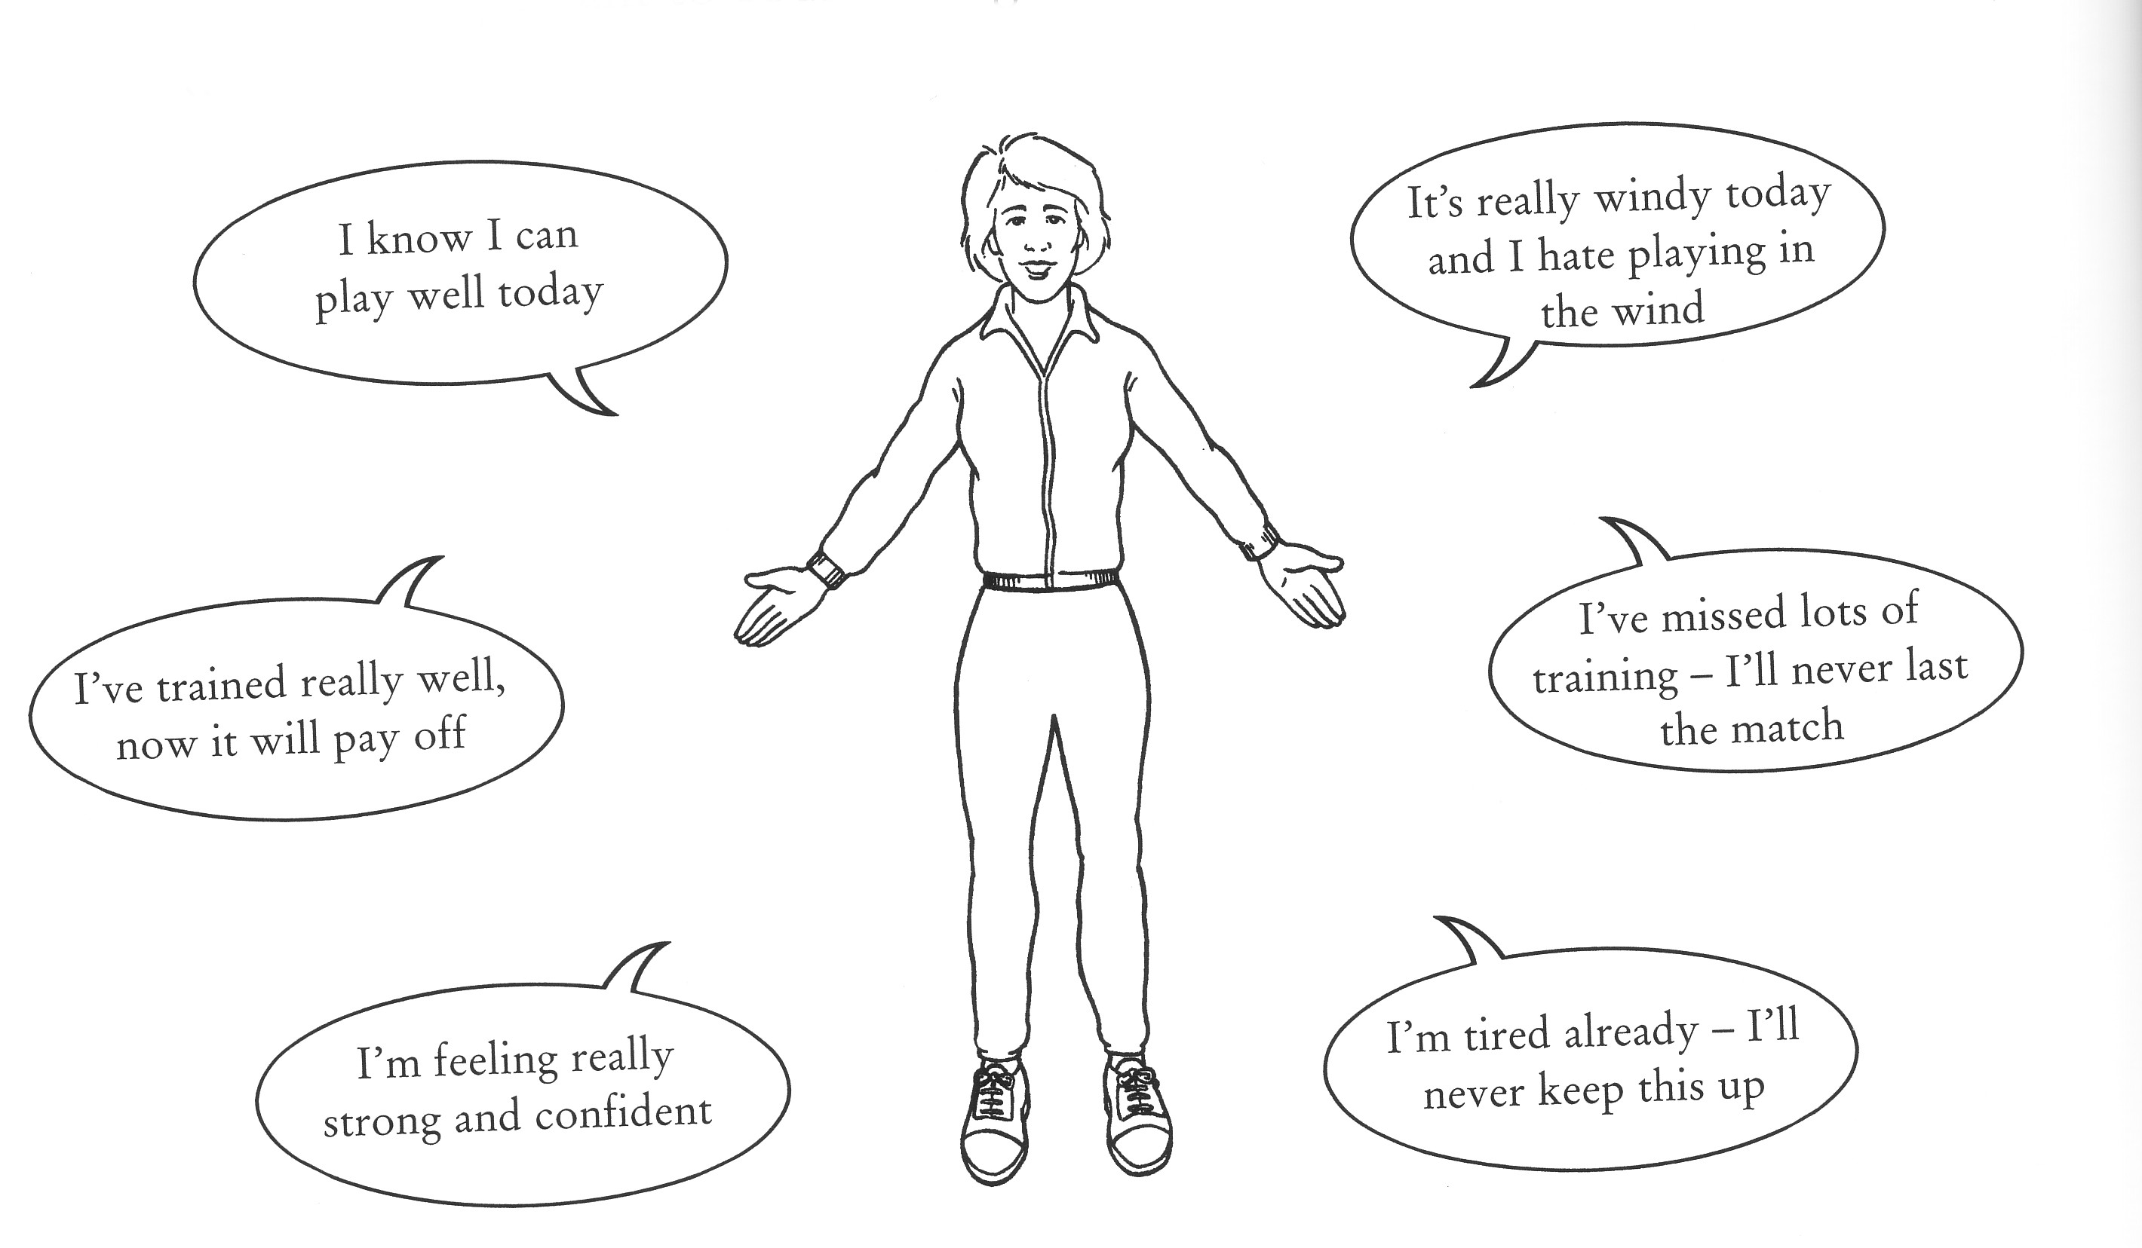

In any pressured situation in your sport or work, note the typical negative statements you make and the thoughts that come into your mind. Try to be as specific as possible -note the exact context and the effect it has on your performance. It may help first to read the example from tennis:

Situation | Statement | Consequences
5-2 up in the final set against a higher ranking player, about to serve | 'Only four points away from beating the number one seed - I can't lose | Muscle tension in elbow, erratic ball toss, double fault from here?'

Rewrite each of your negative statements from the last activity into positive ones. An example is provided to help you:

Negative / Irrelevant Statement | Positive / counter response
“Only four points away from beating the number one seed – I can’t lose from here.” | “Lets enter the fire – kick it into her backhand and work hard for the volley.”

Thought Stopping

If you do have negative thoughts during performance, you must stop them and then replace them with your positive statements. For example, say “Stop, hold it or counter”. Once stopped, use one of your positive statements from your store.

