Measuring Anxiety

Assessing the CSAI-2

Normative data for CSAI-2

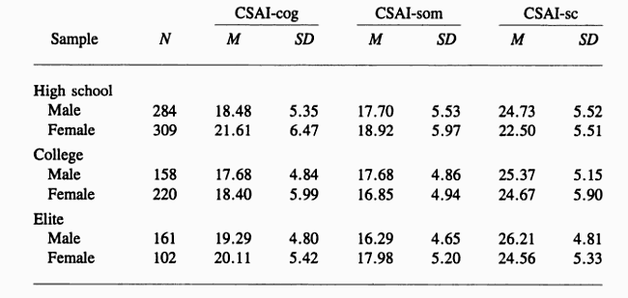

Now complete the State – Trait Anxiety Inventory (STAI) provided.

You have already completed the Sport Competition Anxiety Test (SCAT) online.

Test | Your score | What does it measure? | Issues with self-report questionnaires
SCAT

STAI

CSAI-2

Other Methods of Measuring Anxiety

 | Examples | Issues
Observation

Physiological Measurements

Examination Questions

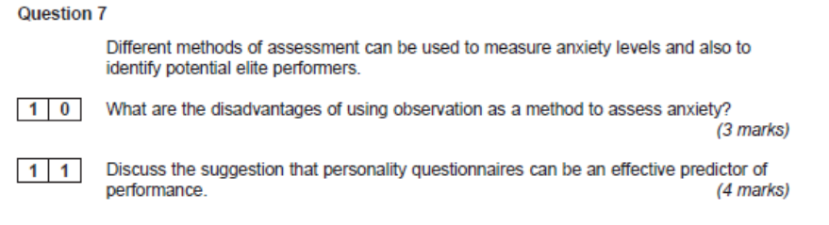
Jun 2012

Jan 2006
Before important competitions, cyclists tend to become anxious.
(a) Name and explain the different forms of anxiety that a performer may experience. (4 marks)

(b) Various tests have been designed for measuring anxiety in sport. Name one of these tests, state how it is administered and what aspect of anxiety it measures. (3 marks)

