Social Facilitation

‘The influence of the presence of others on performance’

Audience Effect - passive spectators who are watching.

Coaction Effect - other people performing the same task but not in direct competition. (E.g. team mates, training partner)

Early Research

Triplett (1897)
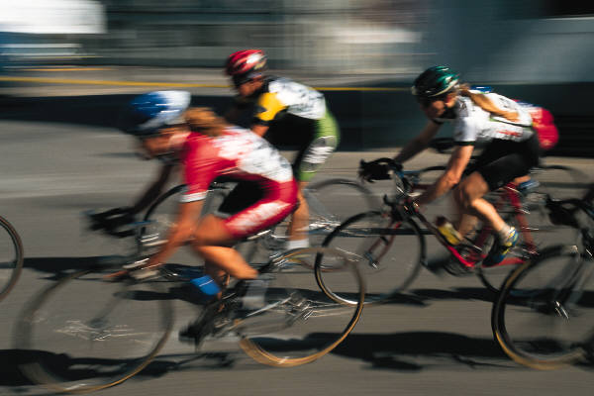
Investigated official cycle records in three different situations:

- Alone
- Paced against time
- Paced in competition with others

Findings
- Paced performed better than un-paced
- Fastest time was produced by those competing against others

Performance was enhanced by the arousal of a competitive drive (‘competitive instinct’).

Allport (1924)

First used term ‘social facilitation’ to refer to performance improvement due to the presence of others

Improvement was not necessarily a result of competition but the mere sight and sound of others performing the same action

Zajonc (1965)
Linked Social Facilitation with Drive Theory (Hull-Spence)

Four proposals –

- Presence of others, either as coactors or as an audience, creates arousal or drive.

- Increased arousal increases the likelihood that the individuals dominant response will occur

- If the skill is simple or well learned, the dominant response will be correct and performance is improved

- If the skill is complex or not well learned, the dominant response will be incorrect and performance is impaired

Zajonc suggested that the ‘mere presence’ of others was sufficient to increase arousal levels.
Recent research - ‘mere presence’ does not take into account the interaction between the athlete and the audience.
The athlete is capable of evaluating and acting upon the influence of others

Two alternative views:

1, Evaluation Apprehension Theory – Cottrell (1968, 1972)

- Arousal is increased through the athlete’s perception of the audience evaluating his/her performance.

  - Audience is only arousing if they are able to make evaluations
2, Distraction Conflict Theory – Barron (1978)

- Audience affect performance because the performer is distracted from the task, therefore, they are not concentrating fully on the game.

Home Crowd Effect
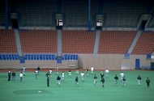

Schwartz and Brasky

Investigated ‘home crowd advantage’

Catalogued professional games in the US

- Baseball (53% home wins)
- Ice Hockey (64%)
- American Football (60%)
- Basketball (64%)

Is the home crowd advantage a result of an increase in performance by the home team or a decrease by the visiting side?

Varca (1980)

Basketball

Proposed advantage was due to more functionally assertive play by the home team and more dysfunctionally assertive play by the visiting team.

Functionally assertive play = rebounding, steals and blocked shots
Dysfunctionally assertive play = personal fouls

Do certain audience characteristics lead to greater home court advantage?

- % Wins increases with crowd size

- Audience density and intimacy may be more important than crowd size.

Basketball and Ice Hockey are more affected than American football and Baseball (Agnew and Carron 1994)

- Crowd Hostility has a negative impact on visiting side (Greer 1983)

- Home crowd advantage is different depending on the nature of the event.

The home crowd is an advantage for early games, but during more decisive games (later in the season) the home crowd can become disadvantageous.

Why? High crowd expectations

COPING WITH THE AUDIENCE
- Reassurance / support

- Imagery & Mental rehearsal

- Somatic and cognitive relaxation techniques

- Introduction of spectators into training sessions

- Improve selective attention / Concentration exercises

- Reduce importance of the event

Jun 2010 Question

