Leadership in Sport
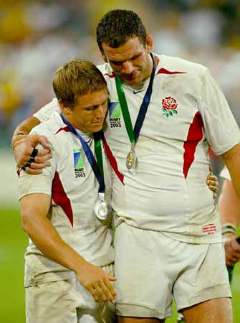
“The behavioural process of influencing individuals and groups towards set goals” Barrow 1977
Characteristics of good leaders:

How is a leader made?
Trait, Social learning or a bit of both?

Carron (1981) suggests an individual can become a leader in one of two ways:
Emergent Leader: comes from within the group, often because they are skilful or the rest of the team has selected them. E.g.
Prescribed Leader: is appointed from an external source to a team. E.g.

Styles of Leadership

There are many different types but can fall into two rough groups:

Task Oriented: task demands of the group.

Person Oriented: interpersonal behaviour of the group members.

Lewin (1935) divided leadership into three main styles:
- Authoritarian Style: task oriented and dictatorial. They make all the decisions and command the group with little regard for the interests of the group members.

- Democratic Style: people oriented and value the views of other group members. They tend to share decisions and show a good deal of interest in the individuals of the group.

- Laissez Faire Style: take very few decisions and give very little feedback. Individual group members do as they wish.

Which is best?

Fiedler’s Contingency Model of Leadership

Fiedler believes it depends on the favourableness of the situation:

Highly favourable | Highly unfavourable

Sketch Fiedler’s model

Explain Fiedler’s model

The Multidimensional model of Sports Leadership (Chellanduria)
Situation Characteristics
Required Behaviour

Leader Characteristics
Actual Behaviour
1, Performance 2, Satisfaction

Member Characteristics
Preferred Behaviour

Explain Chellanduria’s model.

Situational characteristics

Leader characteristics

Member characteristics

Required behaviour

Actual behaviour

Preferred behaviour

