Attitude I

“…an idea charged with emotion (positive or negative) which predisposes a class of actions to a particular class of social situation.” Triandis, 1971

Attitudes are learned through the social world and are direct responses to attitude objects.


Cognitive


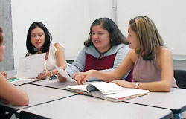
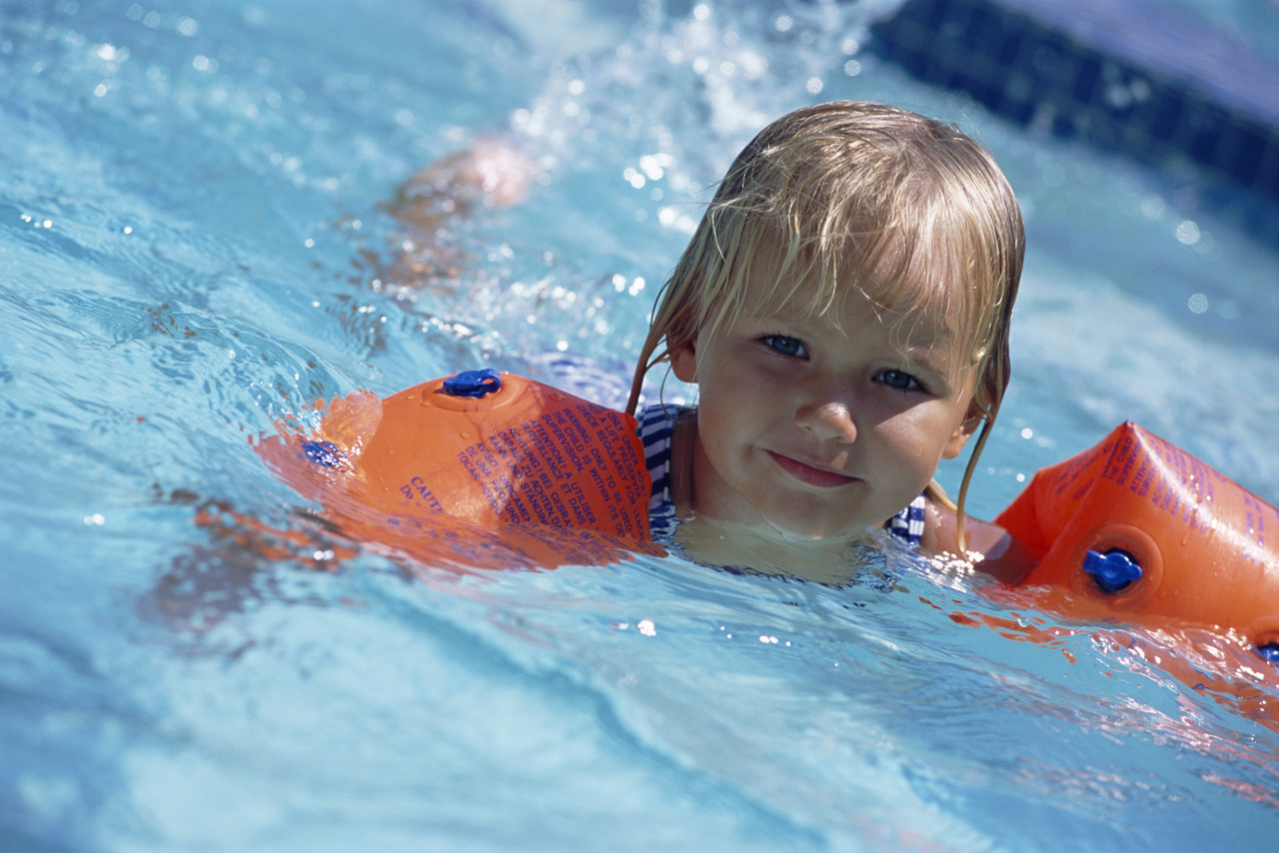
Behavioural
Affective
Identify four factors that have influenced your attitude

Attitude

The Triadic Model of Attitude
Using the examples above, what is your attitude towards swimming?

Does a certain behaviour always occur because of an certain attitude?

It is true that our attitudes will affect our behaviour in certain situations but it is very difficult to infer someone’s attitude from their behaviour. Have a look at this small case study.

Kevin is one of the most talented players on the team but during squad training he does not put in much effort. He avoids team practices that require cooperation with his team mates and only really tries on individual skill drills where he can show what he can do. He never passes!
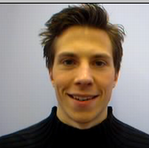
What attitude do you think Kevin has?

Are there any other reasons you can think of for this behaviour?

The coach thinks Kevin is lazy, egotistical, and arrogant but he has formed this opinion based on only limited information. In other words, the coach is prejudiced against Kevin, he has made a pre-judgement without all of the facts.

List a number of groups that are often prejudiced against in sport.

Another form of prejudice is stereotyping – write some examples here.

June 2010

Elite tennis players have to devote large amounts of time to develop their skills, requiring a positive attitude and high levels of motivation.

Name and explain the components of attitudes, giving an example of how a tennis player would display a positive ‘attitude’. [3]

Recap:

Write down the three components of the Triadic Model:

Changing Attitude

A psychologist called Festinger believed that if a person holds two ideas or attitudes that oppose and conflict with each other, that person will feel a kind of discomfort. He called this discomfort Dissonance.

A typical example in sport would be a player knows that training is important to play at the top level. However, the same player does not want to commit that extra time. Coaches, teachers and sports psychologists can use this dissonance as a method of changing an attitude and this theory is known as Cognitive Dissonance Theory.

To create dissonance, we can use the triadic model and change any one of the three components to bring about dissonance.

Use the boxes below to describe how you would create dissonance by changing one of the components below.
Affective
Behavioural
Cognitive

A second approach to changing attitude is known as Persuasive Communication.

The persuader
The message

Persuasive Communication

The recipient
The situation

Summary Task and Homework

Create a cue card, for revision use, that covers the following questions:


- Define the term attitude.
- What is an attitude object?
- How is an attitude formed?
- Name three components of an attitude.
- What is a prejudice and how are they formed?
- How could you change the negative attitude of a student?
- How well do attitudes predict behaviour in sport?

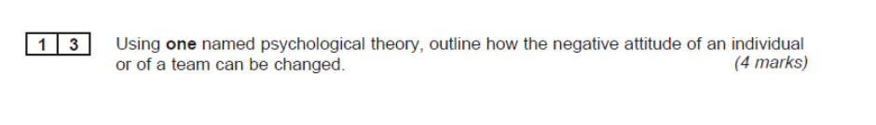
Jun 2011

