**Aggression in Sport**

**Definitions**

The term aggression is used in many different ways to describe a massive range of actions. In general terms it is used to describe actions ranging from a strong but fair tackle to a fight in a football game. It is important therefore to understand what is meant by aggression and the different forms it can take.

Baron (1977) believed aggression to be:

‘*Any behaviour directed at the goal of harming or injuring another being who is motivated to avoid such treatment’*

Thus Baron is suggesting that a key element is the intent to harm. This may be physical or mental, but the key is that the harm is intentional.

Lloyd *et al* (1984) regarded aggression in terms of being a socially undesirable act.

# BUT

Baron in his work identified that aggressive acts can and do take different forms, and can be divided into three categories:

Hostile/Reactive Aggression

These acts reflect Baron’s original definition, in that the main intention is to cause harm. A player who retaliates to a previous occurrence is showing reactive aggression as they are reacting and are intending to cause injury to the opponent. This form of aggression is outside the rules of the game and is often punished with a penalty or a punishment in sport.



### Assertive Behaviour

Assertion it can be argued is not really a form of aggression as it falls within the rules of the game and there is no intention to harm. Assertive behaviour in sport is the use of legitimate force to win, not to harm. A hard tackle in rugby or a drive through a group of players in basketball is assertive but not aggressive as the aim is to get the ball or score a basket rather than to hurt the other players.

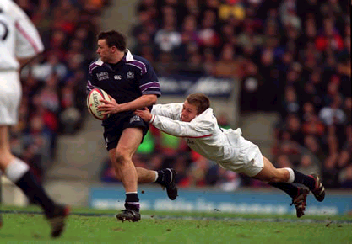

### Instrumental Aggression

This second form of aggression involves an aggressive act where the intention is to win and to cause harm, even if the harm is psychological. This type of aggression is seen in activities such as boxing where “aggression” is an integral part of the sport. It is often difficult to legislate against this form of aggression as it often falls within the rules of the game, as the main aim is to win even though there is still the intention to harm. This is sometimes known as “channelled aggression”.

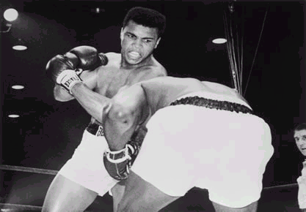

Definition

Explanation

One further theory that relates to the impact of frustration, but also shows the influence of arousal is **Berkowitz’s aggressive-cue theory** (1969). Berkowitz sees frustration leading to an increase in arousal, which can then, depending on the situation, lead to aggression or not. He suggests that if there are aggressive cues such as guns or bats, the sport is aggressive – rugby boxing etc. or you are in a situation where you have been aggressive before then you are more likely to be aggressive than if those cues do not exist.

### Frustration/Aggression Hypothesis

Many aggressive acts in sport appear to be the result of frustration, be that frustration over performance, a referee’s decision, the score or whatever. The Frustration/Aggression Hypothesis was formulated following the work of Dollard (1939). This hypothesis suggests that when an aim or a goal (a need) is frustrated, then aggression results. This theory is related to the instinct theories in that it suggests that when we are frustrated in fulfilling a need, the pent up frustration and aggression are released through aggressive acts, although instinct theory suggests that aggression itself is the goal, where as the frustration aggression theory suggests that aggression is the result.

### Social Learning Theory

Bandura (1969) and other social learning theorists have suggested that there is much more to aggression than the purely biological. They suggest that whatever aggression we are born with is culturally over-ridden. They suggest that aggression is based on modelling. That is we learn from watching and mimicking others and that our behaviour relates to our experiences.

Bandura in his experiments with Bobo dolls found that children who observed aggressive acts were more likely to show aggression than those who didn’t. As was discussed earlier, key elements in observational learning are what we see, who we see doing it and also how our actions are then reinforced.

### Instinct Theory

Instinct theories of aggression are based on the work of Sigmund Freud (1933). Freud held the view that aggression is an instinct that we all have and that we are born with, it is a *death instinct* which generates a subconscious self-destructive force (*thanatos)*. This instinct, Freud suggests manifests itself in different ways, one of which is in acts of aggression. Research by Freud, Lorenz (1966) *et al* suggest that as in animals, we are biologically determined to act aggressively in an attempt to become dominant. Lorenz suggests that aggressive energy builds up and needs to be released.

It has been suggested that sport can play a central role in a civilised world for the release of this aggressive energy.

A number of theories have been developed to explain why we are aggressive. Most of these relate in particular to hostile aggression, but also to some degree to instrumental aggression and do not just relate to aggression in sport.

Picture1

**What can the coach do to reduce aggression in their players?**

* Providing positive, non-aggressive role models
* Severe penalties for those involved in aggressive acts such as substitution, bans etc.
* Remove player from source of frustration.
* Reinforce non-aggressive acts.
* Use Cognitive techniques to help performers control arousal and anxiety such as counting to ten, imagery etc.
* Use Somatic techniques such as PMR and breathing control. (see later)
* Demonstrate to players how being aggressive can let down the whole team e.g. David Beckham & Argentina (the time before we beat them!)
* Give greater responsibility to player. e.g. Roy Keane.

Application

## Past examination questions

**Jun 2008**

Rugby is a team game that has high psychological and physiological demands. During a

rugby match there is considerable physical contact, but incidents of aggression are

relatively rare.

(i) Explain the terms *hostile aggression,* *instrumental aggression* and *assertion.* [3]

(ii) Explain how *frustration* may lead to *aggression*. [4]

(iii) How might a coach try to reduce the aggressive tendencies of one of their

players? [3]