Giacometti Woman with her throat cut

* 1932, cast 1949
* 20.3 x 87.6 x 63.5 cm
* 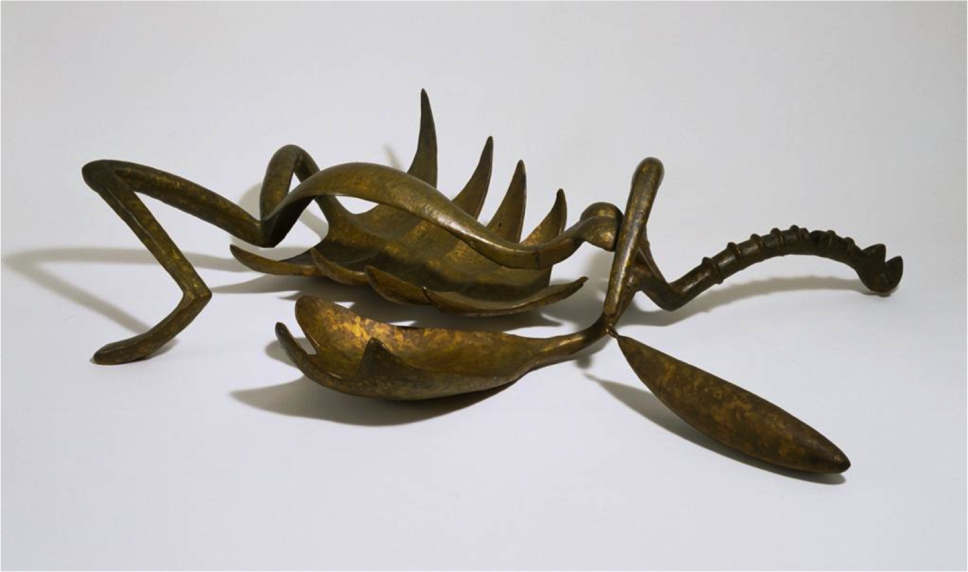MOMA

1. Annotate the image. Label the parts of the woman’s ‘body’ and think about further additional symbolism/similarities for each part you label.
2. If Giacometti had not titled this work, what would you have called it?
3. This work was cast in bronze. This is certainly an atypical use of the material in terms of expectations and subject matter. List the advantages that might have influenced Giacometti in his decision.

|  |  |
| --- | --- |
| Material advantages | Implications/effects |
| Tensile strength |  |
| Colour |  |
| Casting method |  |
| Strength |  |
| Flexibility |  |
| Finish/light reflection |  |
| Subject matter |  |

1. This is a Surrealist work. Read the definition below and consider why an art style that begins as a literary or cultural movement might develop differently from one that is initiated by

**Surrealism** is a [cultural movement](https://en.wikipedia.org/wiki/Cultural_movement) that began in the early 1920s, and is best known for its [visual artworks](https://en.wikipedia.org/wiki/Work_of_art) and [writings](https://en.wikipedia.org/wiki/Literature). Artists painted unnerving, illogical scenes with [photographic precision](https://en.wikipedia.org/wiki/Photorealism), created strange creatures from everyday objects, and developed painting techniques that allowed the [unconscious](https://en.wikipedia.org/wiki/Unconscious_mind) to express itself. Its aim was to "resolve the previously contradictory conditions of dream and reality into an absolute reality, a super-reality".

Works of surrealism feature the element of surprise, unexpected juxtapositions and non sequitur; however, many surrealist artists and writers regard their work as an expression of the philosophical movement first and foremost, with the works being an artifact. Leader [André Breton](https://en.wikipedia.org/wiki/Andr%C3%A9_Breton) was explicit in his assertion that Surrealism was, above all, a revolutionary movement.

Surrealism developed out of the [Dada](https://en.wikipedia.org/wiki/Dada) activities during [World War I](https://en.wikipedia.org/wiki/World_War_I) and the most important center of the movement was Paris. From the 1920s onward, the movement spread around the globe, eventually affecting the visual arts, literature, film, and [music](https://en.wikipedia.org/wiki/Surrealist_music) of many countries and languages, as well as political thought and practice, philosophy, and social theory. [Wikipedia]

|  |  |
| --- | --- |
| 1 |  |
| 2 |  |
| 3 |  |

visual artists. *Give three reasons in the grid below.*

Now combine these ideas with your annotations on Giacometti’s work and answer the following exam-style question in no more than seven minutes.

**Explain how one work of art made during this period is associated with Surrealism. (5 marks)** Now try another variant on this, exploring how the materials, techniques and processes are unusual in this work.

**Explain how the choice of material and technique has affected the meaning of one sculpture produced during this period.**

(Again you have 7 minutes. Notice that although you are still writing about the same work of art, your answer should look very different as every sentence must be crafted to make a relevant and detailed response **to this question**.)

*Now look at this question and complete the grid below:*

**Explore and evaluate the influence of Dada on Surrealism with reference to at least one work of art from each style. ((15 marks)**

|  |  |  |
| --- | --- | --- |
|  | Dada: **Duchamp Fountain** | Giacometti **Woman with her throat cut** |
| *Subject matters* |  |  |
| *Method or techniques* |  |  |
| *Importance of chance* |  |  |
| *Opportunity for disruption* |  |  |
| *Influence of Freud* |  |  |
| *Political convictions* |  |  |
| *Use of materials* |  |  |
| *Message or effect* |  |  |

|  |  |
| --- | --- |
| Artist | Giacometti |
| Title | Women with her throat cut |
| Date | 1932 |
| Medium | Sculpture/ Bronze |
| Scale | 20.3 x 87.6 x 63.5 cm |
| Scope | Female Figure |
| Style | Surrealism |
| Location | The Surrealist Exhibition- Paris-1932, now at Tate Modern. |
| Function | Challenge the audience, rethinking sculpture in space |



|  |  |
| --- | --- |
| Formal features | |
| Composition | Juxtaposition, distortion and displacement of body parts to express the fears and urges of the subconscious. The body is splayed open, disembowelled, arched in an outbreak of sex and death. The body appears thin and long making her look weak. Insect like form of the woman inspired by the praying mantis, which is said to devour its mate after copulation. The body parts are translated into abstract forms which include the spiky ribs which have been cracked open showing no protection, huge and exaggerated hands, long, thin legs which push off from the ground, a small head as thoughts are rational and shows you can’t have control of your body in your dreams.. |
| Colour or texture | The work is bronze which has been in a cast and then polished, creating a texture like a lobster shell. Therefore, is smooth and perfected, arguably similar to the sexual standards of women at the time.  It isn’t made in marble as it would have been impossible to mould and most likely would have broken. Marble is also more luxurious than bronze and wouldn’t have matched the grungy subject matter that Giacometti is presenting.  The bronze adds darkness to the piece and allows an open pose. |
| Light & tone | Bronze absorbs the light, making the piece dark which is fitting for the Surrealism style which focuses on subjects such as death and violence, both of which are taboo and sincere. |
| Space & depth or relief | Intended to be on the floor, without pedestal, entirely in our space and goes against traditional sculptures which would usually have a plinth to add height and to make the sculpture look powerful and strong. Not on a plinth so we as an audience look down on the woman. |
| Line or brushwork | The lines of the woman appear curved and more rounded than an idealised female body. The woman also appears to be dangerous and violent through her jagged and sharp lines. |

Influence from technological factors:

Film making which was able to be longer than 10 minutes became popular in the 1910’s. This allowed artists to explore the idea of involving movement within art.

Influence from cultural/social factors:

The ideas of imagination and unconsciousness were becoming common occurrences, as scientific research was becoming more popular at the time due to the fascination of the human body/ brain e.g. Sigmund Feud.

Influence from political factors:

Surrealists felt Dada lacked clear direction for political action and therefore took it upon themselves to create an avant-garde style. After WW1 artists wanted to express their liberation through their unconscious thoughts (dreams) and explore imagination which eventually created the method automatism within the Surrealist style.

Stylistic comment and artistic influence:

This piece includes many common subject matters seen throughout Surrealism. Firstly “throat cut” represents death, the arched spine represents sex, open legs represent the female body being raped and then killed, no skin on the sculpture means we are seeing the inside of the body and finally the scale is disproportionate. These were all common in Surrealist works as Surrealism was interested in identity and subconscious thoughts, sexuality, desire and violence due to influences at the time.

* Andre Breton- Writer of the Surrealism Manifesto.
* Sigmund Feud- Neurologist/ founder of psychoanalysis (a clinical method for treating psychopathology).
* Salvador Dali- Surrealist.
* Dadaism- The previous style that looked at political views around the time of WW1.

Critical text quote: “An elegant woman is a woman who despises you and has no hair under her arms”- Salvador Dali “Only the marvellous is beautiful”- Andre Breton “An overwhelming majority of symbols in dreams are sexual symbols”- Sigmund Feud