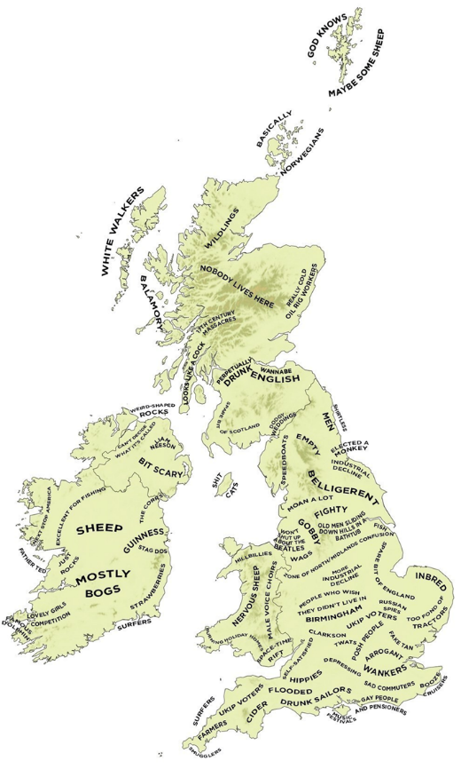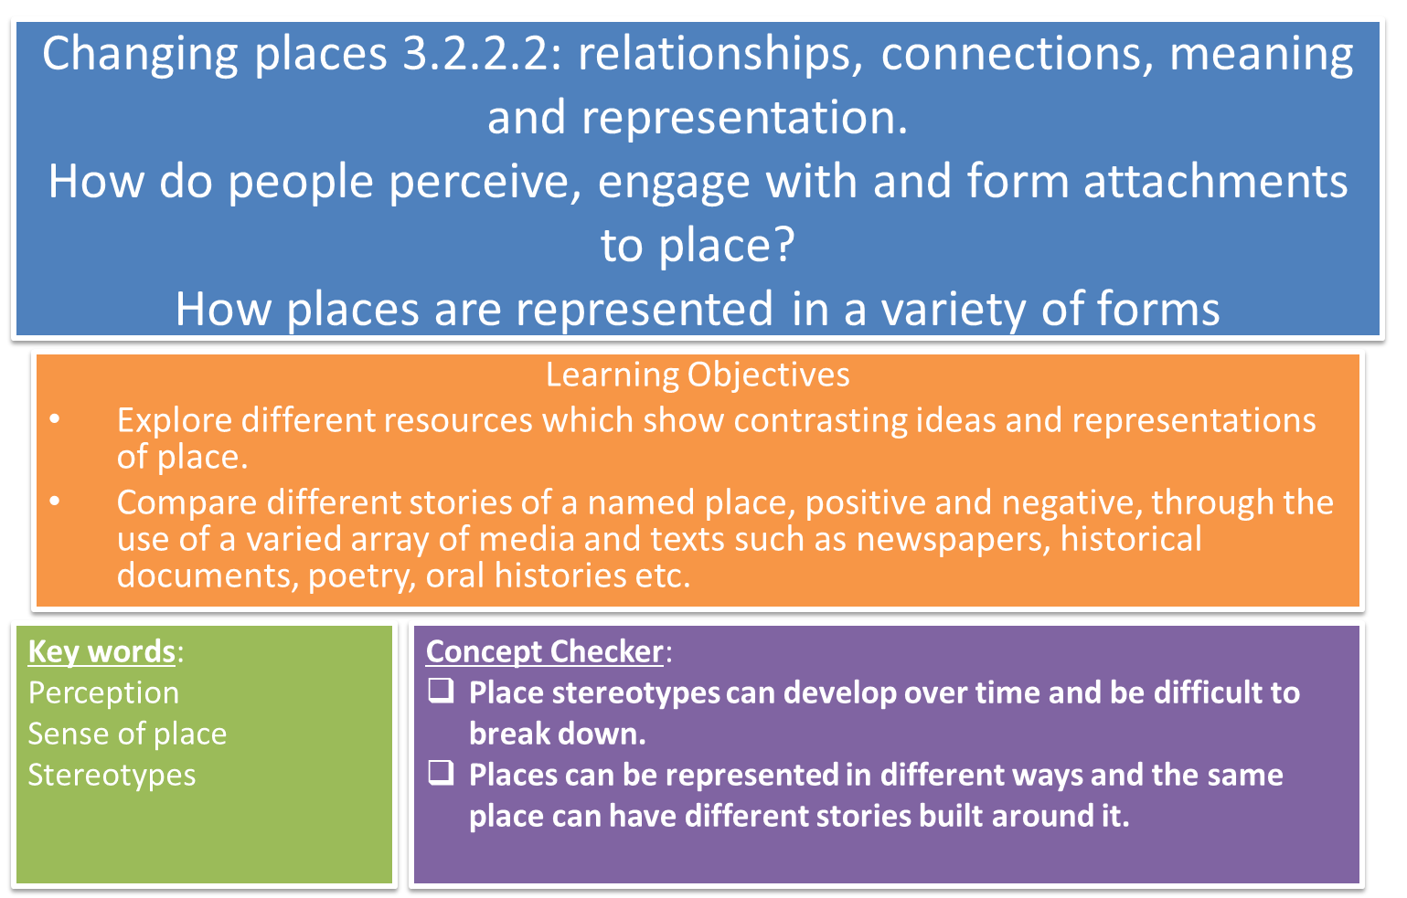

**PLACE STEREOTYPES**

Why do place stereotypes about places develop?

What influences the stereotypes that are formed?

**KEY WORDS**

**Perception of place**

**Sense of place**

Use your homework on the changing image and perception of Liverpool to help you answer this question:

How has its past functions and cultural history influenced perceptions of Liverpool today?

What are the different ways in which places can be represented? For each method you think of, evaluate its effectiveness.

Think about Godalming; how might it be represented and where could we look?

Representations of Godalming

Read the article ‘*11 British Regional Stereotypes as portrayed on screen’*

In pairs, choose two examples from the article:



For both examples you have chosen, explain how film and TV programmes can be influential in the formation of stereotypes and negative perceptions of a place:

*GROUP TASK – SEPARATE SHEET*

**Different representations of place.**

Place can be represented through many different channels, from tourist brochures to Instagram and from sculpture to musicals. Can you add other ways place can be represented?



**Social Media**

Various social media platforms can present varied representations of place. This can then change and influence peoples’ perceptions of places.

One example that started small and has since become a global phenomenon is ‘Humans of New York’ which started life as a one-man photo blog. <https://www.youtube.com/watch?v=pw4HyVS9Wy0>

Facebook used its ‘check-in’ data to identify the 25 most ‘social’ cities in the world and the most visited landmarks within them (they removed transport hubs like airports from the calculation).

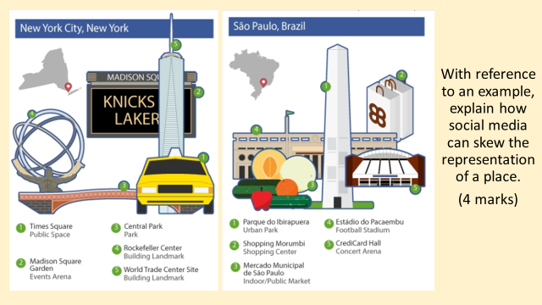

Discuss the question with a partner then draft an answer:

**Poetry of place**

Poets have written about and been inspired by places for centuries. Some poems can be powerful in representing places in a particular way. John Betjeman famously wrote these lines in his poem ‘Slough’:

***Come friendly bombs and fall on Slough!  
It isn't fit for humans now,   
There isn't grass to graze a cow.   
Swarm over, Death!***

***Come, bombs and blow to smithereens  
Those air -conditioned, bright canteens,   
Tinned fruit, tinned meat, tinned milk, tinned beans,   
Tinned minds, tinned breath.***

***Mess up the mess they call a town-  
A house for ninety-seven down  
And once a week a half a crown   
For twenty years.***

What image of Slough does it portray? Is it an accurate portrayal?

[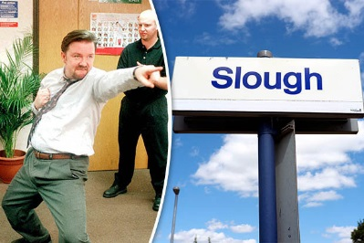](https://www.google.co.uk/url?sa=i&rct=j&q=&esrc=s&source=images&cd=&cad=rja&uact=8&ved=2ahUKEwjTn96k-sLdAhWR6aQKHSrxDKIQjRx6BAgBEAU&url=https://www.dailystar.co.uk/showbiz-tv/hot-tv/591793/BBC-Panorama-White-Brits-minority-town-Slough-David-Brent-The-Office&psig=AOvVaw3x1v5K8DdPpNramVbFULtJ&ust=1537305160073280)

Slough has struggled over the decades to shrug off the negative perceptions this poem created, further compounded by Ricky Gervais’ comedy series ‘The Office’.

**Place in art**

**[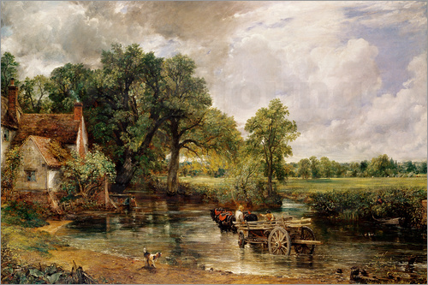](https://www.google.co.uk/url?sa=i&rct=j&q=&esrc=s&source=images&cd=&cad=rja&uact=8&ved=2ahUKEwjQ2tjHnMLdAhXKyYUKHV_zBCAQjRx6BAgBEAU&url=https://www.posterlounge.co.uk/the-hay-wain-pr126920.html&psig=AOvVaw0xrNdszHghYRat6TZwlF8E&ust=1537279950914936)**

*The Hay Wain, Constable*

What does it show? Is it an accurate portrayal of life in the countryside?

Constable's painting is based on a site in Suffolk, on the River Stour. Although the painting evokes a Suffolk scene, it was created in the artist's studio in London.

According to the Guardian *“He wanted to put the English landscape on canvas…you could taste the tang of Suffolk air, smell the cow dung. No painting so defines the English countryside as The Hay wain”*

**Exam Question practice:**

**1) ‘Experienced place’ and ‘media place’ are two categories of place. Explain what is meant by the two terms. (4 marks)**

**2) ‘Today media places are as real as experienced places for many’. Evaluate this statement. (6 marks)**

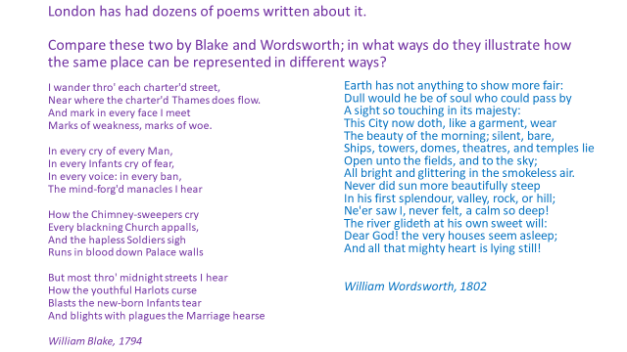**Extension task**

***HOMEWORK: See separate homework sheet.***