Key work: **Kirchner** Street Scene, Berlin (MOMA)

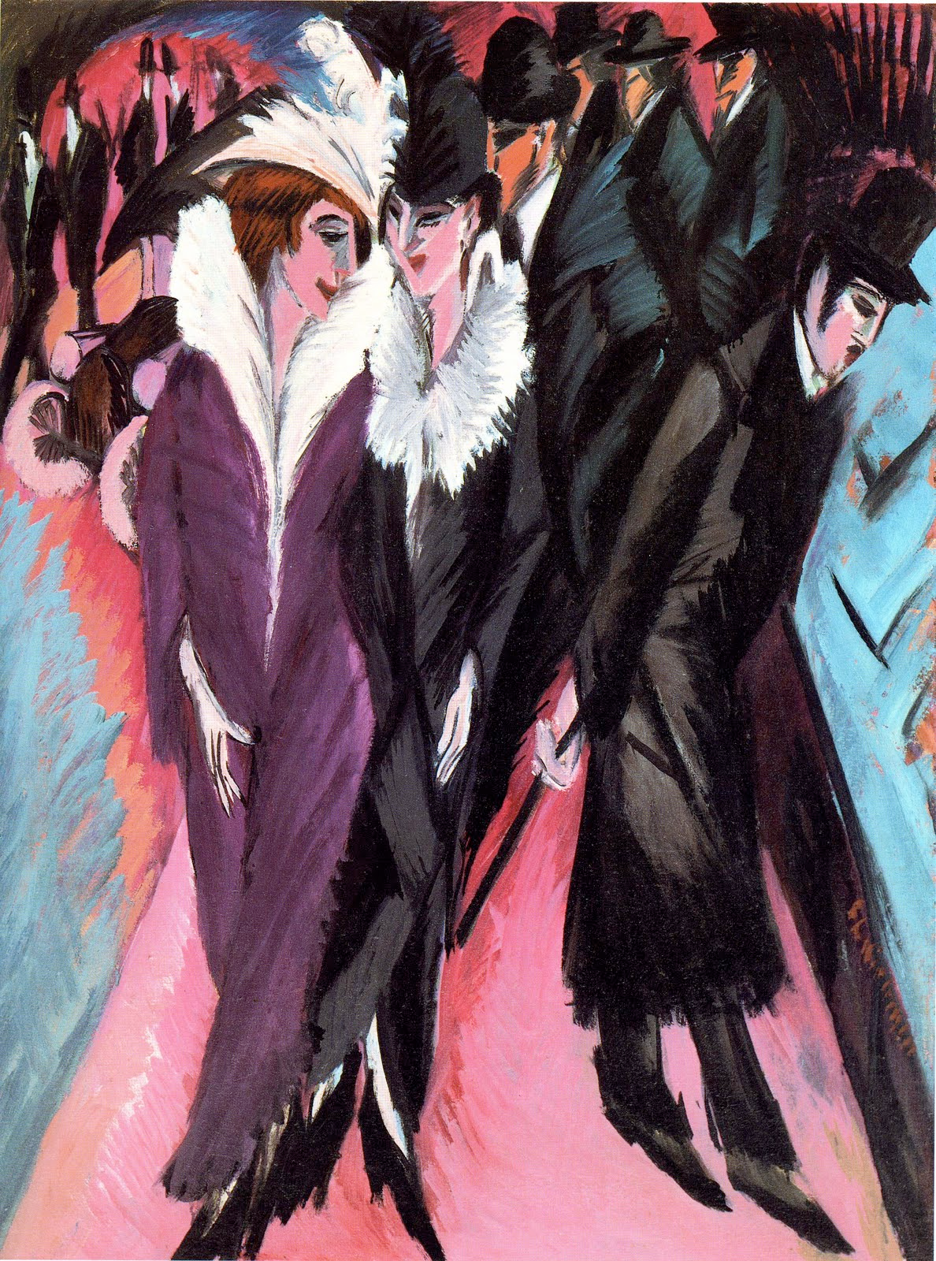

* Date: 1913
* Medium: oil on canvas
* Size:
* Scope of work for Pearson specification: Modern urban life by a NON-FRENCH artist
* Nationality: German

After his success with the Die Brücke group in Dresden and Moritzburg, Ernst Ludwig Kirchner moved to Berlin in 1911. Here, the harsh realities of life in the chaotic modern city took its toll. Berlin had expanded rapidly over the years since German unification in 1871.

**Context:** This painting is from Kirchner’s famous collection of ‘street paintings’. Having moved to Berlin in 1911 from Dresden he became influenced by the vibrant metropolis of the city. Kirchner rebelled against the traditional Hapsburg bourgeoisie of German society at this time (ruled by Kaiser Wilhem I) which he felt was stagnant and restricted creative expression. In this series of paintings the dynamic and modern atmosphere of the city is exaggerated through dramatic lines and jagged, angular shapes along with acute perspective and menacing colour. Kirchner focussed on the harsh realities of life in a modern city. These paintings frequently feature prostitutes mixing with male clientele and suggest that Berlin had a seedy underbelly which polite society pretended didn’t exist.

**Composition:** The asymmetrical and cluttered composition is claustrophobic. The pink has been used to form an ironic heart shape across the work, parodying the idea of love, and suggesting instead that it is ‘for sale’ in modern Berlin. The work depicts a crowded street scene in which the men are dressed completely in black. They appear to be businessmen or city workers and lack individuality, although show wealth and conventional conformity in their suits and top hats. Their simplified forms contrast to the striking and dynamically posed women at the forefront of the painting. These women appear with large fur coats and plumed hats identifying them as prostitutes. The woman at the very front turns her body away from the viewer, preventing a connection with the viewer while the position of her hand emphasizes her role as a sexual product in this modern city.

**Space and depth:** The lack of a receding horizon line pushes the scene forward, uncomfortably challenging the viewer. The perspective in this painting is irregular and sharp, exaggerated by the dramatic lines and jagged edges. The forefront of the painting appears to be tipping towards the viewer as the pointed feet of the figures appear to touch the frame directly in front of us. The brightness of the pink at the base pushes the darker forms of the figures further towards the viewer.

**Colour**: Although the colours are bright purples and pinks, their lurid and acidic tone is discomforting. The cold colours also enhance the menacing black of the men’s clothing as well as the sharp, jagged outlining. The deep purple hues remind the viewer instead of dusk, the sun setting and therefore a sense of impending danger and doom. In the background the dark lines and the purples swirl together also creating a sense of confusion and multiplied cosmopolitan motifs.

**Brush handling**: Feathery and visible brushstrokes enhance the angular from of the Gothic influenced elongated shapes. They also create a sense of drama and vividness, celebrating the surface of the picture plane, showing how Kirchner had seen Matisse’s work in exhibitions in Dresden. Further evidence of this can be seen in the thick application of paint and the lack of blending.

**Scope of Work: Modern urban life**: This work criticizes the modern city as a lonely, isolating and commercial place, lacking a sense of community or individuality. Influenced by the increasing fears of war as well as the very rapid industrialization and population expansion, Kirchner expresses his frustration with the bourgeois society under Kaiser Wilhelm I. Kirchner and many of his fellow Expressionists were trained as architects rather than as artists and this is shown through the angular and primitive forms of their Gothic inspired work. The city appears congested and claustrophobic, the men anonymous and potential clients for the women. A car in the background sets the scene in the modern era and is placed to push up on the women creating an uncomfortable pressure both compositionally and iconographically. The pink form might ironically mimic a heart, crudely suggesting the business arrangement between these women and the men.

**Possible part a/b exam questions:**

* *Explain how one work represents the modern urban city (5 marks)*
* *Explain how one work is associated with German Expressionism (5 marks)*
* *Explain how one work presents the female form (5 marks).* Make sure you focus on the 2 female figures for this response!
* *Explain how one non-French painting, produced during this period, has been affected by its social and/or political context.*